Topolobampo, Sinaloa, Mexico
An authentic Sinaloan port on the Sea of Cortez — gateway to the world's greatest canyon train journey, wild dolphins, and some of the best seafood in Mexico.
⚓ Pier (docked) · 🕒 Typical call: 8-10 hrs · 💵 Mexican Peso preferred · 🗣️ Spanish — little English · 🐬 Dolphin bay tours
✍️ MY DAY IN PORT (FILL IN)
Ship / Date
In port | arrive ______ · all aboard ______
Booked excursion
Notes / meeting point
GETTING ASHORE
- Docking: Docked at commercial pier; shuttle to Malecón (5-10 min)
- Walk to Center: ~20 min on foot from berth, or take ship/port shuttle
- Best For: Copper Canyon day trips, bay boat tours, Sinaloan seafood
- Don't Miss: El Pechocho the friendly wild dolphin & pescado zarandeado
GETTING AROUND
- 🚕 Taxi: 70–120 MXN (~–7 USD) — Taxis wait dockside. Agree on the fare before you ride — meters are not common. Short rides around town are inexpensive.
- 📱 Rideshare: ✅ Uber
TOP THINGS TO DO
- Copper Canyon by Rail (El Chepe Train) — The Barrancas del Cobre system is four times larger than the Grand Canyon.
- Topolobampo Bay Dolphin & Bird Tour — Hire a local panga (small motorboat) at the Malecón to explore the mangrove-lined bay.
- Playa El Maviri Beach Day — A long sandy barrier island 15–20 minutes by taxi from the port.
- El Fuerte Colonial Town — About 90 minutes inland, El Fuerte is a beautifully preserved colonial town and the reputed birthplace of Zorro lore.
- Isla Farallón Sea Lion Island — A rocky island about 15 km offshore, home to a lively sea lion colony and bird rookery.
BEST WALKS
- Malecón & Mirador Stroll: Easy • ~1 hr • Free — Walk the renovated waterfront promenade for bay views and the colorful 'Topolobampo' sign, then…
- Playa El Maviri Palapa Walk: Easy • 2-3 hrs • Taxi required — Taxi to El Maviri beach, then walk the sandy strip past the row of palapa restaurants.
WEATHER · DAYLIGHT · MONEY
Month | High °F | Low °F | Rainy days
May | 88 | 67 | 0
Jul | 93 | 80 | 0
Sep | 92 | 79 | 1
Daylight: May 5:30AM–6:54PM · Jul 5:35AM–7:09PM · Sep 6:02AM–6:19PM
cruiseports.org/topolobampo · Confirm terminal & all-aboard time with your ship

Topolobampo, Sinaloa, Mexico — Port Map
Red = walkable sights · Amber = excursions farther out · P = cruise terminal
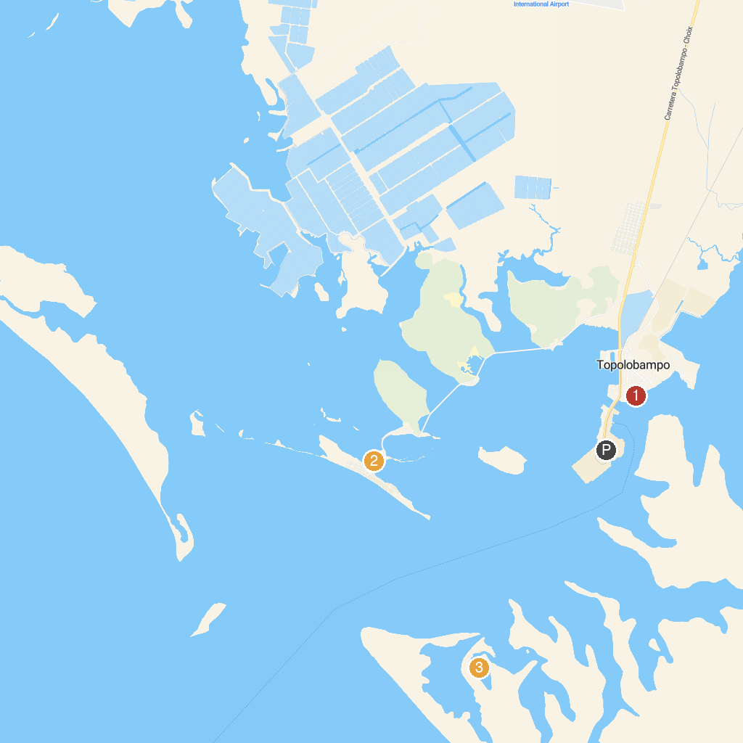
MAP KEY
1. Letras de Topolobampo | 3. The Pechocho
2. Tirolesa Playa Maviri
P. Cruise port / terminal
Map © MapTiler © OpenStreetMap contributors · cruiseports.org

