Tokushima, Shikoku, Japan
Built on a river delta on Shikoku's eastern coast, Tokushima blends 400 years of dance tradition with one of the world's most dramatic natural spectacles — the thundering Naruto whirlpools — and a pilgrimage culture that's still very much alive.
⚓ Pier (no tender) · 🕒 Typical call: 8-10 hrs · 💴 Currency: Japanese Yen (¥) · 🗣️ Language: Japanese · 🌸 Cultural / Nature
✍️ MY DAY IN PORT (FILL IN)
Ship / Date
In port | arrive ______ · all aboard ______
Booked excursion
Notes / meeting point
GETTING ASHORE
- Docking: Pier — Okinosu-soto or Akaishi Wharf (Komatsushima area); no tender
- Walk to center: Not walkable — shuttle or taxi required (15-40 min by vehicle)
- Best For: Japanese culture, natural wonders, pilgrimage temples, local food
- Don't Miss: Naruto Whirlpools and a bowl of Tokushima ramen with a raw egg
GETTING AROUND
- 🚕 Taxi: ¥1,800 — From the closer Okinosu-soto Wharf, a taxi to Tokushima Station takes about 15 minutes and costs roughly ¥1,800. Good va
- 📱 Rideshare: ✅ Uber
TOP THINGS TO DO
- Naruto Whirlpools — The Naruto Strait produces some of the world's largest tidal whirlpools — up to 20 m across during spring tides.
- Awa Odori Kaikan & Mt. Bizan — The Awa Odori Kaikan museum celebrates Tokushima's 400-year-old dance festival with daily live performances you can join.
- Tokushima Castle Ruins & Park — The stone foundations of the 16th-century Tokushima Castle sit in a leafy park beside the Shinmachi River, just minutes from…
- Otsuka Museum of Art — Japan's largest exhibition space houses over 1,000 full-size ceramic reproductions of Western masterpieces — from the Sistine…
- Ryozenji Temple (Pilgrimage Temple 1) — The official starting point of the 88-Temple Shikoku Pilgrimage, one of Buddhism's great walking routes.
BEST WALKS
- Castle Park & Canal Loop: 2 km · 45 min · Easy — From Tokushima Station, cross west into Castle Park to explore the stone ruins and traditional…
WEATHER · DAYLIGHT · MONEY
Month | High °F | Low °F | Rainy days
May | 76 | 61 | 1
Jul | 88 | 76 | 2
Sep | 84 | 72 | 3
Daylight: May 5:00AM–6:56PM · Jul 5:01AM–7:13PM · Sep 5:44AM–6:08PM
cruiseports.org/tokushima · Confirm terminal & all-aboard time with your ship

Tokushima, Shikoku, Japan — Port Map
Red = walkable sights · Amber = excursions farther out · P = cruise terminal
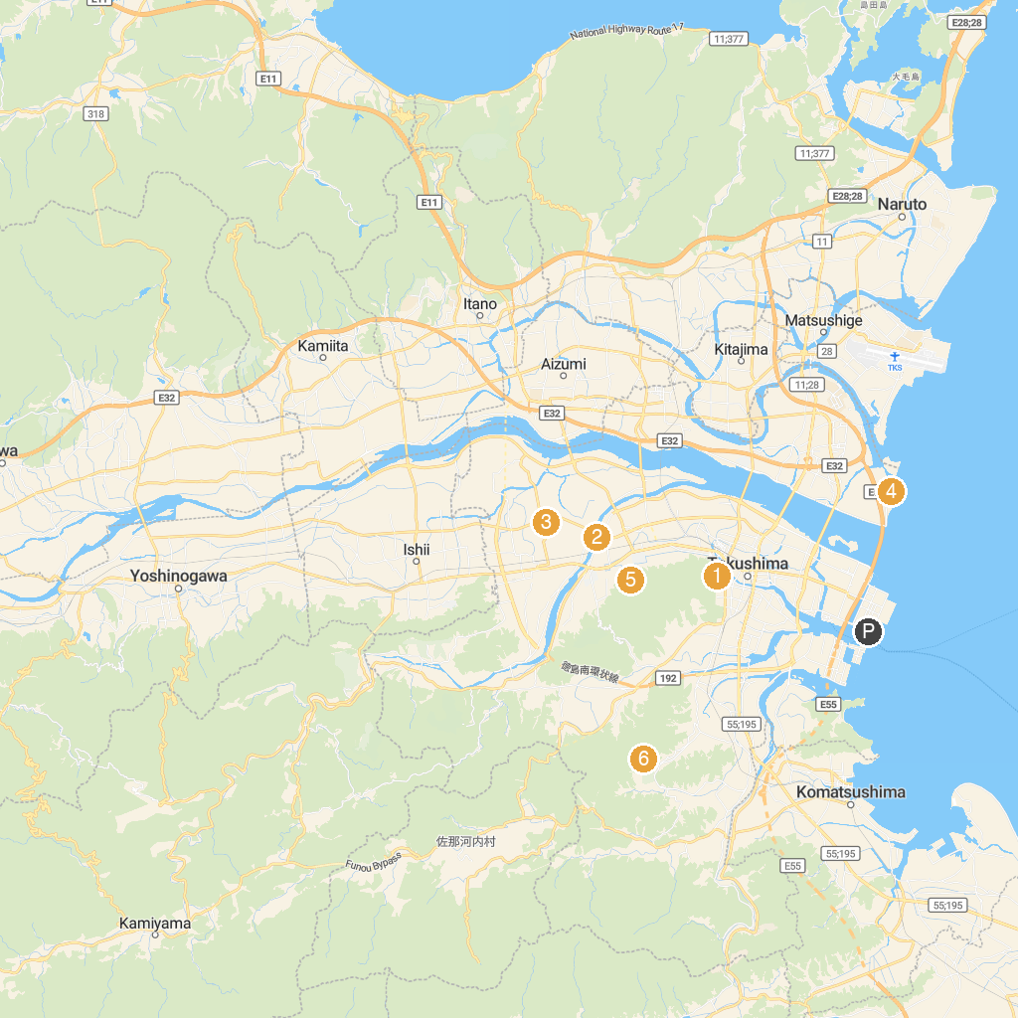
MAP KEY
1. Tenjin Shrine | 4. Komatsu Beach
2. Akuigawa Kasenshiki Ryokuchi Park | 5. Seibu Park
3. Idoji Temple | 6. Tokushima Botanical Garden
P. Cruise port / terminal
Map © MapTiler © OpenStreetMap contributors · cruiseports.org

