Tobermory, Ontario, Canada
Where Georgian Bay meets Lake Huron at the wild tip of the Bruce Peninsula — crystal freshwater, ancient limestone cliffs, and shipwrecks you can see from a glass-bottom boat.
⚓ Tender (no pier for cruise ships) · 🕒 Typical call: 7-9 hrs · 💵 Canadian Dollar (CAD) · 🗣️ English · 🌊 Fathom Five Marine Park
✍️ MY DAY IN PORT (FILL IN)
Ship / Date
In port | arrive ______ · all aboard ______
Booked excursion
Notes / meeting point
GETTING ASHORE
- Docking: Tender into Little Tub Harbour — no dedicated cruise pier
- Walk to center: Tender dock is right in the village; everything walkable
- Best For: Flowerpot Island boat tours, glass-bottom shipwreck cruises, hiking The Grotto
- Don't Miss: Glass-bottom boat over the Sweepstakes wreck (1885, only 20 ft down)
GETTING AROUND
- 📱 Rideshare: ❌ not available
TOP THINGS TO DO
- Flowerpot Island Drop-Off Cruise — Boat out to Flowerpot Island in Fathom Five National Marine Park to see the iconic sea-stack rock formations, limestone caves, a…
- Glass-Bottom Shipwreck Cruise — See perfectly preserved 19th-century schooners through a glass-bottom boat hull — the cold fresh water of Lake Huron keeps wooden…
- The Grotto & Indian Head Cove — Hike through ancient Niagara Escarpment forest to The Grotto — a spectacular limestone sea cave with luminous turquoise water…
- Scuba Diving Fathom Five — Dive operators in Tobermory run guided dives to multiple shipwrecks in Fathom Five National Marine Park — considered one of the…
- Kayaking Georgian Bay — Guided kayak tours explore the rocky Georgian Bay shoreline, sea caves, and clear water above visible shipwrecks.
BEST WALKS
- Little Tub Harbour Stroll: 1 km · 20 min · Flat · Paved — Walk the length of the harbour from the tender dock past Blue Heron Cruises, local shops, the Sweet…
- Visitor Centre Lookout Tower: 0.5 km · 10 min · Easy — Walk up Chi sin tib dek Road to the Bruce Peninsula National Park Visitor Centre.
WEATHER · DAYLIGHT · MONEY
Month | High °F | Low °F | Rainy days
May | 59 | 41 | 1
Jul | 74 | 57 | 1
Sep | 67 | 53 | 1
Daylight: May 5:56AM–8:50PM · Jul 5:54AM–9:10PM · Sep 7:05AM–7:36PM
cruiseports.org/tobermory-on · Confirm terminal & all-aboard time with your ship

Tobermory, Ontario, Canada — Port Map
Red = walkable sights · Amber = excursions farther out · P = cruise terminal
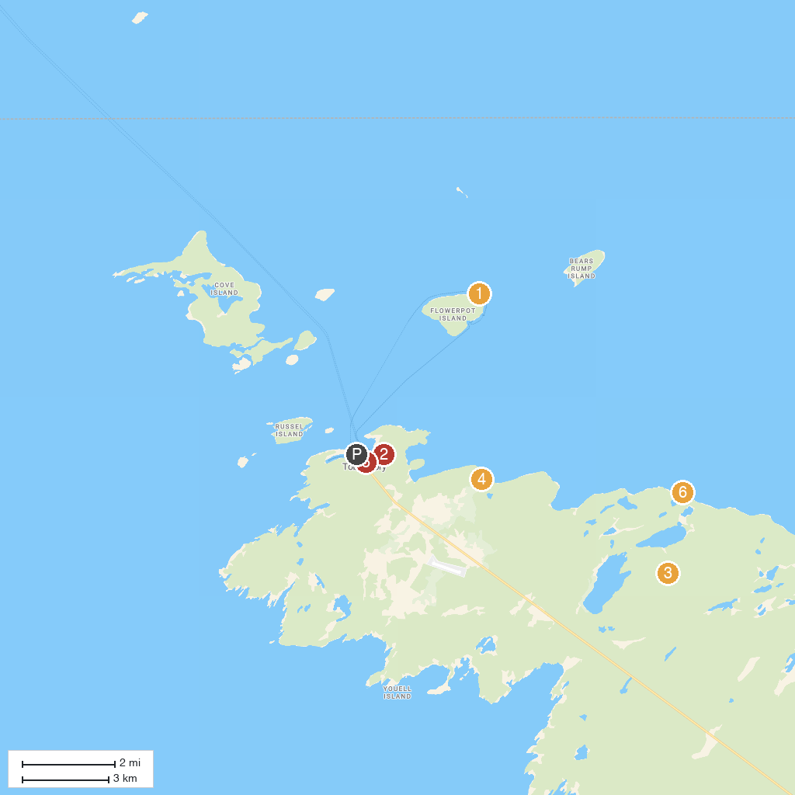
MAP KEY
1. Flowerpot Island Lighthouse | 5. Tobermory Wave Adventures Cruises
2. Fathom Five National Marine Park | 6. The Grotto, Bruce Peninsula National Park
3. Bruce Peninsula National Park | 7. Halfway Log Dump Parking
4. Little Cove
P. Cruise port / terminal
Map © MapTiler © OpenStreetMap contributors · cruiseports.org

