Toba, Mie, Japan
Birthplace of the cultured pearl, Toba pairs a working fishing bay with one of Japan's most sacred pilgrimage routes — all within easy reach of the tender pier.
⚓ Tender port (anchor & tender) · 🕒 Typical call: 8–10 hrs · 💴 Currency: Japanese Yen (JPY) — carry cash · 🗣️ Language: Japanese (English at main sites) · 🦪 Known for: pearls, Ama divers, seafood
✍️ MY DAY IN PORT (FILL IN)
Ship / Date
In port | arrive ______ · all aboard ______
Booked excursion
Notes / meeting point
GETTING ASHORE
- Docking: Tender — ships anchor in Toba Bay; tenders land at Toba Marine Terminal (Sadahama Pier)
- Walk to center: 5–10 min flat walk to Toba Station and seafood stalls
- Best For: Pearl culture history, Ama diver encounters, Ise Grand Shrine day trip
- Don't Miss: Mikimoto Pearl Island Ama diver demonstrations (hourly)
GETTING AROUND
- 🚕 Taxi: ¥400–¥750 base fare — Taxis are metered; the short ride from the terminal into central Toba will typically be at or just above the base fare.
- 📱 Rideshare: ✅ Uber
TOP THINGS TO DO
- Mikimoto Pearl Island — Walk across the pedestrian bridge to the island where Kokichi Mikimoto perfected cultured pearls in 1893.
- Toba Aquarium — One of Japan's largest aquariums with 1,200+ species across 12 zones.
- Ise Grand Shrine (Ise Jingu) Day Trip — Japan's most sacred Shinto shrine — dedicated to sun goddess Amaterasu — sits in 5,500 hectares of ancient cedar forest.
- Ama Hut Experience (Osatsu) — Meet real Ama divers at a traditional Ama-goya hut where they grill fresh-caught abalone, lobster, and shellfish over an open…
- Meoto Iwa — The Wedded Rocks — At Futami Okitama Shrine, two sacred rocks in the sea are bound by a thick shimenawa rope representing the creator gods of Shinto.
BEST WALKS
- Waterfront Pearl & Aquarium Loop: 2.5 km · 40 min · flat · easy — From the Toba Marine Terminal, walk along the harborfront to Mikimoto Pearl Island, cross the…
- Castle Hill Viewpoint: 2 km round-trip · 30 min · gentle climb · easy-moderate — Head inland from the tender pier to Shiroyama Park (Toba Castle Ruins) for panoramic views over…
WEATHER · DAYLIGHT · MONEY
Month | High °F | Low °F | Rainy days
May | 74 | 58 | 2
Jul | 86 | 74 | 3
Sep | 82 | 71 | 2
Daylight: May 4:50AM–6:47PM · Jul 4:51AM–7:05PM · Sep 5:35AM–5:59PM
cruiseports.org/toba-mie · Confirm terminal & all-aboard time with your ship

Toba, Mie, Japan — Port Map
Red = walkable sights · Amber = excursions farther out · P = cruise terminal
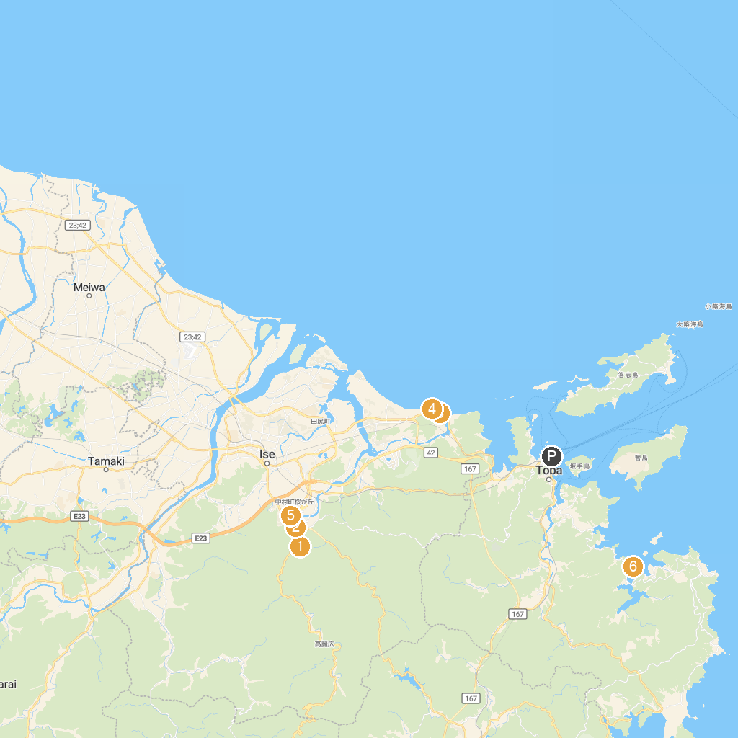
MAP KEY
1. Kotai Jingu (Ise Jingu Naiku, Inner Sanctuary) | 5. Futami Okitama Shrine
2. Shima City Museum of History and Folklore | 6. Sarutahiko Shrine
3. Okage Yokocho | 7. Toyouke Daijingu (Ise Jingu Geku, Outer Sanctuary)
4. ISE Sea Paradise | 8. Kaiko Raft Fishing
P. Cruise port / terminal
Map © MapTiler © OpenStreetMap contributors · cruiseports.org

