Toamasina, Atsinanana, Madagascar
Madagascar's busiest port carries the sweet scent of vanilla and cloves in the air. Toamasina is your gateway to lemur encounters, canal boat rides through lush waterways, and a city where French colonial boulevards meet the colour and chaos of Africa.
⚓ Docked (commercial pier) · 🕒 Typical call: 8-10 hrs · 💵 Malagasy Ariary (MGA) — cash essential · 🗣️ Malagasy & French spoken · 🦎 Endemic wildlife
✍️ MY DAY IN PORT (FILL IN)
Ship / Date
In port | arrive ______ · all aboard ______
Booked excursion
Notes / meeting point
GETTING ASHORE
- Docking: Ships dock at Mole B / Passenger Berth in the commercial port — no tendering
- Walk to center: ~1 mile but walking through the active port is prohibited — use ship shuttle or taxi
- Best For: Lemurs, canal boat trips, spice markets, colonial-era city walk
- Don't Miss: Parc Ivoloina lemur reserve and a pousse-pousse ride through the palm-lined avenues
GETTING AROUND
- 🚕 Taxi: $2–$5 USD (5,000–15,000 MGA) — Yellow taxis wait at the port gate and are the primary transport into city center. Agree on fare before departing — no m
- 📱 Rideshare: ❌ not available
TOP THINGS TO DO
- Parc Ivoloina Lemur Reserve — The standout excursion from Toamasina.
- Pangalanes Canal Boat Ride — Glide along Madagascar's great network of man-made and natural canals running parallel to the east coast.
- Bazary Be Spice Market — Toamasina exports vanilla, cloves, cinnamon, and wild pepper to the world — and Bazary Be is where you smell it all at once.
- Colonial City Walk & Cathedral — Walk Avenue de l'Indépendance — a grand palm-lined boulevard of French colonial buildings — to the Cathédrale Saint-Joseph on…
- Foulpointe Beach & Coral Lagoon — Madagascar's closest safe swimming beach sits 60 km north in a shallow coral-reef lagoon.
BEST WALKS
- Avenue de l'Indépendance & Waterfront Loop: ~2 km | 45–60 min | Easy — From the port gate, head to the main boulevard lined with giant palms and colonial architecture.
- Banyan Tree Square & Port Area: ~1 km | 20–30 min | Easy — Near the port entrance, the Place Bienvenue hosts massive ancient banyan trees with dramatic aerial…
WEATHER · DAYLIGHT · MONEY
Month | High °F | Low °F | Rainy days
May | 83 | 69 | 3
Jul | 78 | 64 | 3
Sep | 81 | 65 | 1
Daylight: May 6:01AM–5:16PM · Jul 6:14AM–5:22PM · Sep 5:38AM–5:37PM
cruiseports.org/toamasina · Confirm terminal & all-aboard time with your ship

Toamasina, Atsinanana, Madagascar — Port Map
Red = walkable sights · Amber = excursions farther out · P = cruise terminal
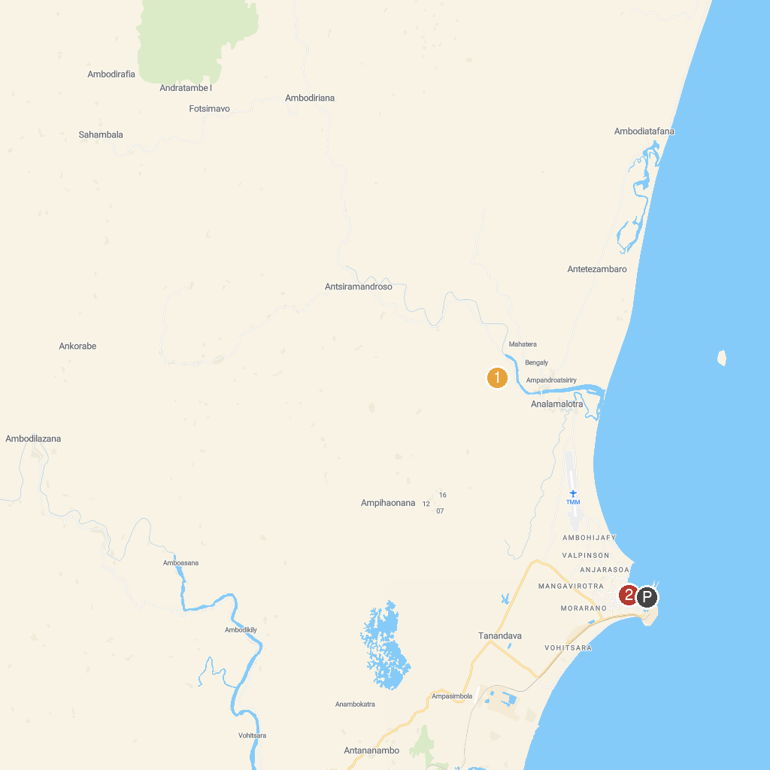
MAP KEY
1. Parc Ivoloina | 2. Toamasina Beach
P. Cruise port / terminal
Map © MapTiler © OpenStreetMap contributors · cruiseports.org

