Tivua Island, Mamanuca Islands, Fiji
A postcard-perfect private coral cay ringed by 500 acres of living reef, Tivua Island delivers the all-inclusive Fijian beach day — snorkeling, kava, and a beach BBQ — in one sun-drenched package.
⚓ Tender / Beach Landing · 🕒 Typical call: 6-8 hrs · 💵 Fijian Dollar (FJD) · 🗣️ Fijian / English
✍️ MY DAY IN PORT (FILL IN)
Ship / Date
In port | arrive ______ · all aboard ______
Booked excursion
Notes / meeting point
GETTING ASHORE
- Docking: Anchor offshore; tender to beach — no pier
- Walk to center: Everything is on the island — 5 min beach walk
- Best For: Snorkeling, coral reef swimming, Fijian culture
- Don't Miss: Guided snorkel tour over the coral gardens
GETTING AROUND
- 🚕 Taxi: FJ–FJ from Nadi — If making your own way to Port Denarau for a day cruise, local taxis from Nadi town or Nadi Airport charge roughly FJ–FJ
- 📱 Rideshare: ❌ not available
TOP THINGS TO DO
- Guided Snorkel Tour — A marine guide leads you through 500 acres of coral gardens where you'll find tropical fish, sea turtles, starfish, and sea…
- Glass-Bottom Boat Tour — Stay dry while a marine interpreter narrates the reef below.
- Kayaking & Paddleboarding — Paddle around the island's calm lagoon on kayaks or stand-up paddleboards — equipment is usually included with day packages.
- Kava Ceremony & Cultural Demos — Join a traditional kava ceremony with island staff, watch coconut husking and weaving demonstrations, and get a taste of…
- Scuba Diving — Certified divers can explore deeper reef sections, wrecks, and encounters with eels, sharks, and stingrays.
BEST WALKS
- Island Circumnavigation Walk: ~1 km | 15–20 min | Easy | Flat sand — Walk the entire perimeter of Tivua Island along the beach.
- Coral Reef Education Walk: 30 min | Easy | Guided — Island marine biologists lead a shoreline walk explaining reef ecology, coral health, and Tivua's…
WEATHER · DAYLIGHT · MONEY
Month | High °F | Low °F | Rainy days
May | 83 | 72 | 10
Jul | 82 | 70 | 5
Sep | 83 | 71 | 11
Daylight: May 6:28AM–5:45PM · Jul 6:41AM–5:51PM · Sep 6:06AM–6:05PM
cruiseports.org/tivua-island-fiji · Confirm terminal & all-aboard time with your ship

Tivua Island, Mamanuca Islands, Fiji — Port Map
Red = walkable sights · Amber = excursions farther out · P = cruise terminal
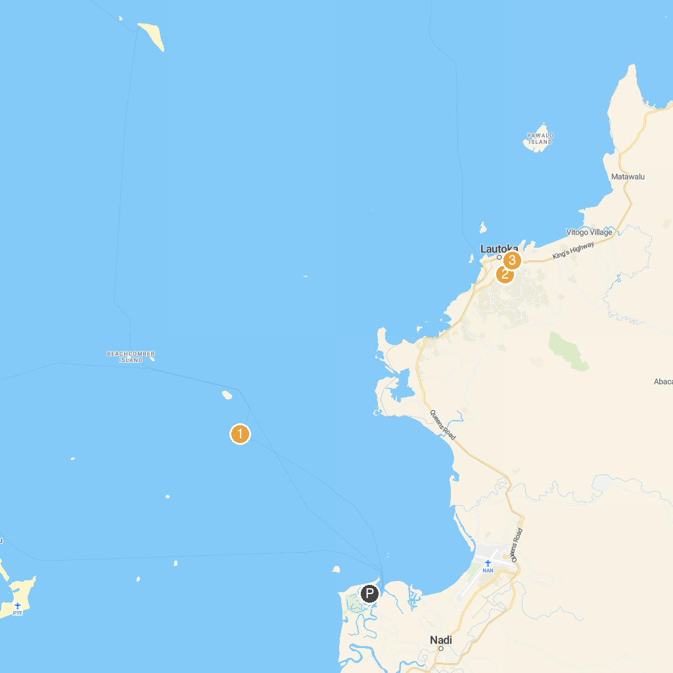
MAP KEY
1. South Sea Island | 3. Lautoka Jame Masjid
2. Lautoka Botanical Gardens
P. Cruise port / terminal
Map © MapTiler © OpenStreetMap contributors · cruiseports.org

