Tinos Island, Cyclades, Greece
Just a short sail from Mykonos but worlds apart, Tinos is a place of deep faith, artisan marble craft, and superb food — an Aegean gem that rewards every curious cruiser.
⚓ Tender or pier (size-dependent) · 🕒 Typical call: 6-8 hrs · 💶 Currency: Euro (€) · 🗣️ Language: Greek (English widely spoken) · 🌬️ Famous for the Meltemi wind
✍️ MY DAY IN PORT (FILL IN)
Ship / Date
In port | arrive ______ · all aboard ______
Booked excursion
Notes / meeting point
GETTING ASHORE
- Docking: Larger ships anchor and tender to the Old Port; smaller vessels may dock at the New Port pier — both are steps from town
- Walk to center: 2-5 min to Chora shops; 10-15 min uphill to the famous church
- Best For: Culture, spirituality, local cuisine, scenic villages, beaches
- Don't Miss: Panagia Evangelistria church, marble-carving village of Pyrgos, Venetian dovecotes
GETTING AROUND
- 🚕 Taxi: €10–€15 — Taxis wait at the port and can take you to Tinos Town (Chora) in about 5 minutes. Pre-booking via Aegean Taxi is recomme
- 📱 Rideshare: ❌ not available
TOP THINGS TO DO
- Panagia Evangelistria Church — Greece's most sacred pilgrimage destination, this imposing white-marble church houses the Miraculous Icon of the Virgin Mary.
- Pyrgos Marble Village — The marble-carving capital of Greece, Pyrgos is a village built from its own material — marble bus stops, fountain squares…
- Volax & the Boulder Village — One of Tinos's most surreal landscapes: hundreds of giant round granite boulders encircle a whitewashed village where…
- Agios Fokas Beach — The closest decent beach to the port — a long sandy stretch lined with tamarisk trees, beach bars, and sunbeds.
- Tinos Food & Local Flavors — Tinos is one of Greece's top culinary destinations.
BEST WALKS
- Port to Panagia Evangelistria: 800m · 10-15 min · Easy uphill — Follow the marble-paved Megalocharis Avenue from the port up to Greece's most sacred church.
- Chora Backstreets & Archaeology: 1km loop · 30-40 min · Easy — Duck off the main avenue into Chora's whitewashed alleys lined with bougainvillea and tiny chapels…
WEATHER · DAYLIGHT · MONEY
Month | High °F | Low °F | Rainy days
May | 74 | 63 | 0
Jul | 86 | 75 | 0
Sep | 80 | 71 | 0
Daylight: May 6:10AM–8:21PM · Jul 6:10AM–8:39PM · Sep 7:01AM–7:26PM
cruiseports.org/tinos-island · Confirm terminal & all-aboard time with your ship

Tinos Island, Cyclades, Greece — Port Map
Red = walkable sights · Amber = excursions farther out · P = cruise terminal
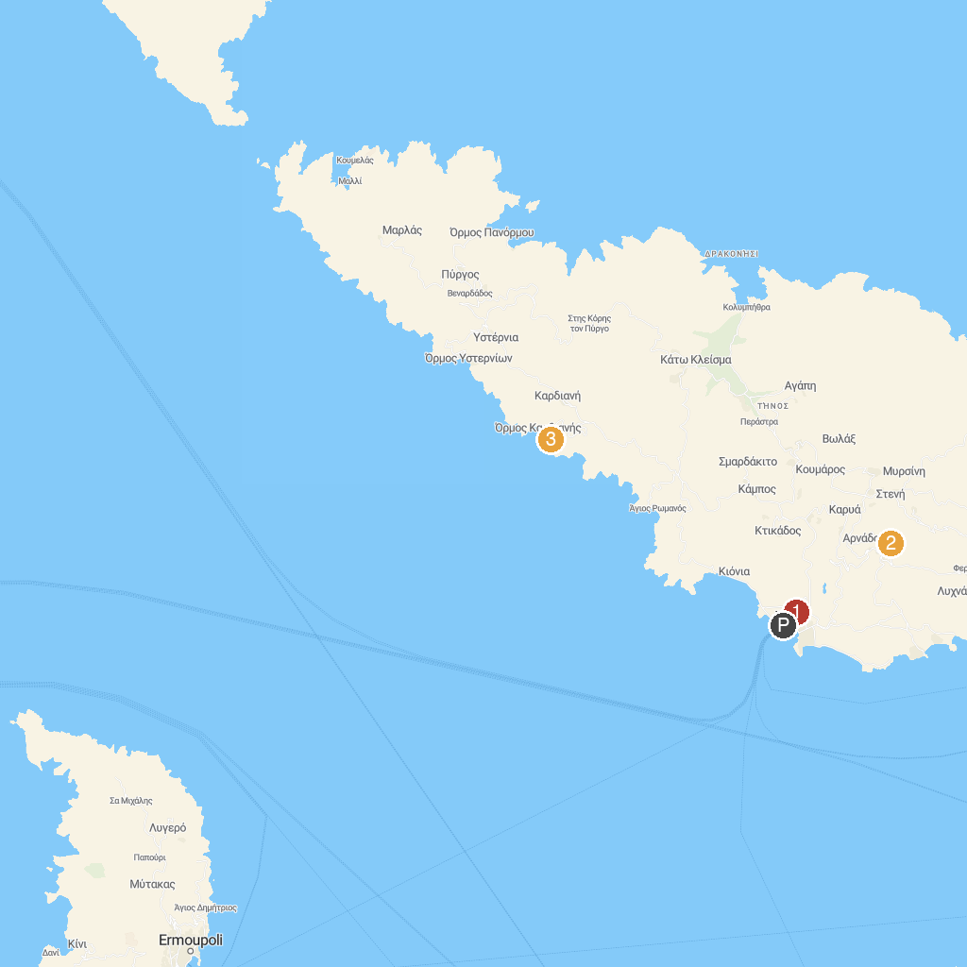
MAP KEY
1. Ιερός Ναός Παναγίας Ευαγγελίστριας της Τήνου | 3. Παραλία Καλύβια
2. Πλατεία Δύο Χωριά
P. Cruise port / terminal
Map © MapTiler © OpenStreetMap contributors · cruiseports.org

