Tinian Island, Northern Mariana Islands, USA
A sleepy CNMI island of sweeping contrasts — pristine white-sand beaches completely to yourself, ancient Chamorro latte stone ruins, and the sobering airfield where the atomic age began.
⚓ Tender port · 🕒 Typical call: 6–8 hrs · 💵 USD · 🗣️ English & Chamorro · 🏝️ Remote & uncrowded
✍️ MY DAY IN PORT (FILL IN)
Ship / Date
In port | arrive ______ · all aboard ______
Booked excursion
Notes / meeting point
GETTING ASHORE
- Docking: Tender to San Jose Harbor
- Walk to center: 5 min — San Jose village is right at the pier
- Best For: WWII history, empty Pacific beaches, Chamorro culture
- Don't Miss: The atomic bomb loading pits at North Field (needs vehicle)
GETTING AROUND
- 🚕 Taxi: $5–$15 — A small number of local taxis operate on the island. Arrange through your hotel or ask at the pier; no app-based hailing
- 📱 Rideshare: ❌ not available
TOP THINGS TO DO
- North Field Atomic Bomb Pits & WWII Tour — The must-do on Tinian.
- House of Taga Latte Stones — A five-minute walk from the tender dock, these towering ancient Chamorro latte stones are the largest in the Marianas.
- Taga & Tachogna Beach Half-Day — Two stunning beaches a 15-minute walk from the pier.
- Tinian Blowhole & Chulu Beach — The northeast coast blowhole shoots seawater skyward through limestone crevices.
- Snorkeling & Diving off Tinian — Tinian's clear, warm Pacific waters offer excellent visibility and healthy coral.
BEST WALKS
- Pier to House of Taga & Taga Beach: 1.2 km • 15 min • Flat & easy — From the harbor walk south through San Jose village to the House of Taga latte stone site, then…
- Harbor to Kammer Beach: 0.5 km • 5 min • Flat — A quick stroll right beside the harbor.
WEATHER · DAYLIGHT · MONEY
Month | High °F | Low °F | Rainy days
May | 73 | 54 | 0
Jul | 81 | 59 | 0
Sep | 81 | 59 | 0
Daylight: May 5:58AM–8:09PM · Jul 5:59AM–8:27PM · Sep 6:50AM–7:14PM
cruiseports.org/tinian-island-marianas · Confirm terminal & all-aboard time with your ship

Tinian Island, Northern Mariana Islands, USA — Port Map
Red = walkable sights · Amber = excursions farther out · P = cruise terminal
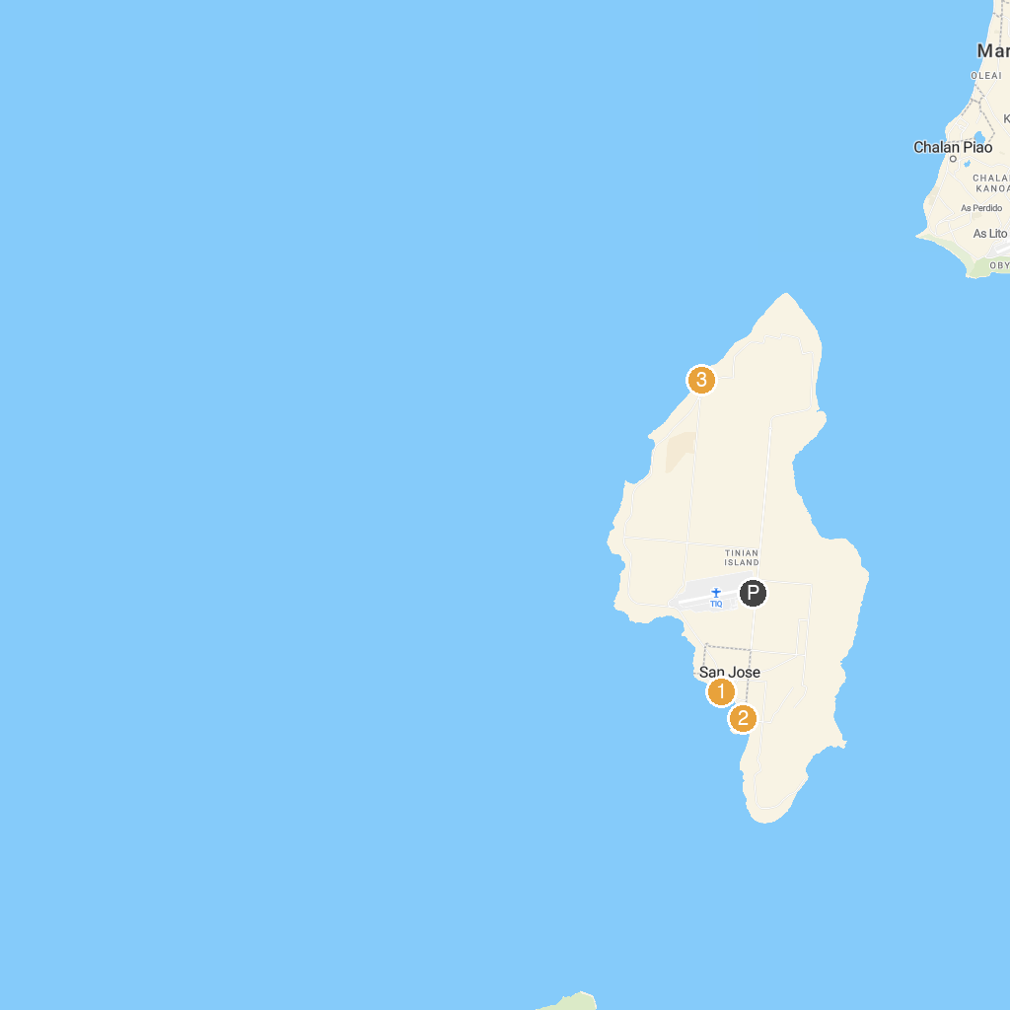
MAP KEY
1. House of Taga | 3. Chulu Beach
2. Taga Beach | 4. Coral Ocean Resort Golf Course
P. Cruise port / terminal
Map © MapTiler © OpenStreetMap contributors · cruiseports.org

