Timaru, South Canterbury, New Zealand
Built on ancient lava flows and dressed in dark bluestone, Timaru is South Canterbury's compact, walkable port city — with a crescent beach, world-class Māori rock art, and a charming historic centre just a shuttle ride from the wharf.
⚓ Pier (PrimePort Timaru) · 🕒 Typical call: 7-9 hrs · 💵 NZD · 🗣️ English / Te Reo Māori · 🐧 Little Blue Penguins
✍️ MY DAY IN PORT (FILL IN)
Ship / Date
In port | arrive ______ · all aboard ______
Booked excursion
Notes / meeting point
GETTING ASHORE
- Docking: Pier — No. 1 Wharf or North Mole, PrimePort Timaru
- To Town: Free shuttle to Stafford St / Caroline Bay (5-10 min); walking through port not permitted
- Best For: Bluestone architecture, Māori culture, beach walks, South Canterbury day trips
- Don't Miss: Te Ana Māori Rock Art Centre & Caroline Bay beach
GETTING AROUND
- 🚕 Taxi: NZD 10–18 — Taxis meet ships on cruise days at PrimePort. The city center is very close, so fares are typically under NZD 15. Availa
- 📱 Rideshare: ✅ Uber
TOP THINGS TO DO
- Te Ana Māori Rock Art Centre — Explore one of New Zealand's richest collections of ancient Māori rock drawings.
- Bluestone Heritage Walk & South Canterbury Museum — Follow the free heritage trail through Timaru's intact Victorian and Edwardian CBD — dark volcanic bluestone buildings line…
- Caroline Bay Beach & Trevor Griffiths Rose Garden — Timaru's showpiece beach is sheltered by the harbour breakwater, making it one of the safest swimming beaches on the South Island.
- Aigantighe Art Gallery — The South Island's third-largest public art collection, housed in a historic home with a sculpture garden.
- Lake Tekapo & Mackenzie Basin Day Trip — About 2.5 hours inland, Lake Tekapo's turquoise glacial waters, lupins (Nov–Dec), and Church of the Good Shepherd are iconic…
BEST WALKS
- Caroline Bay & Boardwalk Loop: 2 km · 30-45 min · Easy · Free — From the shuttle drop-off near Stafford Street, head to the foreshore path along Caroline Bay.
- Stafford Street Heritage Stroll: 1.5 km · 20-30 min · Easy · Free — Walk Stafford Street end-to-end to take in Timaru's remarkable bluestone commercial precinct.
WEATHER · DAYLIGHT · MONEY
Month | High °F | Low °F | Rainy days
May | 58 | 38 | 1
Jul | 51 | 34 | 2
Sep | 59 | 37 | 1
Daylight: May 7:44AM–5:17PM · Jul 8:06AM–5:15PM · Sep 6:38AM–6:23PM
cruiseports.org/timaru · Confirm terminal & all-aboard time with your ship

Timaru, South Canterbury, New Zealand — Port Map
Red = walkable sights · Amber = excursions farther out · P = cruise terminal
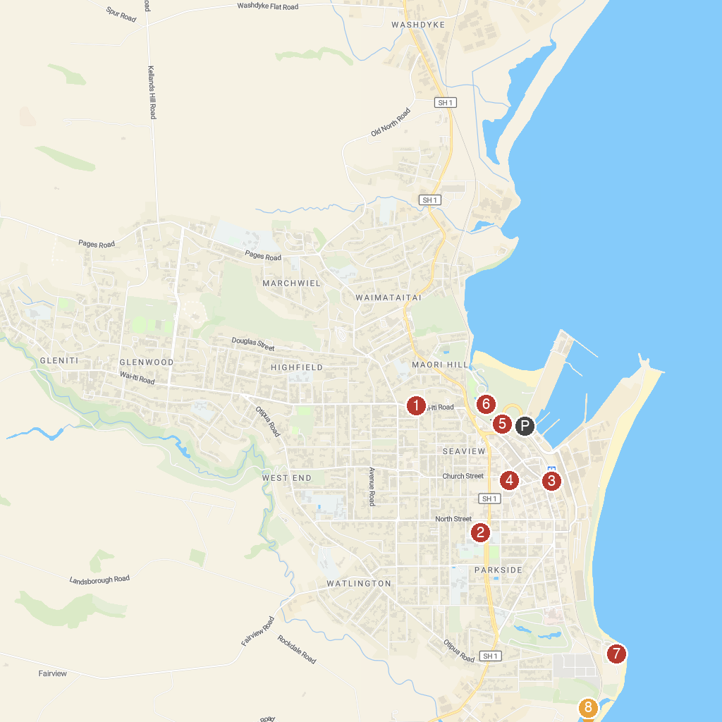
MAP KEY
1. Aigantighe Art Gallery | 5. Trevor Griffiths Rose Garden
2. Sacred Heart Basilica | 6. Caroline Bay Association
3. Te Ana Maori Rock Art Centre | 7. Patiti Point
4. South Canterbury Museum | 8. Jack's Point Lighthouse
P. Cruise port / terminal
Map © MapTiler © OpenStreetMap contributors · cruiseports.org

