Tilos Island, Dodecanese, Greece
Europe's greenest island runs entirely on wind and solar, recycles 85% of its waste, and welcomes cruise passengers with medieval castles, a ghost village, dwarf-elephant fossils, and peacocks on the beach — all within a 7 km radius of the tiny port of Livadia.
⚓ Tender (most ships) · 🕒 Typical call: 6-8 hrs · 💶 Euro (€) · 🗣️ Greek · 🌿 Eco island
✍️ MY DAY IN PORT (FILL IN)
Ship / Date
In port | arrive ______ · all aboard ______
Booked excursion
Notes / meeting point
GETTING ASHORE
- Docking: Tender for most ships; small vessels (<150 m) may dock at Livadia pier
- Walk to center: 3-5 min to Livadia town along the flat waterfront
- Best For: Eco travelers, hikers, quiet Greek island lovers
- Don't Miss: The Knight's Castle above Megalo Chorio — 360° Aegean views
GETTING AROUND
- 🚕 Taxi: €5–€15 — Tilos has just one taxi for the entire island. It can take you to Megalo Chorio (the hilltop capital) or other villages;
- 📱 Rideshare: ❌ not available
TOP THINGS TO DO
- Megalo Chorio Village & Knight's Castle — Take the bus to Tilos' hilltop capital, explore whitewashed alleys and the tiny Elephant Museum (fossilized dwarf elephants…
- Mikro Chorio Ghost Village Walk — An abandoned medieval settlement in the hills above Livadia, evacuated in the 1950s and left frozen in time.
- Eristos Beach Day — The island's finest sandy beach — a 1 km arc of golden sand and fine pebbles with wild, uncommercialized surroundings.
- Plaka Beach & Wild Peacocks — A secluded northern bay where a flock of wild peacocks roams the tamarisk trees fringing the beach.
- Monastery of Agios Panteleimonas — A 15th-century monastery built into a cliff face on the wild western end of the island, featuring ancient frescoes and a sacred…
BEST WALKS
- Livadia Waterfront Stroll: 20 min | Flat | Free — Walk the length of Livadia Beach from the port pier to the far end of the bay, passing tavernas, a…
- Trail to Mikro Chorio (Ghost Village): ~1 hr each way | Moderate, uphill | Free — A marked footpath climbs 3.5 km from the edge of Livadia up to the abandoned village of Mikro Chorio.
cruiseports.org/tilos-island · Confirm terminal & all-aboard time with your ship

Tilos Island, Dodecanese, Greece — Port Map
Red = walkable sights · Amber = excursions farther out · P = cruise terminal
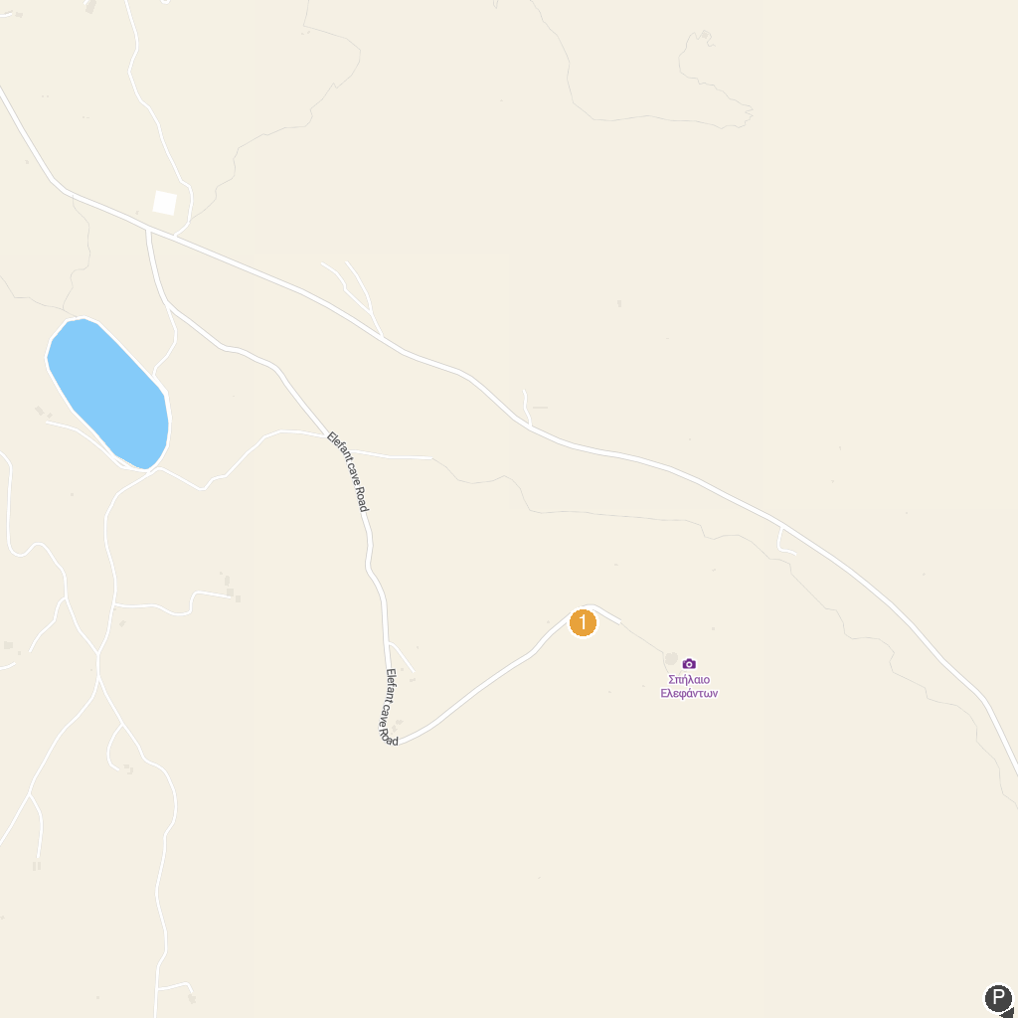
MAP KEY
1. Elephant Museum | 3. Datça Palamutbükü
2. Stefanos Crater
P. Cruise port / terminal
Map © MapTiler © OpenStreetMap contributors · cruiseports.org

