Thunder Bay, Ontario, Canada
Where the Canadian Shield meets Lake Superior — Thunder Bay delivers raw wilderness, a record-setting fur-trade fort, and a quirky Finnish-Canadian food culture all within easy reach of the pier.
⚓ Direct pier (Pool 6 Terminal) · 🕒 Typical call: 8-10 hrs · 💵 Canadian Dollar (CAD) · 🗣️ English (French signage) · 🏔️ Great Lakes / Boreal
✍️ MY DAY IN PORT (FILL IN)
Ship / Date
In port | arrive ______ · all aboard ______
Booked excursion
Notes / meeting point
GETTING ASHORE
- Docking: Direct pier at Pool 6 Cruise Terminal — no tender required
- Walk to center: ~15 min (1.2 km) along the waterfront to downtown Port Arthur
- Best For: History buffs, nature lovers, and adventurous foodies
- Don't Miss: Fort William Historical Park and a local Persian pastry
GETTING AROUND
- 🚕 Taxi: CAD – — Diamond Taxi and other local cabs serve the cruise terminal. Short hop to city center is typically CAD – depending on de
- 📱 Rideshare: ❌ not available
TOP THINGS TO DO
- Fort William Historical Park — One of North America's largest living-history sites — a meticulously reconstructed 1816 North West Company fur-trade post where…
- Kakabeka Falls — Niagara of the North — A 40-metre (130-ft) waterfall plunging through Precambrian rock gorge with accessible wrap-around boardwalks and dramatic spray.
- Sleeping Giant Panoramic Views — The Sleeping Giant (Sibley Peninsula) dominates the harbour skyline — a massive rock formation that looks uncannily like a…
- Terry Fox Monument & Terry Fox Lookout — A moving tribute to Canadian hero Terry Fox, who was forced to end his Marathon of Hope near Thunder Bay in 1980.
- Lake Superior Zodiac & Catamaran Tour — Sail Superior Tours departs from Marina Park (steps from the ship) offering high-speed zodiac and catamaran tours out onto Lake…
BEST WALKS
- Waterfront Trail: Pier to Downtown: 1.5 km · 20 min · Flat, paved — Walk north along the waterfront from Pool 6, through the Prince Arthur's Landing parkland, past the…
- Hillcrest Park Harbour Overlook: ~3 km round trip · 45 min · Gentle uphill — Head inland from downtown to Hillcrest Park for a panoramic view of the harbour, the towering grain…
WEATHER · DAYLIGHT · MONEY
Month | High °F | Low °F | Rainy days
May | 59 | 36 | 1
Jul | 77 | 53 | 1
Sep | 66 | 46 | 1
Daylight: May 6:16AM–9:30PM · Jul 6:12AM–9:53PM · Sep 7:34AM–8:08PM
cruiseports.org/thunder-bay-on · Confirm terminal & all-aboard time with your ship

Thunder Bay, Ontario, Canada — Port Map
Red = walkable sights · Amber = excursions farther out · P = cruise terminal
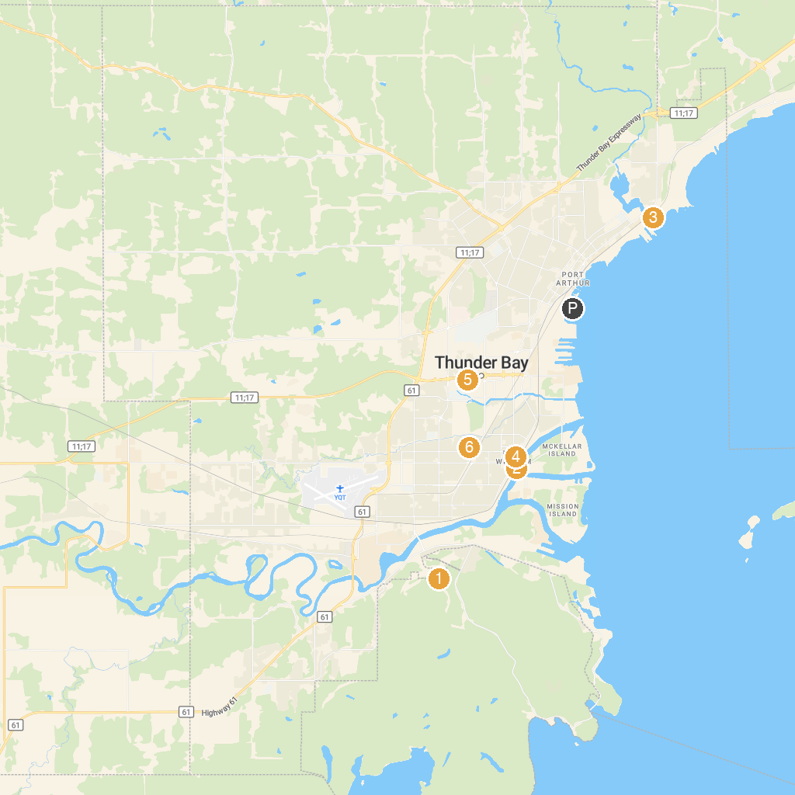
MAP KEY
1. Mount McKay Scenic Lookout | 5. Thunder Bay Museum
2. Kaministiquia River Heritage Park | 6. Thunder Bay Art Gallery
3. Lorne Allard Fisherman's Park | 7. Loch Lomond Ski Area
4. Cascades Conservation Area | 8. International Friendship Gardens
P. Cruise port / terminal
Map © MapTiler © OpenStreetMap contributors · cruiseports.org

