Thionville, Moselle, France
A compact French Moselle city where medieval towers, Maginot Line fortresses, and mirabelle plum tarts converge at the Luxembourg border — all walkable from the river quay.
⚓ Docked (river quay) · 🕒 Typical call: 6-8 hrs · 💶 Euro (€) · 🗣️ French (German & English understood)
✍️ MY DAY IN PORT (FILL IN)
Ship / Date
In port | arrive ______ · all aboard ______
Booked excursion
Notes / meeting point
GETTING ASHORE
- Docking: Moored alongside the Moselle quay; town center 5-10 min walk
- Walk to center: ~5 min to Place du Marché; Tour aux Puces 10 min
- Best For: History buffs, Maginot Line visits, Lorraine food & wine
- Don't Miss: Tour aux Puces medieval museum & authentic Quiche Lorraine at lunch
GETTING AROUND
- 🚕 Taxi: €7–€10 — Local taxis are available at the port area. Base pickup fare is ~€3.08 plus ~€1.84/km daytime; the ride to the city cent
- 📱 Rideshare: ✅ Uber, Bolt
TOP THINGS TO DO
- Ouvrage du Hackenberg (Maginot Line) — The largest Maginot Line fortress still open to visitors.
- Tour aux Puces Archaeological Museum — Thionville's medieval keep — a striking 14-sided tower dating to the 11th century — houses eight rooms of archaeological…
- Day Trip to Luxembourg City — A quick 25-minute train ride drops you in the heart of one of Europe's most scenic capitals — the old Casemates, Grand Ducal…
- Rodemack — La Petite Carcassonne Lorraine — One of France's 'Most Beautiful Villages,' Rodemack is a medieval walled village about 16 km from Thionville with 700 m of intact…
- Fort de Guentrange — A German Imperial-era fort on the hill above Thionville, built between 1899 and 1906, now open for guided visits.
BEST WALKS
- Old Town Heritage Walk: 1.5 km · Easy · 30-45 min — A circular stroll through Thionville's compact medieval centre, taking in the market belfry…
- Moselle Riverside Promenade: 2 km · Easy · 40 min — Walk north along the Moselle towpath from the cruise quay, crossing at the bridge to see the…
WEATHER · DAYLIGHT · MONEY
Month | High °F | Low °F | Rainy days
May | 68 | 43 | 1
Jul | 80 | 53 | 1
Sep | 72 | 46 | 1
Daylight: May 5:51AM–9:12PM · Jul 5:46AM–9:35PM · Sep 7:12AM–7:47PM
cruiseports.org/thionville · Confirm terminal & all-aboard time with your ship

Thionville, Moselle, France — Port Map
Red = walkable sights · Amber = excursions farther out · P = cruise terminal
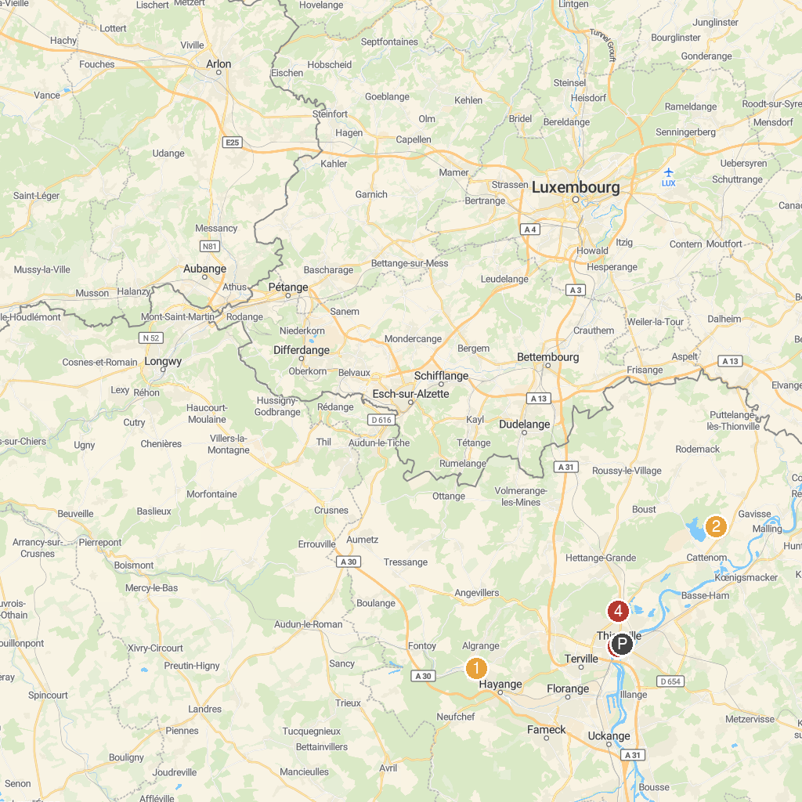
MAP KEY
1. Zoo d'Amnéville | 5. Église catholique Saint-Maximin à Thionville
2. Château de Nilvange | 6. Chateau La Grange
3. The Maginot Line - Large Artillery Fortress Galgenberg | 7. Centre de Soins pour la Faune Sauvage
4. Magic Park | 8. Parc Le'h Adventures Sàrl
P. Cruise port / terminal
Map © MapTiler © OpenStreetMap contributors · cruiseports.org

