Thessaloniki, Macedonia, Greece
Greece's second city packs two millennia of Roman, Byzantine, and Ottoman history into a walkable waterfront — and feeds you better than Athens.
⚓ Pier (no tender) · 🕒 Typical call: 8-10 hrs · 💶 Euro (€) · 🗣️ Greek / English widely spoken
✍️ MY DAY IN PORT (FILL IN)
Ship / Date
In port | arrive ______ · all aboard ______
Booked excursion
Notes / meeting point
GETTING ASHORE
- Docking: Pier — Alexander the Great Cruise Terminal, Pier 2
- Walk to center: ~10 min to Aristotle Square; 20-25 min to White Tower
- Best For: Byzantine history, foodie culture, free walking
- Don't Miss: Bougatsa for breakfast, White Tower views, Ano Poli streets
GETTING AROUND
- 🚕 Taxi: €5–€10 — Metered taxis wait at the port exit. Fares are regulated with a €1.07 port surcharge; expect €5–10 to the city center.
- 📱 Rideshare: ✅ Uber, Bolt, Free Now
- 🚌 Hop-on hop-off: ✅ City Sightseeing
TOP THINGS TO DO
- White Tower & Waterfront Walk — Climb the iconic Ottoman tower for 360° views, then stroll the Nea Paralia promenade past the Umbrellas sculpture to Aristotle…
- Ano Poli (Upper Town) & Byzantine Walls — The only neighborhood to survive the 1917 fire — cobblestone lanes, Ottoman-era mansions, Byzantine city walls, and sweeping…
- Archaeological Museum of Macedonia — World-class collection including gold burial artifacts from the tomb of Philip II of Macedon (father of Alexander the Great).
- Thessaloniki Food & Market Tour — Graze on bougatsa, mussel saganaki, trigona, and fresh cheese at the Kapani and Modiano markets, then sit for coffee in the…
- Halkidiki Beach Day — The crystalline beaches of the Halkidiki peninsula are 1-1.5 hours by car — white sand, turquoise water, and beach tavernas.
BEST WALKS
- Waterfront Promenade — Pier to White Tower: 2.5 km · 25 min one way · Flat — Walk east from the cruise terminal along the Nea Paralia promenade.
- Arch of Galerius to Ano Poli: 2 km · 40 min · Moderate uphill — From Kamara (Arch of Galerius) walk through the bustling Navarinou shopping district, then climb…
WEATHER · DAYLIGHT · MONEY
Month | High °F | Low °F | Rainy days
May | 77 | 57 | 0
Jul | 91 | 70 | 0
Sep | 82 | 63 | 1
Daylight: May 6:11AM–8:38PM · Jul 6:10AM–8:57PM · Sep 7:09AM–7:36PM
cruiseports.org/thessaloniki · Confirm terminal & all-aboard time with your ship

Thessaloniki, Macedonia, Greece — Port Map
Red = walkable sights · Amber = excursions farther out · P = cruise terminal
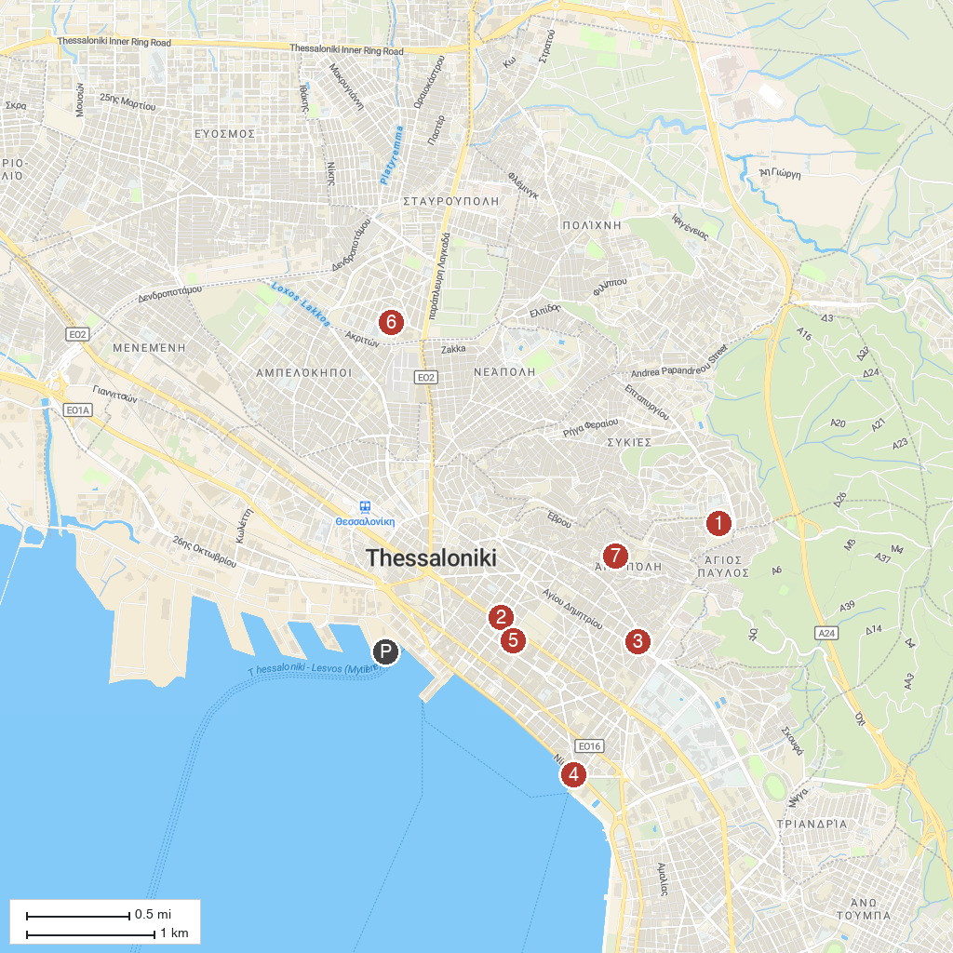
MAP KEY
1. Heptapyrgion of Thessaloniki | 5. Kapani Market
2. Alcazar (Hamza Bey) | 6. MOMus - Museum of Modern Art - Kostakis Collection
3. Ataturk Museum of Thessaloniki | 7. Latomos Monastery - Holy Church of Hosios David
4. White Tower of Thessaloniki
P. Cruise port / terminal
Map © MapTiler © OpenStreetMap contributors · cruiseports.org

