Thasos Island, Northern Aegean, Greece
Greece's Emerald Island rewards cruise passengers with ancient ruins steps from the tender dock, dazzling white-marble beaches, and pine forests that spill straight into turquoise water.
⚓ Tender port · 🕒 Typical call: 6–8 hrs · 💶 Currency: Euro (€) · 🗣️ Language: Greek · 🌿 Most authentic Greek island (2025)
✍️ MY DAY IN PORT (FILL IN)
Ship / Date
In port | arrive ______ · all aboard ______
Booked excursion
Notes / meeting point
GETTING ASHORE
- Docking: Tender — ships anchor in the bay; 10-min tender ride to Old Harbor, Limenas
- Walk to center: Immediate — tender lands on the historic waterfront of Limenas town
- Best For: Ancient ruins, marble-pebble beaches, authentic Greek taverna dining
- Don't Miss: The Ancient Agora right behind the harbor and a jar of Thassian pine honey
GETTING AROUND
- 🚕 Taxi: €3–€7 — Taxis wait at the port; base fare €3.50 plus ~€0.70/km. Short ride to town center is just a few euros; cross-island to L
- 📱 Rideshare: ❌ not available
TOP THINGS TO DO
- Ancient Agora & Archaeological Museum — Walk two minutes from the tender dock to the well-preserved Ancient Agora of Thasos, then visit the adjacent museum to see the…
- Saliara Marble Beach by Boat — Thasos's most iconic beach is lined with smooth white marble pebbles instead of sand, making the water glow turquoise.
- Acropolis & Ancient Theater Hike — A 20–40 minute uphill walk from the harbor leads first to the 5th-century BC Ancient Theater — which overlooks the Aegean — then…
- Giola Lagoon & Beach Safari — Giola is a natural seawater pool carved into coastal rock — one of the Aegean's most photographed natural wonders.
- Golden Beach (Chrysi Akti) — The island's most popular beach: a 3 km crescent of golden sand with shallow, calm water, sunbeds, water sports, and beach bars.
BEST WALKS
- Limenas Harbor Loop — Ruins & Waterfront: ~2 km · 45–60 min · easy, flat — From the Old Harbor, walk to the Ancient Agora (3 min), then continue around the coastal path to…
- Uphill to the Ancient Theater & Acropolis: ~1.5 km · 1.5–2.5 hrs · moderate uphill — Head uphill from the Agora through the ancient city walls to the partially restored Ancient Theater…
WEATHER · DAYLIGHT · MONEY
Month | High °F | Low °F | Rainy days
May | 73 | 56 | 1
Jul | 88 | 69 | 0
Sep | 81 | 62 | 0
Daylight: May 6:04AM–8:31PM · Jul 6:02AM–8:50PM · Sep 7:02AM–7:29PM
cruiseports.org/thasos-island · Confirm terminal & all-aboard time with your ship

Thasos Island, Northern Aegean, Greece — Port Map
Red = walkable sights · Amber = excursions farther out · P = cruise terminal
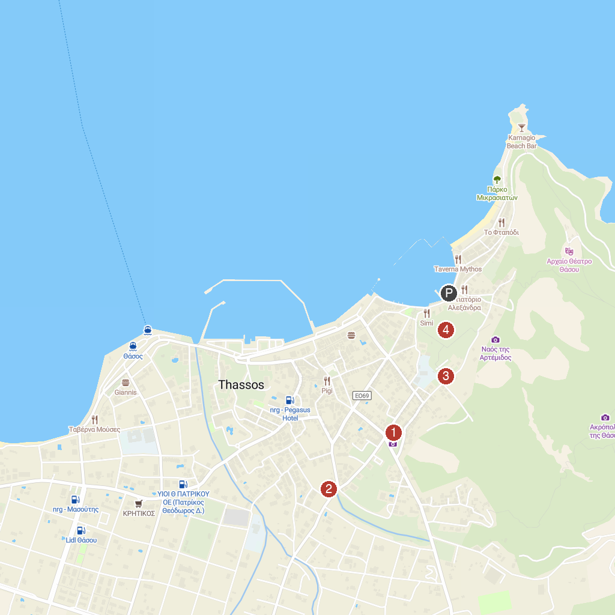
MAP KEY
1. Παραλία Πρίνος | 4. Ancient Odeon
2. Sanctuary of Heracles | 5. Ancient Agora of Thasos
3. Gate of Zeus & Hera
P. Cruise port / terminal
Map © MapTiler © OpenStreetMap contributors · cruiseports.org

