Tauranga, Bay of Plenty, New Zealand
Where golden beaches meet geothermal wonders. Dock in Mount Maunganui and choose between climbing a volcano before breakfast or jumping straight on a bus to Middle-earth.
⚓ Docked (Salisbury Wharf) · 🕒 Typical call: 8-10 hrs · 💵 NZD (cards widely accepted) · 🗣️ English / Te Reo Māori
✍️ MY DAY IN PORT (FILL IN)
Ship / Date
In port | arrive ______ · all aboard ______
Booked excursion
Notes / meeting point
GETTING ASHORE
- Docking: Salisbury Wharf, Mount Maunganui — no tender needed
- Walk to center: Mount Maunganui main beach & shops: 5 min on foot; Tauranga CBD: 15-20 min drive
- Best For: Rotorua geothermal, Hobbiton movie set, Mauao hike, beaches
- Don't Miss: Summit Track up Mauao for 360° Bay of Plenty views
GETTING AROUND
- 🚕 Taxi: NZD $35 fixed to CBD — Tauranga Taxis offer fixed fares for cruise passengers to the CBD (~3.8km, ~10 min). Taxis meet ships at the terminal.
- 📱 Rideshare: ✅ Uber
- 🚌 Hop-on hop-off: ✅
TOP THINGS TO DO
- Hobbiton Movie Set — The Shire — Step into Middle-earth at the original Hobbiton set in Matamata, preserved after filming The Lord of the Rings and The Hobbit…
- Rotorua Geothermal & Māori Culture — Te Puia's Pōhutu Geyser and boiling mud pools sit alongside a living Māori cultural village with carving and weaving masters.
- Kaituna River White-Water Rafting — Tackle Grade 5 rapids and a 7-metre waterfall on the Kaituna River, one of the most accessible commercially-rafted waterfall…
- Mauao Summit Hike — The 232-metre extinct volcano right next to the pier offers two routes: the easy 45-min base track around the mountain or the…
- Kiwifruit Orchard & Honey Tasting — The Bay of Plenty is New Zealand's kiwifruit heartland.
BEST WALKS
- Mauao Base Track: 3.4 km loop | ~45 min | Easy | Paved path — A flat, fully sealed loop around the base of Mauao (Mount Maunganui) with harbour views on one side…
- Mauao Summit Track: ~2 km return | 1 hr | Moderate | Steep steps — Branch off the base track to climb Mauao's summit via the zigzag path.
- Mount Maunganui Village Stroll: ~1 km | 15 min | Easy | Flat — Maunganui Road from the pier area to the village centre is lined with cafes, surf shops, and…
WEATHER · DAYLIGHT · MONEY
Month | High °F | Low °F | Rainy days
May | 62 | 50 | 11
Jul | 56 | 45 | 12
Sep | 59 | 48 | 14
Daylight: May 7:08AM–5:14PM · Jul 7:27AM–5:15PM · Sep 6:16AM–6:05PM
cruiseports.org/tauranga · Confirm terminal & all-aboard time with your ship

Tauranga, Bay of Plenty, New Zealand — Port Map
Red = walkable sights · Amber = excursions farther out · P = cruise terminal
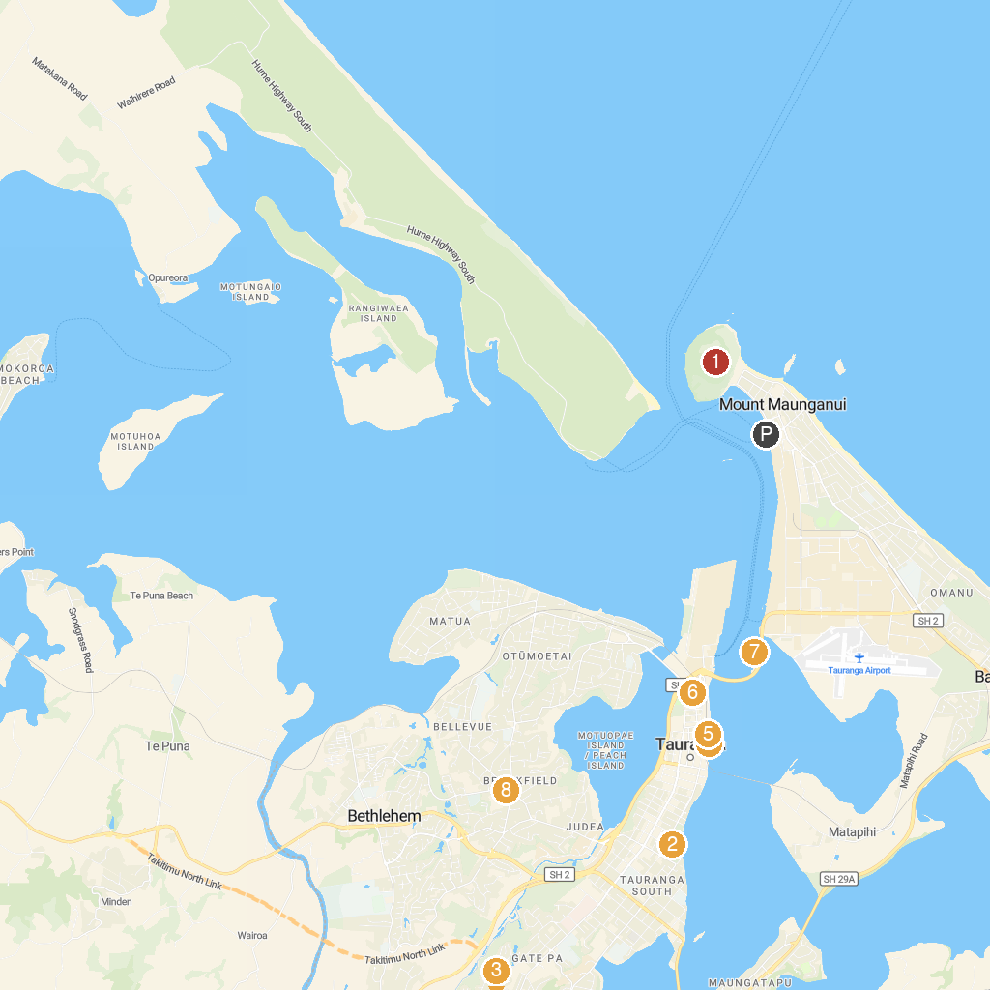
MAP KEY
1. Mauao / Mount Maunganui summit | 5. Hairy Maclary and Friends Sculpture
2. Memorial Park | 6. The Elms | Te Papa Tauranga
3. Morland Fox Park | 7. Orca Wild Adventures | Dolphin Swims
4. Bay Explorer - Dolphin and Wildlife Cruises | 8. Sydenham Botanic Park
P. Cruise port / terminal
Map © MapTiler © OpenStreetMap contributors · cruiseports.org

