Tarascon-sur-Rhône, Provence, France
A medieval fortress rises straight from the Rhône riverbank — and legend says a dragon once lurked in the marshes below. Tarascon is quiet, authentic Provence at its most unhurried.
⚓ Pier (riverbank docking) · 🕒 Typical call: 6–8 hrs · 💶 Euro (€) · 🗣️ French
✍️ MY DAY IN PORT (FILL IN)
Ship / Date
In port | arrive ______ · all aboard ______
Booked excursion
Notes / meeting point
GETTING ASHORE
- Docking: Pier — ships moor directly at the Rhône quay, steps from the old town
- Walk to Castle: 2–5 min from the quay to Château de Tarascon
- Best For: Medieval history, Provençal atmosphere, the Tarasque legend
- Don't Miss: Rooftop terrace of Château de Tarascon — panoramic Rhône views
GETTING AROUND
- 🚕 Taxi: €10–€20 — Local taxi companies (taxitarascon.com, AlloTaxi) serve the town and surroundings. Short in-town trips are inexpensive;
- 📱 Rideshare: ✅ Uber
TOP THINGS TO DO
- Château de Tarascon — One of France's best-preserved medieval water-castles, built in the 15th century by King René of Anjou.
- Provençal Old Town Walk — Wander the Rue des Halles with its medieval stone arcades, visit the Collegiate Church of Saint-Martha (free entry, crypt with…
- Souleiado Museum — Housed in a 14th-century mansion, this museum traces the story of Provençal printed fabric from antique printing blocks to the…
- Day Trip to Avignon — The city of popes is 25 km north.
- Camargue & Saintes-Maries-de-la-Mer — The wild Camargue delta lies 45 km south — flamingos, white horses, black bulls, and wide sandy beaches at…
BEST WALKS
- Tarascon Old Town Loop: 1.5 km · 30 min · Easy — From the quay, walk to the château entrance, continue into the Vieux Tarascon via Rue des Halles…
- Tarascon to Beaucaire Bridge Walk: 3 km round trip · 45 min · Easy — Cross the Pont de Tarascon-Beaucaire to Beaucaire, climb the hill to the ruins of Beaucaire Castle…
WEATHER · DAYLIGHT · MONEY
Month | High °F | Low °F | Rainy days
May | 75 | 55 | 1
Jul | 91 | 68 | 0
Sep | 81 | 60 | 1
Daylight: May 6:16AM–9:00PM · Jul 6:13AM–9:20PM · Sep 7:20AM–7:51PM
cruiseports.org/tarascon-sur-rhone · Confirm terminal & all-aboard time with your ship

Tarascon-sur-Rhône, Provence, France — Port Map
Red = walkable sights · Amber = excursions farther out · P = cruise terminal
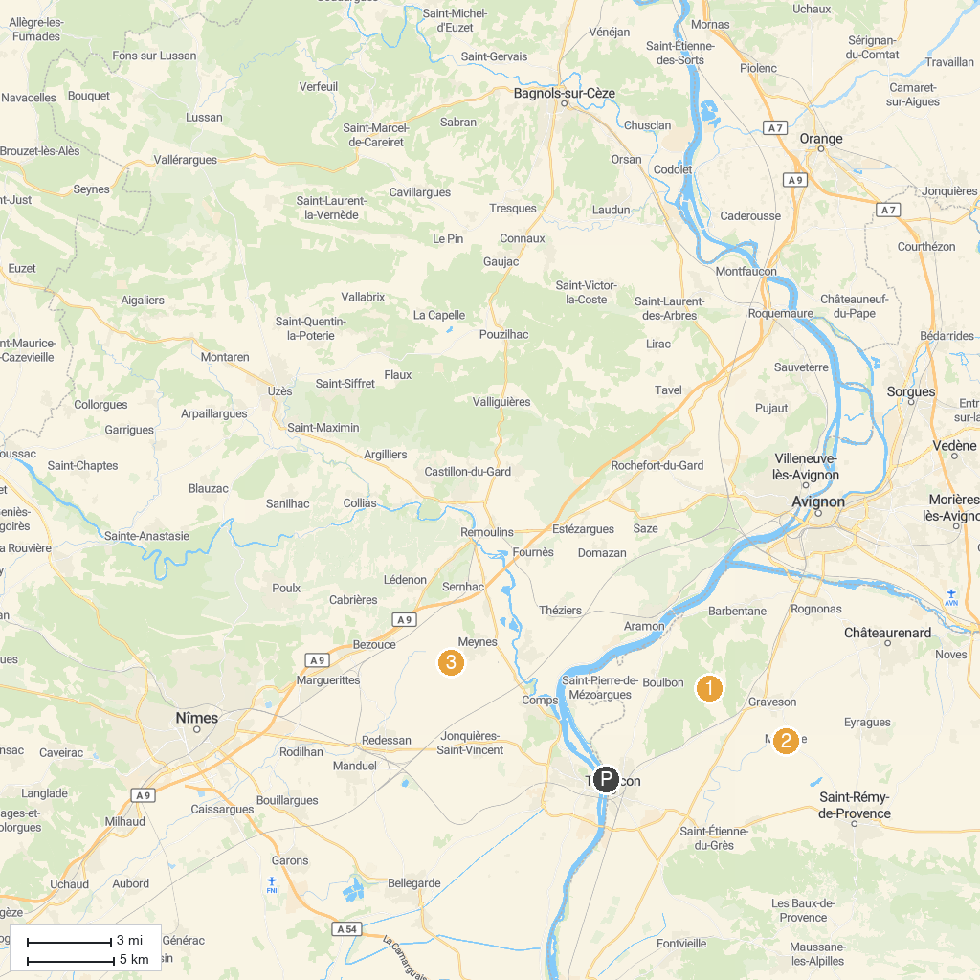
MAP KEY
1. Carrières des Lumières | 5. Musée Frédéric Mistral
2. Frigolet Abbey | 6. SCA des Grands Vins de Pazac
3. Château des Baux-de-Provence | 7. Alpilles Natural Regional Park
4. Arles Amphitheatre
P. Cruise port / terminal
Map © MapTiler © OpenStreetMap contributors · cruiseports.org

