Tangier, Tangier-Tétouan-Al Hoceïma, Morocco
Gateway between Europe and Africa, Tangier sits where the Mediterranean meets the Atlantic — an ancient port city of labyrinthine souks, whitewashed kasbah walls, and views stretching all the way to Spain.
⚓ Docked (cruise terminal) · 🕒 Typical call: 8-10 hrs · 💵 Currency: Moroccan Dirham (MAD) · 🗣️ Language: Arabic, French, Spanish
✍️ MY DAY IN PORT (FILL IN)
Ship / Date
In port | arrive ______ · all aboard ______
Booked excursion
Notes / meeting point
GETTING ASHORE
- Docking: Ships dock at Tangier Ville port — the city cruise terminal, walking distance to the medina.
- Walk to center: 15-20 min on foot from the port gate to the Grand Socco (main square).
- Best For: Medina exploration, Moroccan souks, historic kasbah, day trips to Cape Spartel.
- Don't Miss: The Kasbah Museum, Grand Socco, and the Caves of Hercules at Cap Spartel.
GETTING AROUND
- 🚕 Taxi: 20–35 MAD (~€2–4) — Small blue metered taxis operate within city limits. Fares are government-controlled; 50% surcharge applies after 8 PM.
- 🚌 Hop-on hop-off: ✅ Tanger City Tour
TOP THINGS TO DO
- Medina & Kasbah Walk — Wind through the ancient medina's souks and climb to the Kasbah — Tangier's old fortress district with panoramic views of the…
- American Legation Museum — The only US National Historic Landmark on foreign soil — a beautifully restored palace gifted to the young United States in 1821…
- Cape Spartel & Caves of Hercules — Drive 14 km west to Cape Spartel — the northwestern tip of Africa where the Atlantic meets the Mediterranean.
- Grand Socco & Petit Socco — Start at the Grand Socco (Place du Grand Socco), Tangier's main square linking the modern city to the medina, then descend to the…
- Moroccan Food & Souk Markets — Sample mint tea, msemen flatbread, and briouat pastries at stalls near the Petit Socco.
BEST WALKS
- Port Gate to Kasbah: 2.5 km · ~45 min one way · hilly — Walk north from the port gate along Avenue d'Espagne to the Grand Socco, then enter the medina…
- Waterfront Promenade: 1.5 km · ~20 min · flat — A simple flat stroll east along the Tangier seafront boulevard with views across the strait toward…
WEATHER · DAYLIGHT · MONEY
Month | High °F | Low °F | Rainy days
May | 74 | 59 | 5
Jul | 85 | 68 | 0
Sep | 81 | 67 | 3
Daylight: May 6:18AM–8:21PM · Jul 6:18AM–8:39PM · Sep 7:06AM–7:29PM
cruiseports.org/tangier · Confirm terminal & all-aboard time with your ship

Tangier, Tangier-Tétouan-Al Hoceïma, Morocco — Port Map
Red = walkable sights · Amber = excursions farther out · P = cruise terminal
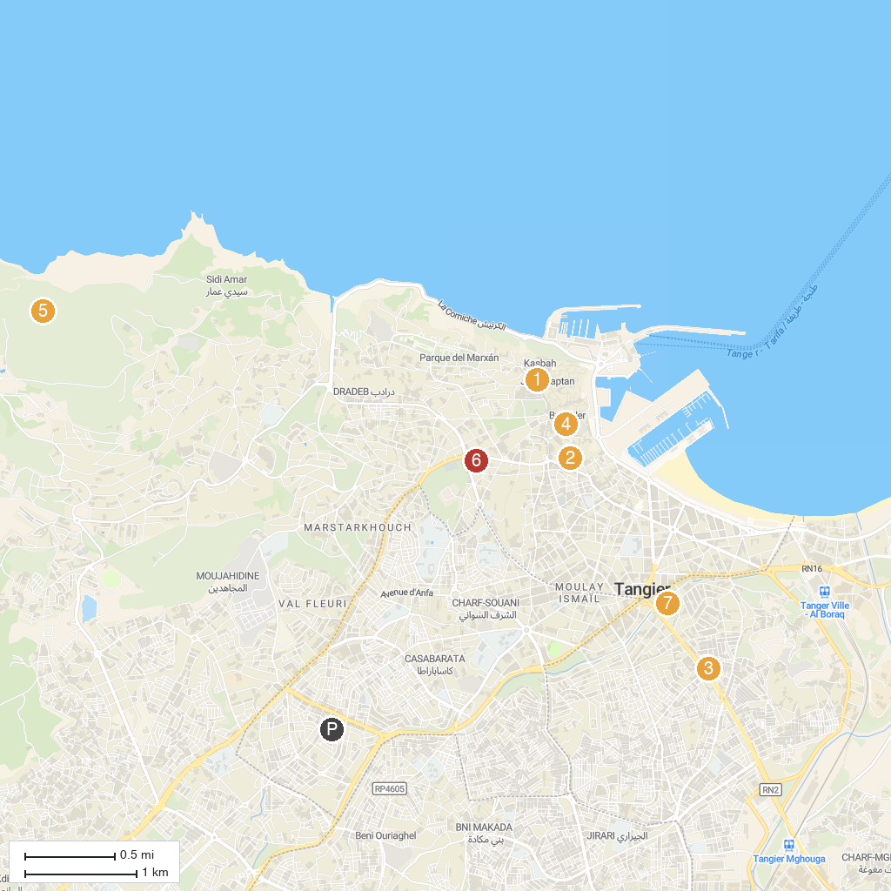
MAP KEY
1. Tomb of Ibn Batutta | 5. Tangier American Legation Museum
2. Medina Art Gallery | 6. Rmilat Park
3. Hercules Caves | 7. Mosque Mohammed V
4. Plaza de Toros | 8. Syrian Mosque
P. Cruise port / terminal
Map © MapTiler © OpenStreetMap contributors · cruiseports.org

