Tangier Island, Virginia, USA
A tiny Chesapeake Bay island where time moves slowly, soft-shell crabs reign supreme, and locals still speak a dialect rooted in 17th-century Cornish English. Small ships only — and that's exactly the point.
⚓ Docked (small ships/ferries only) · 🕒 Typical call: 4–6 hrs · 💵 USD — cash preferred · 🗣️ English (unique Tangier dialect) · 🦀 Soft-shell crab capital
✍️ MY DAY IN PORT (FILL IN)
Ship / Date
In port | arrive ______ · all aboard ______
Booked excursion
Notes / meeting point
GETTING ASHORE
- Docking: Small ships dock at Tangier City Dock or Parks Marina; no mega-ships
- Walk to center: 2 min from dock to main street; entire island walkable in 20 min
- Best For: Seafood, history, unique culture, birdwatching, beachcombing
- Don't Miss: Soft-shell crab sandwich + a golf cart lap of the ridges
GETTING AROUND
- 📱 Rideshare: ❌ not available
TOP THINGS TO DO
- Golf Cart Island Tour — Rent a golf cart at the dock and explore all three ridges — Main, Canton, and West.
- Soft-Shell Crab Lunch at Hilda Crockett's — A Tangier institution since 1939.
- Tangier Island History Museum — A compact, donation-based museum covering the island's watermen heritage, erosion crisis, duck decoys, and a short documentary.
- Kayaking the Guts — Paddle through the island's tidal marsh channels ('guts') for close-up views of herons, osprey, and pelicans.
- Beachcombing at Tangier Beach — A wild, undeveloped beach at the island's southern tip.
BEST WALKS
- The Three Ridges Walk: 1.5 miles · 30–45 min · Flat — Start at the dock, head up Main Ridge Road through the Main Ridge, detour onto Canton Ridge to see…
WEATHER · DAYLIGHT · MONEY
Month | High °F | Low °F | Rainy days
May | 73 | 59 | 1
Jul | 86 | 74 | 1
Sep | 79 | 68 | 1
Daylight: May 5:54AM–8:07PM · Jul 5:54AM–8:25PM · Sep 6:46AM–7:11PM
cruiseports.org/tangier-island-va · Confirm terminal & all-aboard time with your ship

Tangier Island, Virginia, USA — Port Map
Red = walkable sights · Amber = excursions farther out · P = cruise terminal
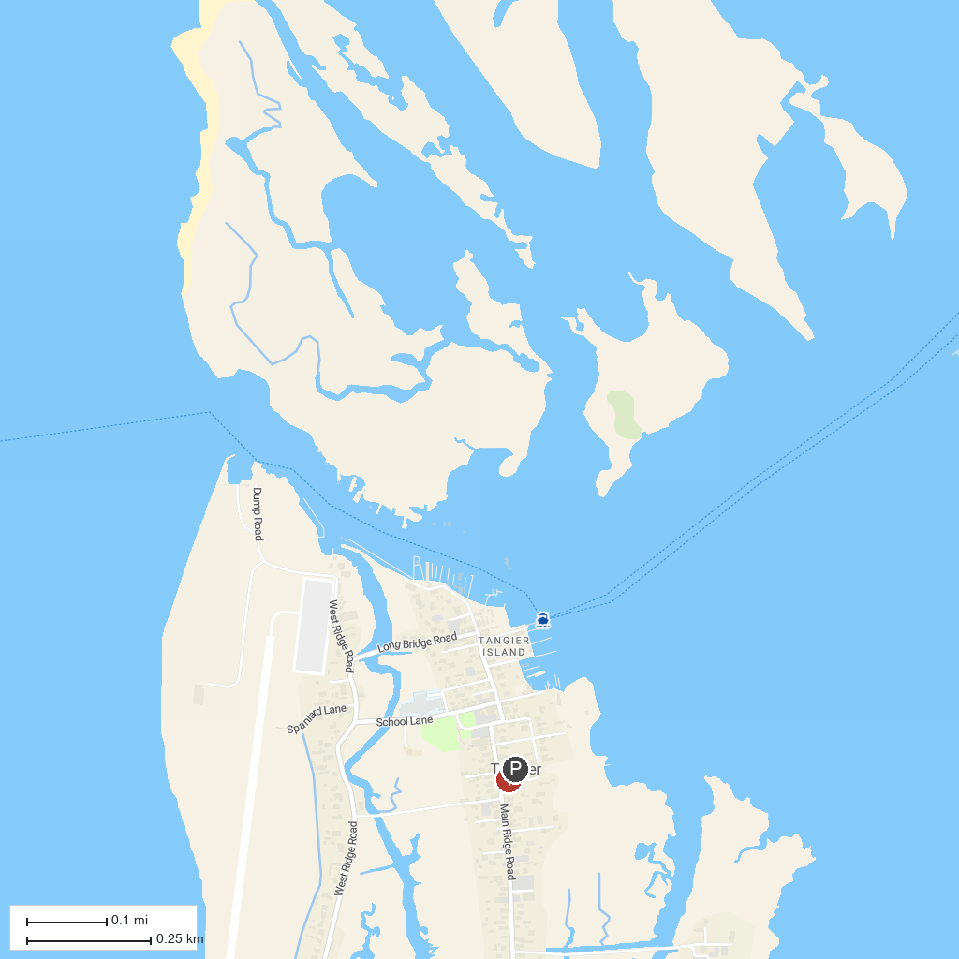
MAP KEY
1. J Millard Tawes Historical Museum | 4. Ker Place (Shore History)
2. Tangier History Museum | 5. Dameron Marsh Natural Area Preserve
3. Reedville Fishermen's Museum | 6. Guard Shore Beach
P. Cruise port / terminal
Map © MapTiler © OpenStreetMap contributors · cruiseports.org

