Tangermünde, Saxony-Anhalt, Germany
Called the "Rothenburg of the North," Tangermünde is a perfectly preserved medieval gem where Emperor Charles IV once kept a royal residence — the half-timbered lanes and intact 14th-century walls feel genuinely untouched.
⚓ Docked — riverside pier · 🕒 Typical call: 6-8 hrs · 💶 Euro (cash strongly advised) · 🗣️ German
✍️ MY DAY IN PORT (FILL IN)
Ship / Date
In port | arrive ______ · all aboard ______
Booked excursion
Notes / meeting point
GETTING ASHORE
- Docking: River pier (Schiffsanleger) on the Elbe — no tender
- Walk to centre: 7-10 min to Marktplatz (~450 m); castle in 3-5 min
- Best For: Medieval architecture, slow walks, local beer & history
- Don't Miss: Gothic Rathaus, Neustädter Tor gate & a glass of Kuhschwanzbier
GETTING AROUND
- 🚕 Taxi: ~€8–€12 — Local taxis serve Tangermünde under the District of Stendal tariff (base ~€5 + ~€2.90/km). The very short distance to th
TOP THINGS TO DO
- Medieval Old Town Walking Tour — Follow a local guide through the intact city walls, past the Neustädter Tor gate, up to Burg Tangermünde, and along Lange Straße…
- Rathaus & Town History Museum — The ornate late-Gothic town hall contains a small museum on Tangermünde's Hanseatic and imperial past, including the legend of…
- Burg Tangermünde Castle Grounds — The partly preserved imperial castle atop the Elbe bluff was Emperor Charles IV's northern residence.
- Elbe Cycle Route (Tagesausflug) — Tangermünde sits on the famous Elbe Radweg (Elbe Cycle Route).
- Kuhschwanzbier & Regional Tasting — Sample Tangermünde's legendary dark "Cow's Tail Beer" at Exempel-Gaststuben — a quirky restaurant decorated like a vintage…
BEST WALKS
- Riverside to Marktplatz via Castle Hill: 1.5 km · 45-60 min · easy-moderate — The classic Tangermünde loop: up from the pier to Burg Tangermünde for Elbe views, then down Lange…
- City Wall Circuit: 2 km · 45 min · easy — Follow the near-intact 14th-century city wall from the Neustädter Tor (one of Germany's finest…
WEATHER · DAYLIGHT · MONEY
Month | High °F | Low °F | Rainy days
May | 68 | 45 | 0
Jul | 79 | 56 | 1
Sep | 71 | 50 | 0
Daylight: May 5:16AM–9:01PM · Jul 5:07AM–9:27PM · Sep 6:46AM–7:26PM
cruiseports.org/tangermunde · Confirm terminal & all-aboard time with your ship

Tangermünde, Saxony-Anhalt, Germany — Port Map
Red = walkable sights · Amber = excursions farther out · P = cruise terminal
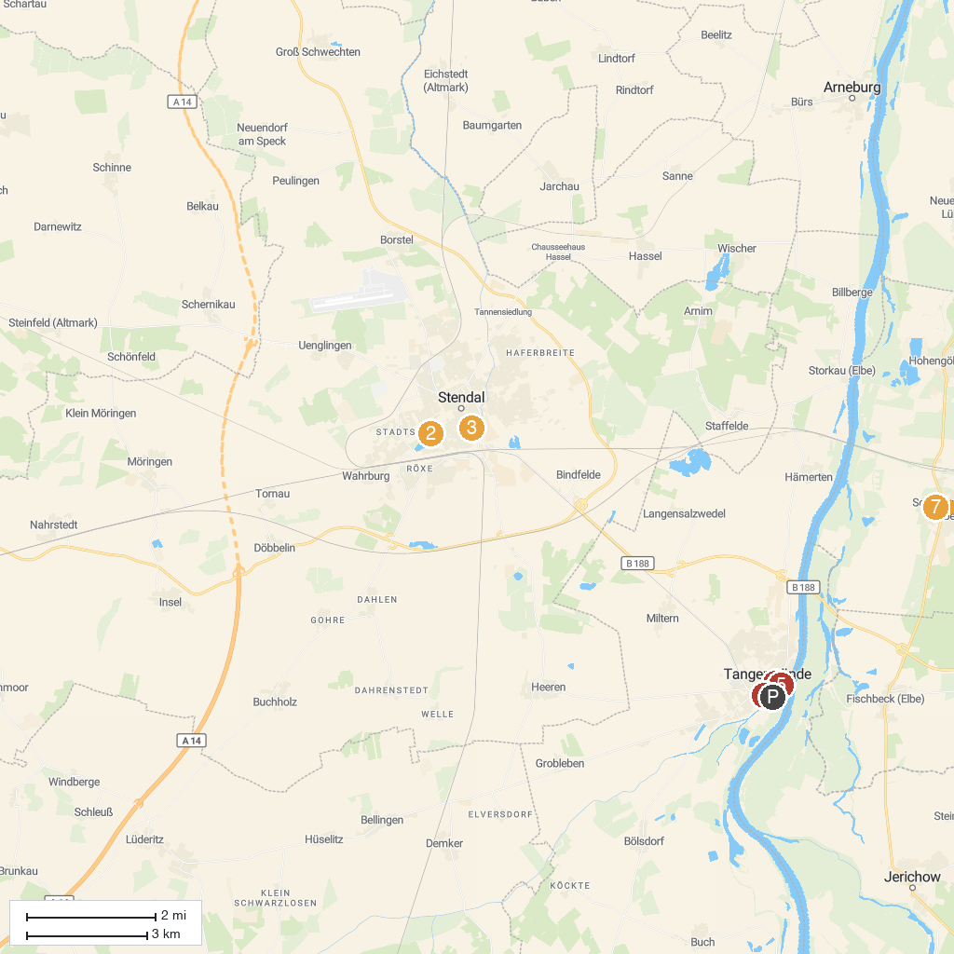
MAP KEY
1. Elbe Gate | 5. Tangermünde Castle
2. Hansestadt Stendal - Tiergarten | 6. Grete Minde Monument
3. Altmärkisches Museum Stendal | 7. Bismarck-Museum Schönhausen
4. Eulenturm
P. Cruise port / terminal
Map © MapTiler © OpenStreetMap contributors · cruiseports.org

