Tan Chau, An Giang, Vietnam
A compact river town near the Cambodian border where cyclo convoys weave past silk workshops, floating fish farms dot the muddy Tiền River, and local markets spill color onto the waterfront.
⚓ River berth / sampan transfer · 🕒 Typical call: 4–6 hrs · 💵 Vietnamese Dong (USD accepted) · 🗣️ Vietnamese (very little English)
✍️ MY DAY IN PORT (FILL IN)
Ship / Date
In port | arrive ______ · all aboard ______
Booked excursion
Notes / meeting point
GETTING ASHORE
- Docking: River berth at basic concrete pier; some ships anchor and transfer passengers ashore by sampan
- Walk to center: Steps from pier — Tan Chau market is 5–10 min on foot
- Best For: Authentic Mekong life, black-silk workshops, Cham village, cyclo tours
- Don't Miss: Lãnh Mỹ A silk workshop and a floating fish-farm sampan ride
GETTING AROUND
- 🚕 Taxi: ~10,000 VND/km (~$0.40/km) — Metered taxis serve An Giang province at roughly 10,000–12,000 VND per kilometer. Useful for longer trips out of town, b
TOP THINGS TO DO
- Lãnh Mỹ A Black Silk Workshop — Watch artisans dip and sun-dry fabric in mặc nưa fruit juice up to 100 times over 45 days to produce Tan Chau's signature…
- Floating Fish Farm Sampan Ride — Board a wooden sampan to reach the floating wooden houseboats that double as Basa fish farms.
- Cham Muslim Village — Chau Giang — A short boat ride across the river brings you to a village of the Cham ethnic minority, practicing Muslims who maintain their own…
- Cao Dai Temple Visit — Tan Chau's colorful Cao Dai Temple is a visual feast — the syncretic religion blends Buddhism, Christianity, Taoism, and more…
- Tan Chau Market & Street Food — Dive into the chaotic, sensory-rich local market for tropical fruits, live seafood, and local snacks.
BEST WALKS
- Waterfront to Market Loop: 1.5 km · 25 min · Easy — From the river pier, follow the waterfront promenade north to watch river traffic, then cut inland…
cruiseports.org/tan-chau · Confirm terminal & all-aboard time with your ship

Tan Chau, An Giang, Vietnam — Port Map
Red = walkable sights · Amber = excursions farther out · P = cruise terminal
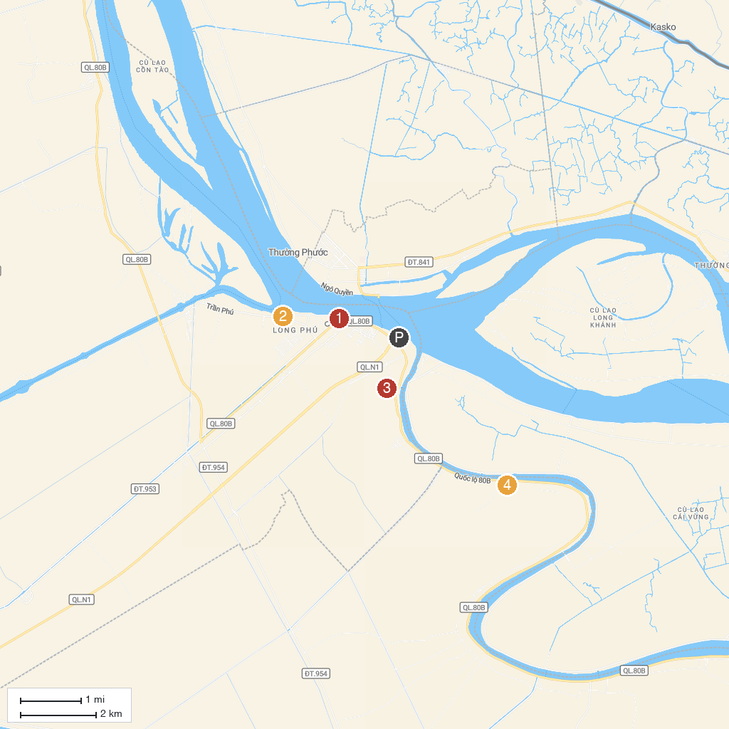
MAP KEY
1. Quảng trường Tân Châu | 3. Chùa Giồng Thành
2. Làng nghề truyền thống Tơ Lụa Tân Châu | 4. Long Quang Pagoda
P. Cruise port / terminal
Map © MapTiler © OpenStreetMap contributors · cruiseports.org

