Tamano, Okayama, Japan
Uno Port puts you steps from ferries to Naoshima — the island that turned a sleepy fishing village into a world-class contemporary art destination. Japan's Seto Inland Sea is at its most scenic here.
⚓ Pier (docked at Uno Port) · 🕒 Typical call: 8-10 hrs · 💴 Currency: Japanese Yen (cash essential) · 🗣️ Language: Japanese (English at major museums)
✍️ MY DAY IN PORT (FILL IN)
Ship / Date
In port | arrive ______ · all aboard ______
Booked excursion
Notes / meeting point
GETTING ASHORE
- Docking: Pier — ships dock at Uno Port cruise quay; no tender required
- Walk to center: 5 min to Uno Station; ferry terminal is right next door
- Best For: Contemporary art, island-hopping, Seto Inland Sea scenery
- Don't Miss: Day trip to Naoshima — Chichu Art Museum and Yayoi Kusama's pumpkins
GETTING AROUND
- 🚕 Taxi: ¥1,400–¥1,900 — Taxis are available at Uno Port. The ride to Uno Station / city center is short (about 3 minutes, 2–3 km). Uber and the
- 📱 Rideshare: ✅ Uber
TOP THINGS TO DO
- Naoshima Art Island — A 20-minute ferry ride delivers you to one of the art world's most talked-about islands.
- Kurashiki Bikan Historical Quarter — A 17th-century merchant district of black-and-white tile warehouses lining a weeping-willow canal.
- Washuzan Lookout — Mt.
- Shibukawa Beach & Marine Aquarium — A calm, white-sand kilometre facing the Seto Inland Sea — sheltered waters make it perfect for wading.
- Bizenyaki Pottery Experience — Bizen-yaki is one of Japan's oldest pottery styles — unglazed, rustic, and fired in traditional kilns.
BEST WALKS
- Uno Port Art Walk: 30–45 min | Flat | Free — A short loop from the pier takes in the outdoor art installations that make Uno one of Japan's most…
- Waterfront to Miyama Park: 20 min by taxi | Easy walking in park | Free — Miyama Park's English-style garden and 7,000-cherry-tree hillside is worth the short taxi ride…
WEATHER · DAYLIGHT · MONEY
Month | High °F | Low °F | Rainy days
May | 78 | 59 | 1
Jul | 89 | 75 | 2
Sep | 84 | 70 | 2
Daylight: May 5:02AM–6:59PM · Jul 5:02AM–7:17PM · Sep 5:47AM–6:11PM
cruiseports.org/tamano · Confirm terminal & all-aboard time with your ship

Tamano, Okayama, Japan — Port Map
Red = walkable sights · Amber = excursions farther out · P = cruise terminal
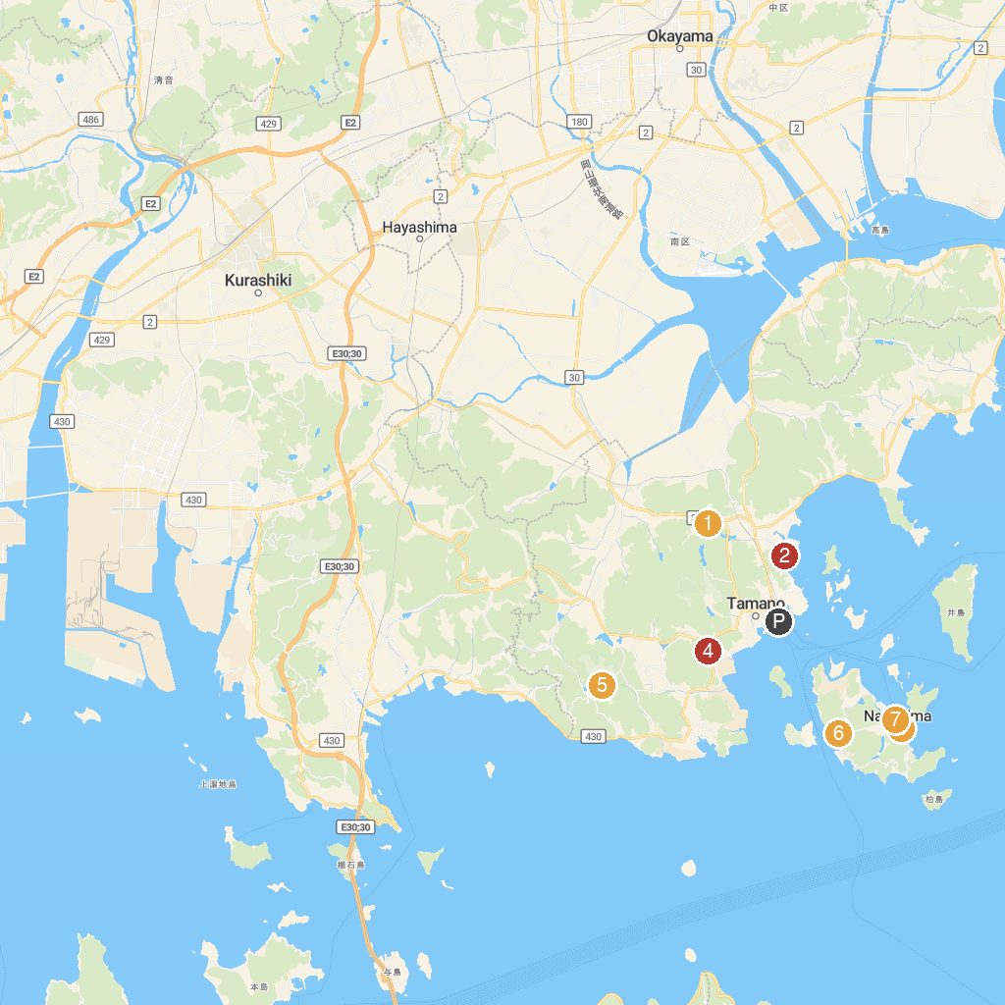
MAP KEY
1. 種松山公園西園地 | 5. Tamahime Shrine
2. Miyama British Garden | 6. Toy Kingdom
3. Tai Minato Park | 7. Naoshima Public Bath I Love Yu
4. Ando Museum | 8. Art House Project: Ishibashi
P. Cruise port / terminal
Map © MapTiler © OpenStreetMap contributors · cruiseports.org

