Tallinn, Harju, Estonia
One of Europe's best-preserved medieval cities, Tallinn's fairy-tale Old Town sits just a short walk from the cruise piers — cobblestone lanes, Gothic spires, and sweeping Baltic views all within a single shore day.
⚓ Docked (Old City Harbour) · 🕒 Typical call: 8-10 hrs · 💶 Euro (€) · 🗣️ Estonian / English widely spoken
✍️ MY DAY IN PORT (FILL IN)
Ship / Date
In port | arrive ______ · all aboard ______
Booked excursion
Notes / meeting point
GETTING ASHORE
- Docking: Alongside at Old City Harbour (Vanasadam); no tender needed
- Walk to Old Town: 15-20 min on foot; free shuttle bus also available from terminal
- Best For: Medieval history, walking, photography, Baltic culture
- Don't Miss: Toompea Hill viewpoints and Town Hall Square (Raekoja Plats)
GETTING AROUND
- 🚕 Taxi: €7–€15 — Official taxis queue at the terminal. Metered fares to city center run €7–€13; pre-booked or app-based rides (Bolt/Uber)
- 📱 Rideshare: ✅ Bolt, Uber
- 🚌 Hop-on hop-off: ✅
TOP THINGS TO DO
- Medieval Old Town Walking Tour — A guided walk through both the Upper Town (Toompea Castle, Alexander Nevsky Cathedral) and Lower Town (Town Hall Square, St.
- Kadriorg Palace & Park — Peter the Great's baroque palace and its surrounding park, now home to the Kadriorg Art Museum.
- Toompea Hill Panorama — Climb to Tallinn's Upper Town for views from the Patkuli and Kohtuotsa viewing platforms — red-tiled rooftops, medieval spires…
- Estonian Food & Market Tour — Sample elk stew, black bread, and local cheeses at Tallinn's Balti Jaama Turg (Baltic Station Market) or the Old Town cellar…
- Tallinn Day Trip to Helsinki by Ferry — A fast ferry crosses the Gulf of Finland in under 2.5 hours each way — feasible on a long port day (10+ hrs).
BEST WALKS
- Lower Town Loop: 2-3 km · 45-60 min · Easy — From Fat Margaret Tower, walk along Pikk Street past the Brotherhood of Blackheads House and Church…
- Upper Town (Toompea) Walk: 1.5 km · 30-45 min · Moderate — Climb Lühike jalg (Short Leg Lane) from the Lower Town to Toompea Hill.
WEATHER · DAYLIGHT · MONEY
Month | High °F | Low °F | Rainy days
May | 59 | 43 | 9
Jul | 70 | 57 | 14
Sep | 61 | 50 | 12
Daylight: May 4:47AM–9:48PM · Jul 4:30AM–10:22PM · Sep 6:49AM–7:40PM
cruiseports.org/tallinn · Confirm terminal & all-aboard time with your ship

Tallinn, Harju, Estonia — Port Map
Red = walkable sights · Amber = excursions farther out · P = cruise terminal
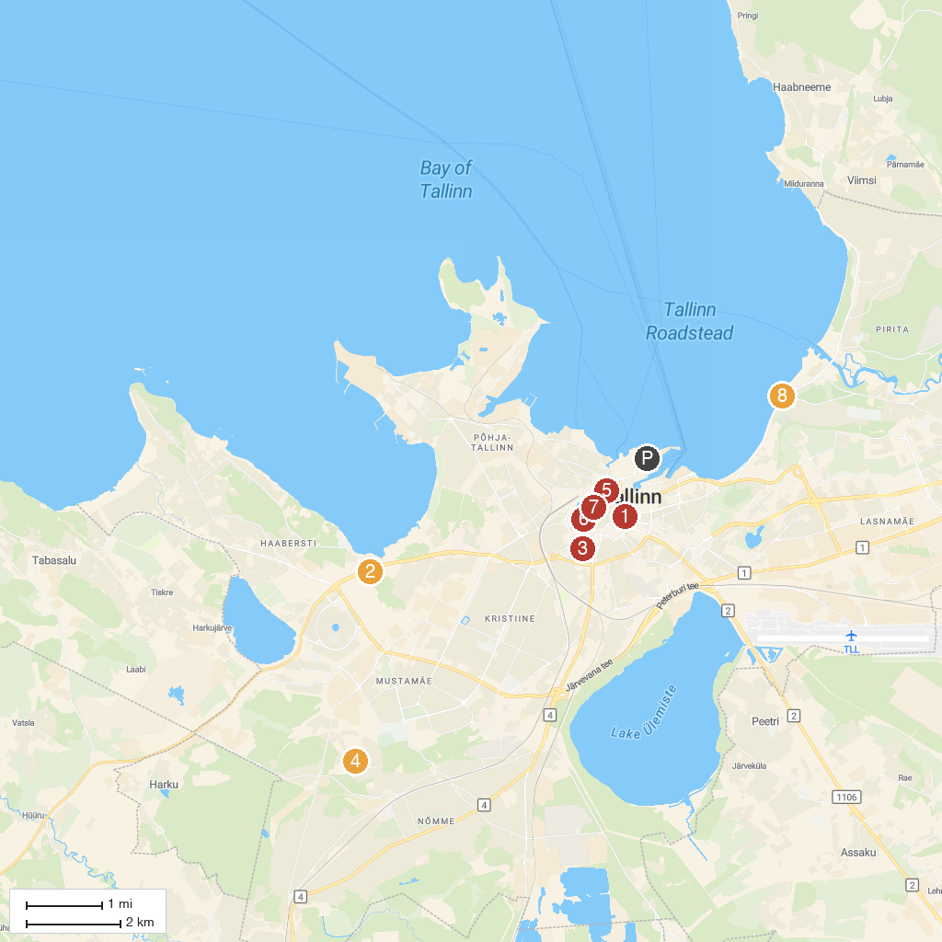
MAP KEY
1. Hotel Viru & KGB Museum | 5. Oleviste kogudus
2. Tallinn Zoo | 6. Alexander Nevsky Cathedral
3. Eesti Rahvusraamatukogu | 7. Estonian Theatre for Young Audiences / Museum of Puppetry Arts
4. Nõmme Seikluspark | 8. Airman Charles Leroaux Memorial
P. Cruise port / terminal
Map © MapTiler © OpenStreetMap contributors · cruiseports.org

