Taichung, Taiwan
Taiwan's most livable city delivers world-class architecture, a world-famous wetlands boardwalk, and the birthplace of bubble tea — all accessible from a working industrial port that rewards those who venture into town.
⚓ Pier (no tender) · 🕒 Typical call: 8-10 hrs · 💵 New Taiwan Dollar (TWD/NT$) · 🗣️ Traditional Chinese · 🚕 Taxi or bus required to city
✍️ MY DAY IN PORT (FILL IN)
Ship / Date
In port | arrive ______ · all aboard ______
Booked excursion
Notes / meeting point
GETTING ASHORE
- Docking: Pier at Port of Taichung (Wuqi District) — no tender
- Walk to center: City center is ~25 km (45–60 min taxi). Gaomei Wetlands: 15 min taxi
- Best For: Architecture fans, foodies, wetlands & nature, cultural explorers
- Don't Miss: Gaomei Wetlands boardwalk, Miyahara dessert palace, National Taichung Theater
GETTING AROUND
- 🚕 Taxi: NT$85 base + NT$15.7/km (~US$19–26 to city center) — Metered taxis are available at the cruise terminal. The ride to Taichung city center takes roughly 23–31 minutes.
- 📱 Rideshare: ✅ Uber
- 🚌 Hop-on hop-off: ✅
TOP THINGS TO DO
- Gaomei Wetlands Boardwalk — A stunning tidal flat famous for its 800-metre wooden boardwalk stretching past wind turbines into a world of fiddler crabs…
- National Taichung Theater — Designed by Pritzker Prize-winning architect Toyo Ito, this extraordinary building has no straight lines — its curved, cave-like…
- Miyahara — Harry Potter Dessert Palace — A 1927 ophthalmology clinic transformed into a breathtaking dessert emporium that resembles a mystical library.
- Rainbow Village — A former military dependents' village painted wall-to-wall by 'Rainbow Grandpa' Huang Yung-fu — a soldier who started painting in…
- Bubble Tea & Night Market Tour — Taichung is the birthplace of bubble tea — Chun Shui Tang on Siwei Street invented it in 1986.
BEST WALKS
- Mitsui Outlet Park & Port Waterfront Stroll: ~1.5 km | Easy | 30–45 min — Take a taxi to Mitsui Outlet Park Taichung Port — a sprawling waterfront open-air mall.
- Wuqi Fisherman's Wharf to Gaomei Wetlands Boardwalk: ~2 km boardwalk | Easy | 1.5–2 hrs — Taxi to Wuqi Fisherman's Wharf for a look at the working fish market and fresh seafood stalls, then…
WEATHER · DAYLIGHT · MONEY
Month | High °F | Low °F | Rainy days
May | 84 | 72 | 2
Jul | 90 | 78 | 2
Sep | 88 | 76 | 2
Daylight: May 5:14AM–6:32PM · Jul 5:18AM–6:47PM · Sep 5:43AM–6:01PM
cruiseports.org/taichung · Confirm terminal & all-aboard time with your ship

Taichung, Taiwan — Port Map
Red = walkable sights · Amber = excursions farther out · P = cruise terminal
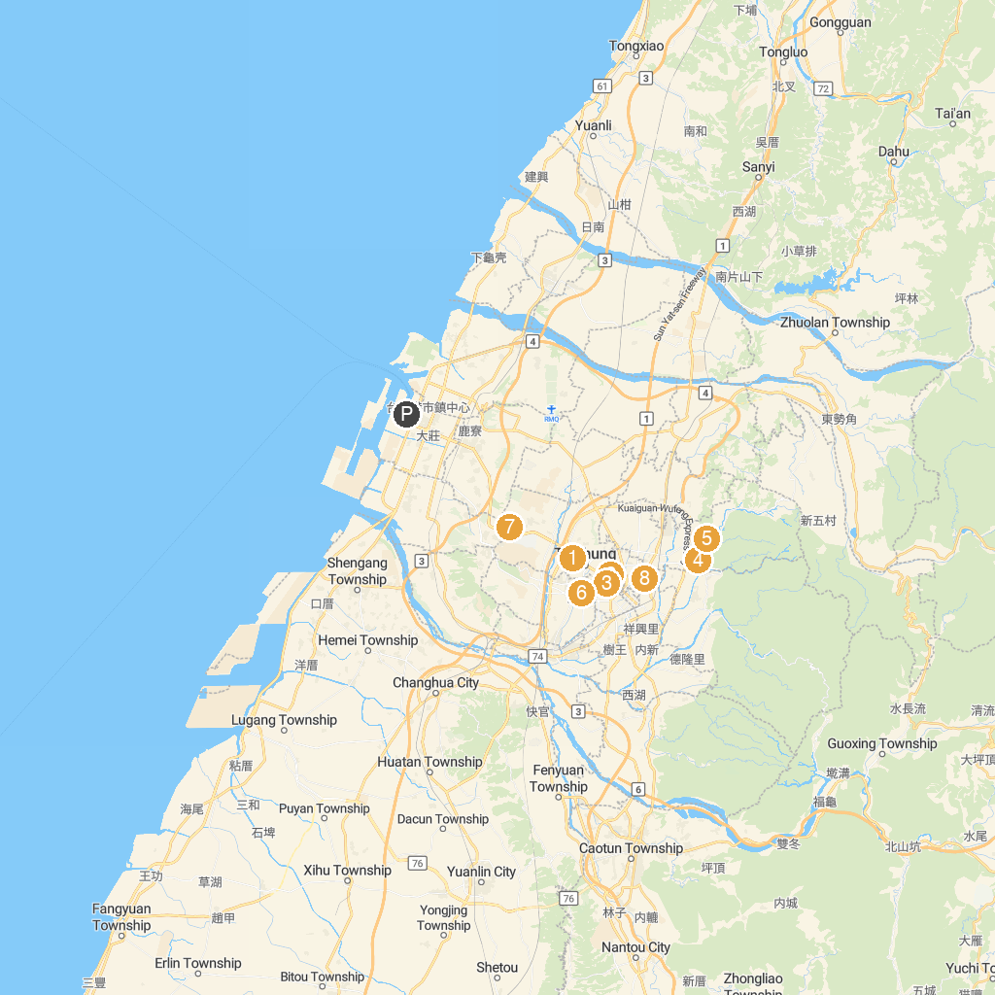
MAP KEY
1. Maple Garden | 5. Dakeng Scenic Area
2. National Museum of Natural Science | 6. Wen-Xin Forest Park
3. Calligraphy Greenway | 7. Donghai Arts Shopping District
4. 大坑情人橋 | 8. Taichung Confucius Temple
P. Cruise port / terminal
Map © MapTiler © OpenStreetMap contributors · cruiseports.org

