Tahaa Island, French Polynesia
Known as the Vanilla Island, Tahaa scents the air with frangipani and hand-pollinated vanilla orchids. It shares a dazzling turquoise lagoon with Raiatea and offers one of the world's best drift snorkels over the Coral Garden.
⚓ Tender (no pier) · 🕒 Typical call: 6-8 hrs · 💵 French Pacific Franc (XPF) · 🗣️ French / Tahitian · 🌺 Vanilla Island
✍️ MY DAY IN PORT (FILL IN)
Ship / Date
In port | arrive ______ · all aboard ______
Booked excursion
Notes / meeting point
GETTING ASHORE
- Docking: Tender only — ship anchors in the lagoon; tenders drop at Patio pier or private motu
- Walk to center: Patio village is steps from the tender pier; no public transport on island
- Best For: Drift snorkeling, vanilla plantation tours, pearl farms, motu beach days
- Don't Miss: Coral Garden drift snorkel near Motu Tautau and a vanilla farm tasting
GETTING AROUND
- 📱 Rideshare: ❌ not available
TOP THINGS TO DO
- Coral Garden Drift Snorkel — The shallow coral passage between Motu Maharare and Motu Tautau is world-famous for its effortless drift snorkel.
- Vanilla Plantation & Pearl Farm Tour — Visit a working vanilla plantation to see hand-pollinated orchids and learn why Tahaa produces over 80% of French Polynesia's…
- Lagoon Safari by Boat — A full lagoon safari by outrigger or motorboat circles the island, hitting multiple snorkel spots, a motu beach stop, and often a…
- 4x4 Island Circuit — A rugged 4x4 drive through the lush interior takes in panoramic views of the bays, neighboring Bora Bora, and the island's five…
- Motu Mahana Private Beach Day — Paul Gauguin Cruises passengers are tendered to the exclusive Motu Mahana islet for a full beach day: white sand, turquoise…
BEST WALKS
- Patio Village Stroll: 0.5 km · 10 min · Flat — From the Patio tender pier, walk along the waterfront into the small village to browse the local…
cruiseports.org/tahaa-island · Confirm terminal & all-aboard time with your ship

Tahaa Island, French Polynesia — Port Map
Red = walkable sights · Amber = excursions farther out · P = cruise terminal
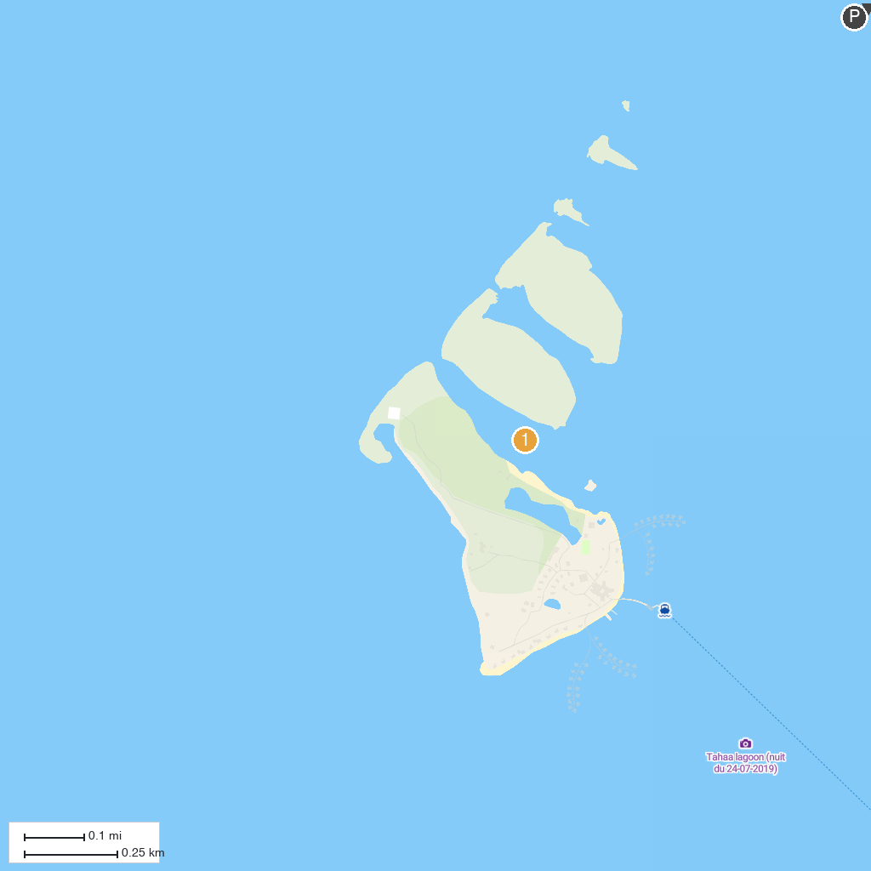
MAP KEY
1. Bora Bora Romantic Tour | 2. Coral garden
P. Cruise port / terminal
Map © MapTiler © OpenStreetMap contributors · cruiseports.org

