Taglio di Po, Veneto, Italy
Where the Republic of Venice re-engineered a river in 1604, Taglio di Po sits at the heart of the Po Delta — a vast, flat wilderness of reed beds, lagoons, and flamingos that feels a world away from tourist Italy.
⚓ River pier (no tender) · 🕒 Typical call: 4–6 hrs · 💶 Euro (€) · 🗣️ Italian
✍️ MY DAY IN PORT (FILL IN)
Ship / Date
In port | arrive ______ · all aboard ______
Booked excursion
Notes / meeting point
GETTING ASHORE
- Docking: River pontoon along Po di Venezia — direct step ashore, no tender
- Walk to center: ~10–15 min (800 m) from river embankment to Piazza Venezia
- Best For: Birdwatching, cycling the delta, authentic Po valley cuisine
- Don't Miss: Pink flamingos in the lagoons and risotto made with protected Po Delta rice
GETTING AROUND
- 🚕 Taxi: €10–€20 — Taxis are available at the port for short rides into Taglio di Po town center. Pre-booking is recommended as this is a s
TOP THINGS TO DO
- Po Delta Flamingo & Bird Watching — The Po Delta is home to thousands of pink flamingos alongside herons, marsh harriers, and migratory species.
- Cycling the Riverbank Paths — Flat embankment trails run for miles alongside the Po and its branches — ideal for cycling.
- Villa Ca' Zen & Lord Byron's Italy — This 18th-century Venetian patrician villa on the Po riverbank is where Lord Byron stayed in 1819 and wrote portions of Don Juan…
- Museo della Bonifica di Ca' Vendramin — Housed in a magnificent early 20th-century water-pumping station 8 km from town, this museum explains how Venetians drained the…
- Wild Delta Beaches at Boccasette — Twenty minutes from Taglio di Po, the sand beaches of Boccasette are reached via a wooden pontoon bridge over a lagoon.
BEST WALKS
- Riverbank to Town Center Stroll: 800 m · 10–15 min · Flat — Follow the raised Po di Venezia embankment from the mooring point into town.
- Oasi di Ca' Mello Nature Walk: ~15 km from town · Requires transport · Easy — A wetland reserve with wooden walkways through reed beds and bird-watching huts.
cruiseports.org/taglio-di-po · Confirm terminal & all-aboard time with your ship

Taglio di Po, Veneto, Italy — Port Map
Red = walkable sights · Amber = excursions farther out · P = cruise terminal
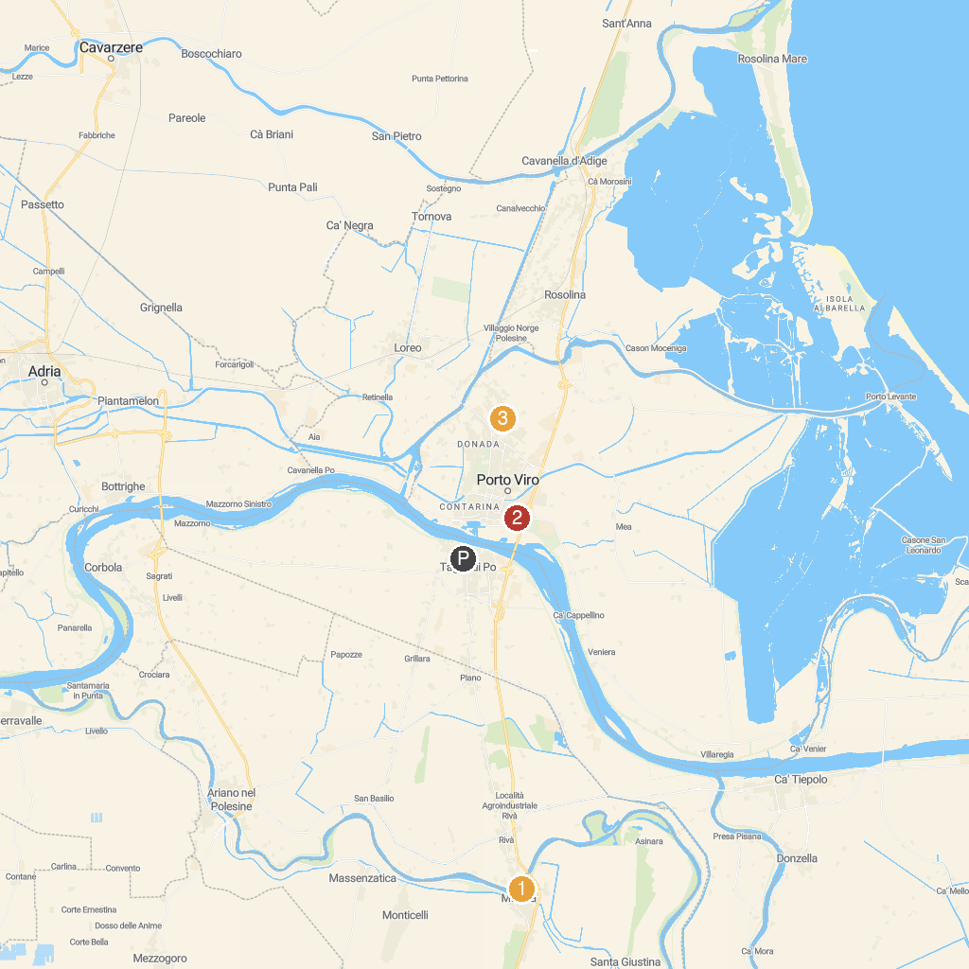
MAP KEY
1. Castle of Mesola | 3. Parco Regionale Veneto del Delta del Po
2. Giardini Scarpari | 4. Dune Fossili di Porto Viro
P. Cruise port / terminal
Map © MapTiler © OpenStreetMap contributors · cruiseports.org

