Tadoussac, Quebec, Canada
Where the dark waters of the Saguenay Fjord meet the St. Lawrence, beluga whales breach within sight of shore and Canada's oldest village watches from the hillside above a sandy bay.
⚓ Tender port · 🕒 Typical call: 7-9 hrs · 💵 Canadian Dollar (CAD) · 🗣️ French (English widely spoken in tourism) · 🐋 World-class whale watching
✍️ MY DAY IN PORT (FILL IN)
Ship / Date
In port | arrive ______ · all aboard ______
Booked excursion
Notes / meeting point
GETTING ASHORE
- Docking: Tender — ships anchor in Anse à l'Eau; tenders land at Quai de Tadoussac
- Walk to center: 5-10 min uphill from tender dock to village center
- Best For: Whale watching, fjord scenery, Quebec history, nature walks
- Don't Miss: Free beluga spotting from Pointe-de-l'Islet trail — no boat required
GETTING AROUND
- 🚕 Taxi: Metered — confirm fare with driver — A handful of local taxis serve Tadoussac for passengers with mobility needs or luggage. Quebec provincial taxi rates app
- 📱 Rideshare: ❌ not available
TOP THINGS TO DO
- Whale Watching Boat Tour — The Saguenay–St.
- Saguenay Fjord Sea Kayak — Paddle the dramatic cliffs of the Saguenay Fjord with a guided kayak tour.
- Tadoussac Sand Dunes Hike — The glacial sand dunes rising 175 m above the St.
- Historic Village Walk: Chapel & Trading Post — Canada's oldest wooden chapel (Chapelle des Indiens, 1747) and the Poste de traite Chauvin — a replica of the 1600 fur-trading…
- Marine Mammal Interpretation Centre (CIMM) — An excellent museum with real whale skeletons (including a 13 m sperm whale), interactive marine ecology exhibits, and…
BEST WALKS
- Pointe-de-l'Islet Shoreline Loop: 1.3 km loop • Easy • ~30 min • Free — A boardwalk trail wrapping around the rocky point at the edge of the bay.
- Village History Stroll: ~1 km • Easy (with hills) • ~1 hr • Free — From the tender dock, head up through the village to the iconic red-roofed Hotel Tadoussac (walk…
WEATHER · DAYLIGHT · MONEY
Month | High °F | Low °F | Rainy days
May | 56 | 41 | 1
Jul | 70 | 53 | 1
Sep | 62 | 48 | 1
Daylight: May 4:59AM–8:11PM · Jul 4:55AM–8:34PM · Sep 6:16AM–6:50PM
cruiseports.org/tadoussac · Confirm terminal & all-aboard time with your ship

Tadoussac, Quebec, Canada — Port Map
Red = walkable sights · Amber = excursions farther out · P = cruise terminal
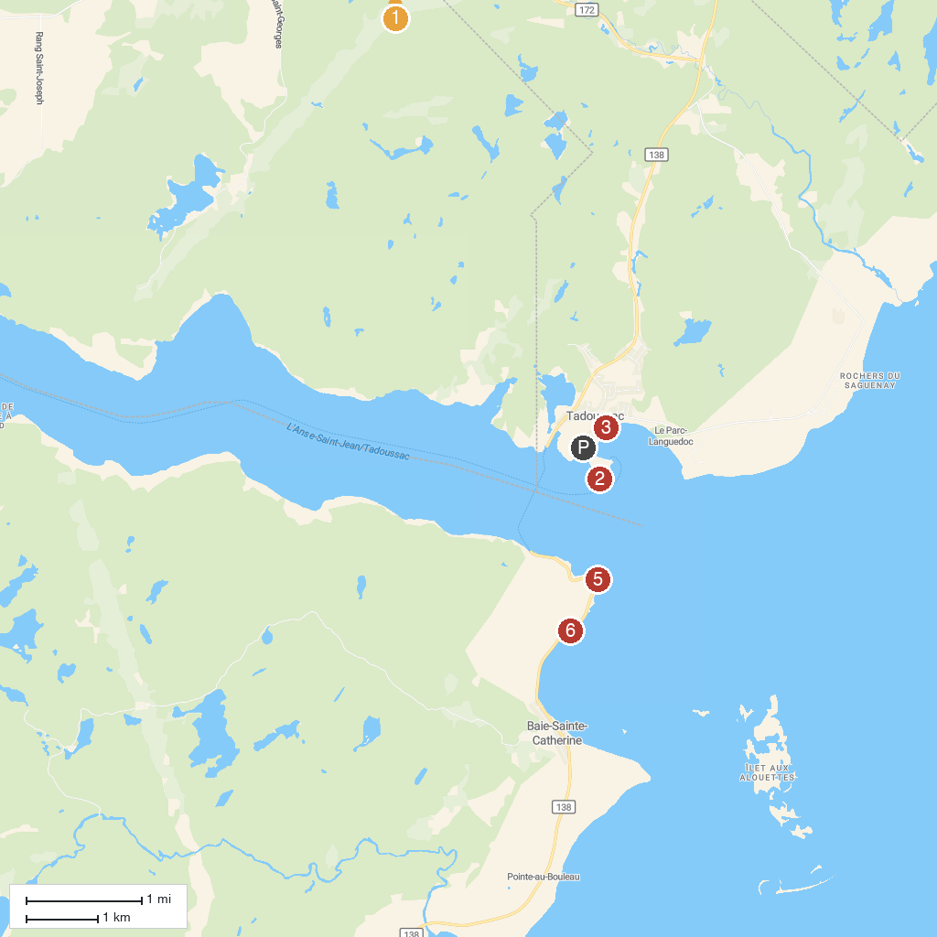
MAP KEY
1. Domaine de l'ours noir - Observation ours noir - hébergement | 5. Pointe-Noire Interpretation and Observation Centre
2. Islet Point | 6. Croisières AML · Charlevoix | Billetterie et embarquement
3. Chapelle de Tadoussac | 7. Centre D'Interpretation Archeo Topo
4. Croisières AML · Cale Sèche | Embarquement croisière en Zodiac
P. Cruise port / terminal
Map © MapTiler © OpenStreetMap contributors · cruiseports.org

