Tacoma, Washington, USA
The birthplace of Dale Chihuly, Tacoma trades its industrial past for stunning glass art, waterfront museums, and jaw-dropping views of Mount Rainier rising above Puget Sound.
⚓ Pier (Dock Street Marina / Thea Foss Waterway) · 🕒 Typical call: 7–9 hrs · 💵 USD · 🗣️ English · 🌲 Pacific Northwest
✍️ MY DAY IN PORT (FILL IN)
Ship / Date
In port | arrive ______ · all aboard ______
Booked excursion
Notes / meeting point
GETTING ASHORE
- Docking: Pier — small ships dock along Thea Foss Waterway near Museum of Glass
- Walk to center: 5–10 min from dock to downtown via Chihuly Bridge of Glass
- Best For: Glass art, Pacific Northwest seafood, urban parks, culture
- Don't Miss: Chihuly Bridge of Glass (free) and live glassblowing at Museum of Glass
GETTING AROUND
- 🚕 Taxi: $10–$20 — Traditional taxis are available in Tacoma, though rideshare apps are generally faster and more convenient. Flat-rate air
- 📱 Rideshare: ✅ Uber, Lyft
TOP THINGS TO DO
- Glass Art Trail — Walk the Chihuly Bridge of Glass (free), then go inside the Museum of Glass to watch live glassblowing in the iconic cone-shaped…
- Point Defiance Park & Owen Beach — One of the largest urban parks in the US, Point Defiance features old-growth forest trails, a free rose garden, and Owen Beach…
- LeMay — America's Car Museum — Four floors of historic, classic, and concept cars tracing America's love affair with the automobile.
- Point Defiance Zoo & Aquarium — The only combined zoo and aquarium in the Pacific Northwest, set inside Point Defiance Park with views of Mount Rainier.
- Ruston Way Waterfront & Craft Beer — Duke's Seafood and The Lobster Shop line the Ruston Way waterfront for award-winning clam chowder and wild Alaskan salmon.
BEST WALKS
- Museum District Walk: 1.5 miles · ~45 min · Easy — From the dock, cross the iconic Chihuly Bridge of Glass to the Museum of Glass, continue to the…
- Historic Downtown Loop: 1 mile · ~30 min · Easy — Stroll through downtown past the McMenamins Elks Temple — a restored 1916 Elks lodge turned brewery…
WEATHER · DAYLIGHT · MONEY
Month | High °F | Low °F | Rainy days
May | 65 | 49 | 0
Jul | 76 | 56 | 0
Sep | 69 | 54 | 1
Daylight: May 5:33AM–8:39PM · Jul 5:29AM–9:01PM · Sep 6:48AM–7:20PM
cruiseports.org/tacoma-wa · Confirm terminal & all-aboard time with your ship

Tacoma, Washington, USA — Port Map
Red = walkable sights · Amber = excursions farther out · P = cruise terminal
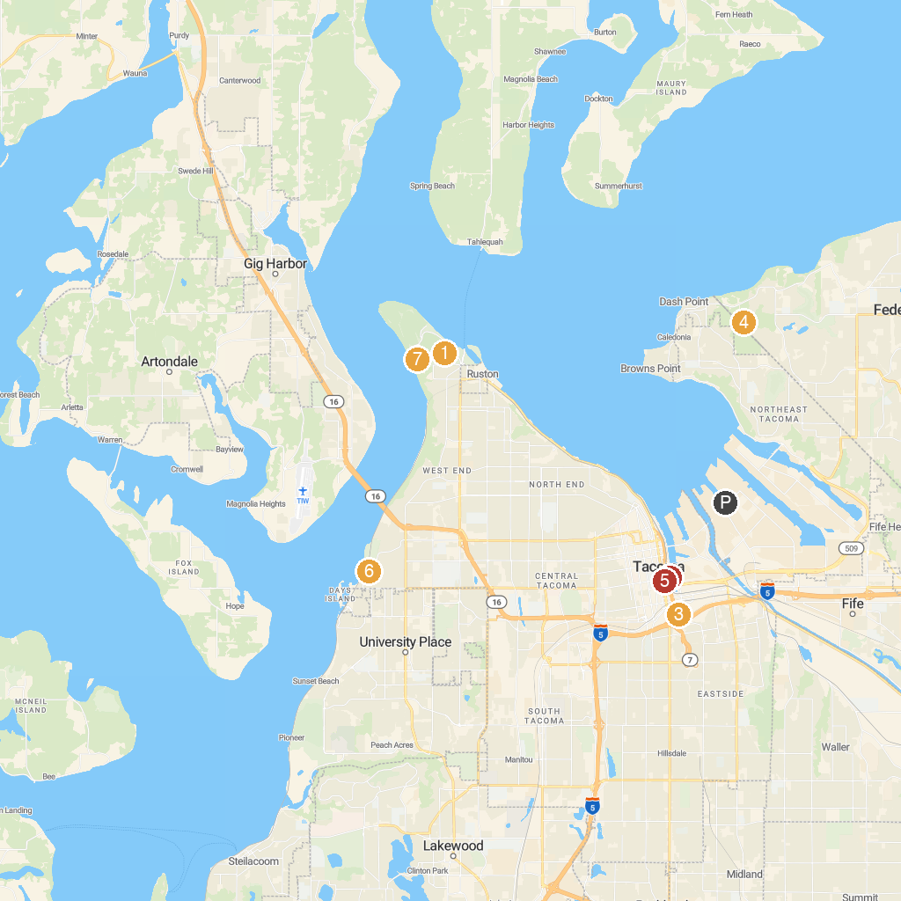
MAP KEY
1. Point Defiance Zoo & Aquarium | 5. Washington State Fair Event Center
2. Museum of Glass | 6. Washington State History Museum
3. LeMay - America’s Car Museum | 7. Titlow Park
4. Dash Point State Park | 8. Fort Nisqually Living History Museum
P. Cruise port / terminal
Map © MapTiler © OpenStreetMap contributors · cruiseports.org

