Sydney, Nova Scotia, Canada
Cape Breton's harbour city greets ships with a giant steel fiddle and a main street that actually lives up to its name. From Celtic pubs to the wild Cabot Trail, this is Canada's east coast at its most authentic.
⚓ Docked (pier) · 🕒 Typical call: 8-10 hrs · 💵 Canadian Dollar (CAD) · 🗣️ English (Gaelic heritage)
✍️ MY DAY IN PORT (FILL IN)
Ship / Date
In port | arrive ______ · all aboard ______
Booked excursion
Notes / meeting point
GETTING ASHORE
- Docking: Ships dock at Joan Harriss Cruise Pavilion, steps from downtown Charlotte Street
- Walk to Centre: 2–3 min on foot to Charlotte Street shops, restaurants, and the Big Fiddle
- Best For: Celtic music lovers, Cabot Trail day-trippers, Canadian history
- Don't Miss: Photo with the world's largest Celtic fiddle at the pier, then live music at a downtown pub
GETTING AROUND
- 🚕 Taxi: CAD 15–30 — Taxis are available at the cruise terminal for rides to destinations beyond the walkable downtown. CB Taxi Tours also of
- 📱 Rideshare: ❌ not available
TOP THINGS TO DO
- Cabot Trail Highlights Drive — The famous coastal highway loops through Cape Breton Highlands National Park.
- Fortress of Louisbourg — North America's largest reconstructed 18th-century French fortress sits about 40 minutes from Sydney.
- Celtic Music & Downtown Sydney Walk — Cape Breton is the heartland of North American Celtic music.
- Cape Breton Miners' Museum — In Glace Bay, 20 minutes from Sydney, retired miners lead underground tours of an actual coal seam.
- Bras d'Or Lake Scenic Drive — The vast inland sea of Bras d'Or Lake is a UNESCO Biosphere Reserve.
BEST WALKS
- Sydney Waterfront & Charlotte Street Stroll: 45–60 min | Easy | 1.5 km — Start at the Big Fiddle at the pier, walk the Esplanade boardwalk north to Wentworth Park, then…
- Cossit House & Historic Core: 30–45 min | Easy | 1 km — From the pier, walk a few blocks inland to Cossit House (c.
WEATHER · DAYLIGHT · MONEY
Month | High °F | Low °F | Rainy days
May | 67 | 52 | 6
Jul | 62 | 47 | 6
Sep | 68 | 51 | 8
Daylight: May 6:40AM–5:02PM · Jul 6:58AM–5:04PM · Sep 5:55AM–5:46PM
cruiseports.org/sydney-ns · Confirm terminal & all-aboard time with your ship

Sydney, Nova Scotia, Canada — Port Map
Red = walkable sights · Amber = excursions farther out · P = cruise terminal
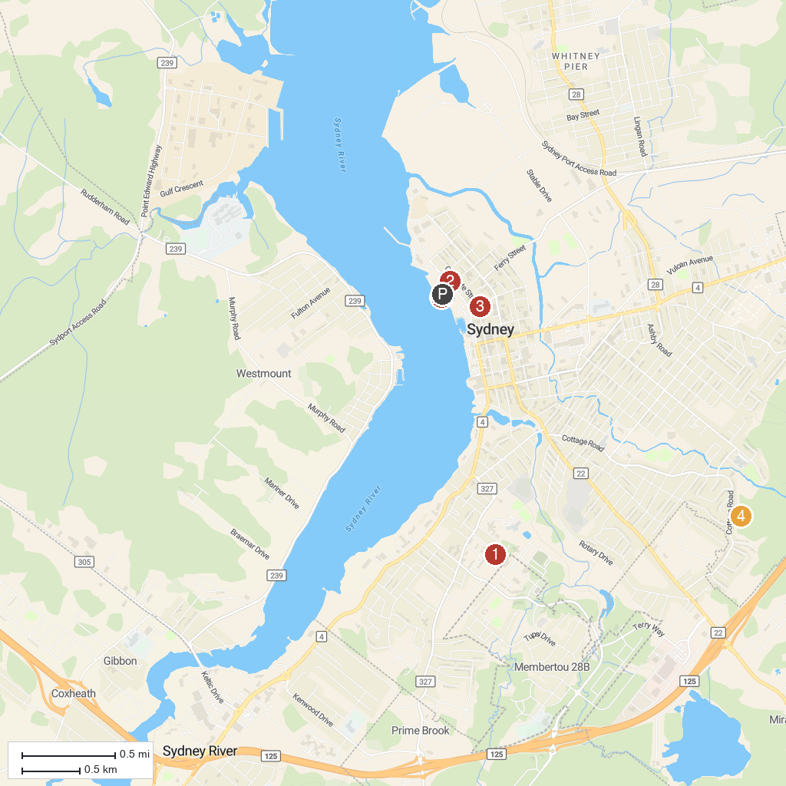
MAP KEY
1. Membertou Heritage Park | 4. Baille Ard Trail
2. St Patrick's Church Museum | 5. Cape Breton Fossil Centre/Sydney Mines Heritage Museum
3. Old Sydney Society | 6. Worlds Largest Fiddle
P. Cruise port / terminal
Map © MapTiler © OpenStreetMap contributors · cruiseports.org

