Świnoujście, Pomerania, Poland
Poland's only city spread across 44 islands, Świnoujście pairs a sweeping Blue Flag beach with intact Prussian fortresses — and you can stroll across the border into Germany for lunch.
⚓ Pier (Władysław IV Quay or Ferry Terminal) · 🕒 Typical call: 8-10 hrs · 💵 Polish Złoty (PLN); Euros widely accepted · 🗣️ Polish / German / English spoken
✍️ MY DAY IN PORT (FILL IN)
Ship / Date
In port | arrive ______ · all aboard ______
Booked excursion
Notes / meeting point
GETTING ASHORE
- Docking: Pier — Władysław IV Quay (Usedom side) for smaller ships; Ferry Terminal (Wolin side) for large ships
- Walk to center: 5–10 min from Usedom quay; Wolin-side ships take free ferry across (~10 min)
- Best For: Baltic beaches, Prussian military history, border-crossing cycling
- Don't Miss: Stawa Młyny windmill beacon & cycling into Ahlbeck, Germany
GETTING AROUND
- 🚕 Taxi: 13–16 PLN (€3–4) — Taxis are plentiful and cheap for the short ride from the cruise terminal to the city center — typically under 2 km. Loc
- 📱 Rideshare: ✅ Uber, Bolt
TOP THINGS TO DO
- Stawa Młyny & West Breakwater Walk — Stroll 1.5 km along the West Mole to the windmill-shaped navigation beacon at its tip — Świnoujście's iconic symbol.
- Fort Gerhard & the Lighthouse — On Wolin Island, Fort Gerhard is one of Europe's best-preserved 19th-century Prussian coastal forts with costumed guides.
- Cycle to Germany — Rent a bike at the port and pedal 6 km along a paved coastal cycle path into Germany — past the border arch to the imperial spa…
- Baltic Beach & Promenade — Świnoujście's Blue Flag beach is up to 200 m wide with powdery white sand — among the finest on the Baltic.
- Fort Anioła & Old Town — Fort Anioła (Fort Angel) on Usedom is modelled on Rome's Castel Sant'Angelo, now housing an art gallery, a café in the brick…
BEST WALKS
- City Centre to Beach via Spa Park: 2 km · 25 min · Easy · Free — From the quay, walk through Plac Wolności (city square), enter the historic Park Zdrojowy designed…
- Breakwater Walk to Stawa Młyny: 3 km round-trip · 40 min · Easy · Free — Head northwest from the port along the West Mole (Zachodnie Nabrzeże) to the tip, where the famous…
WEATHER · DAYLIGHT · MONEY
Month | High °F | Low °F | Rainy days
May | 62 | 47 | 0
Jul | 73 | 58 | 1
Sep | 67 | 53 | 0
Daylight: May 5:00AM–8:59PM · Jul 4:51AM–9:25PM · Sep 6:36AM–7:18PM
cruiseports.org/swinoujscie · Confirm terminal & all-aboard time with your ship

Świnoujście, Pomerania, Poland — Port Map
Red = walkable sights · Amber = excursions farther out · P = cruise terminal
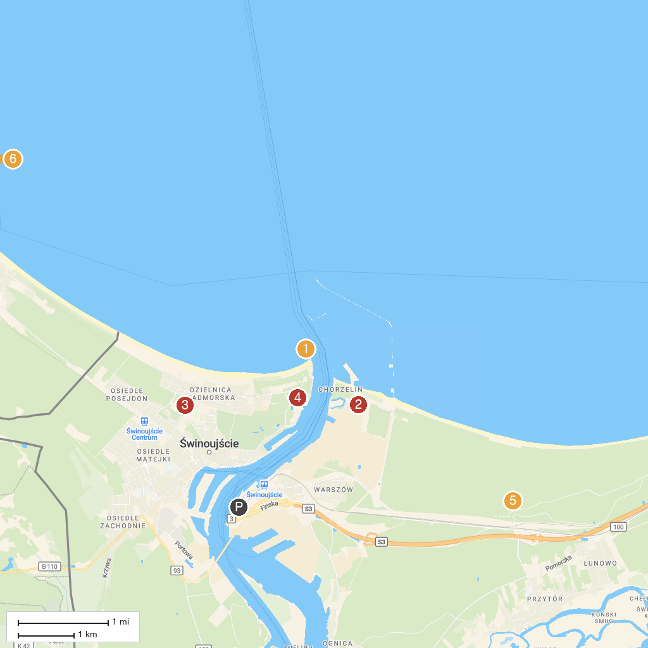
MAP KEY
1. Stawa Młyny | 5. Park Linowy Bluszcz Świnoujście
2. Kawcza Mountain | 6. Western Fort
3. Piaskowa Góra | 7. Underground City (Vineta Battery)
4. Bateria Brzegowa (Strandbatterie) w Świnoujściu | 8. XXL Strandkorb
P. Cruise port / terminal
Map © MapTiler © OpenStreetMap contributors · cruiseports.org

