Swansea, Wales, United Kingdom
Dylan Thomas called it an 'ugly, lovely town' — and he was only half right. Swansea pairs a revived waterfront and Wales' finest indoor market with the Gower Peninsula, Britain's first Area of Outstanding Natural Beauty, just down the road.
⚓ Docked — Kings Dock (lock-gate access) · 🕒 Typical call: 8-10 hrs · 💷 British Pound (GBP) · 🗣️ English; Welsh on all signs
✍️ MY DAY IN PORT (FILL IN)
Ship / Date
In port | arrive ______ · all aboard ______
Booked excursion
Notes / meeting point
GETTING ASHORE
- Docking: Kings Dock — small/mid-size ships only (max ~200 m); shuttle to city required
- Walk to center: 10 min by shuttle; pedestrians not permitted through port zone
- Best For: Coastal walks, Welsh culture, Gower Peninsula day trips
- Don't Miss: Swansea Market laverbread & welshcakes, Mumbles village, Rhossili Bay
GETTING AROUND
- 🚕 Taxi: £3–£5 — The cruise terminal is roughly 1.5 km (1 mile) from Swansea city centre — a very short taxi ride. Standard metered fares
- 📱 Rideshare: ✅ Uber
TOP THINGS TO DO
- Maritime Quarter & Dylan Thomas Trail — The revitalised South Dock area packs in the free National Waterfront Museum (Wales' industrial story), Swansea Museum (Egyptian…
- Mumbles Village & Promenade — Hop the No.
- Gower Peninsula Day Trip — Britain's first AONB offers Three Cliffs Bay and Rhossili Bay — consistently rated among the world's best beaches.
- Swansea Castle & City Centre — The 14th-century ruins of Swansea Castle sit right in the city centre — free to view from outside.
- Rhossili Bay & Worm's Head Walk — Three miles of golden sand backed by dramatic cliffs, ending at Worm's Head — a tidal island only accessible at low tide.
BEST WALKS
- Maritime Quarter to Swansea Bay Beach: 2 km · 25 min · Flat — From the shuttle drop-off near the National Waterfront Museum, walk south along the marina edge…
- Mumbles Promenade & Pier: 2 km · 30 min · Flat — Alight the No.
WEATHER · DAYLIGHT · MONEY
Month | High °F | Low °F | Rainy days
May | 60 | 47 | 1
Jul | 68 | 55 | 1
Sep | 65 | 52 | 1
Daylight: May 5:23AM–9:01PM · Jul 5:16AM–9:26PM · Sep 6:51AM–7:29PM
cruiseports.org/swansea-uk · Confirm terminal & all-aboard time with your ship

Swansea, Wales, United Kingdom — Port Map
Red = walkable sights · Amber = excursions farther out · P = cruise terminal
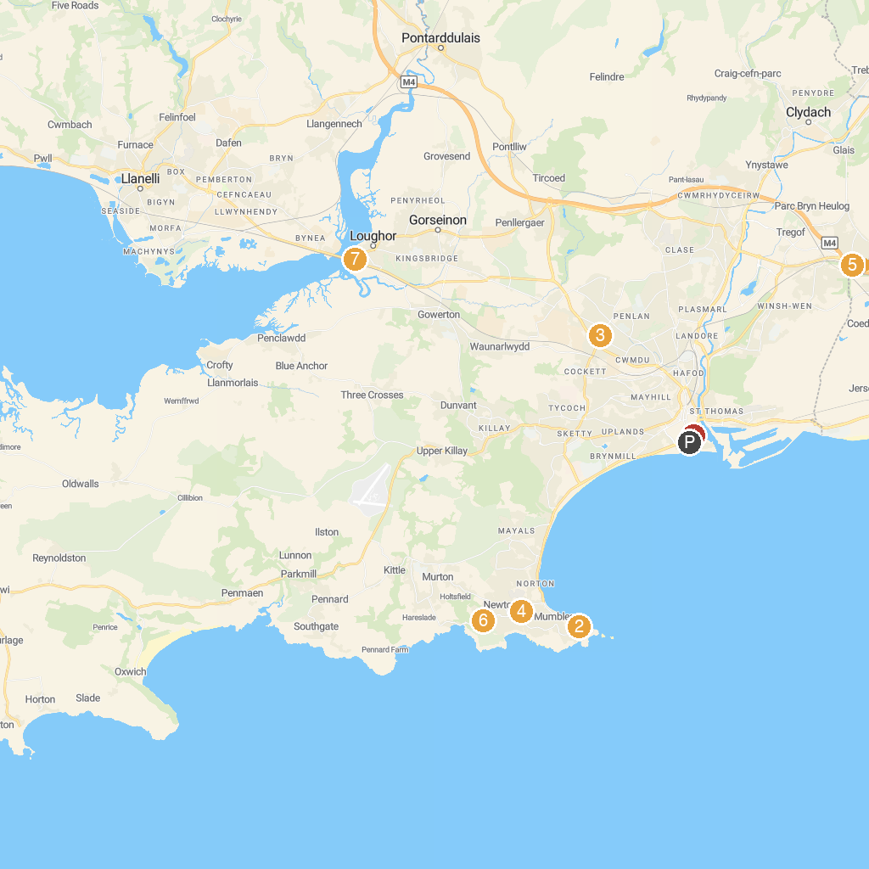
MAP KEY
1. Swansea Museum | 5. Underhill Hub
2. National Trust - Aberdulais | 6. Neath Abbey
3. Mumbles Hill Local Nature Reserve | 7. Bishop's Wood Local Nature Reserve
4. Ravenhill Park | 8. Parc Williams
P. Cruise port / terminal
Map © MapTiler © OpenStreetMap contributors · cruiseports.org

