Svolvær, Lofoten Islands, Norway
Razor-sharp granite peaks rise straight from the Arctic Ocean, framing a lively harbor town that has dried cod and painted wooden cabins for over a thousand years. Svolvær is the Lofoten Islands in miniature — wild, beautiful, and utterly unlike anywhere else on a cruise itinerary.
⚓ Pier (most ships) or tender · 🕒 Typical call: 6–8 hrs · 💳 Cashless — card only (NOK) · 🗣️ Norwegian · ☀️ Midnight Sun May–Jul
✍️ MY DAY IN PORT (FILL IN)
Ship / Date
In port | arrive ______ · all aboard ______
Booked excursion
Notes / meeting point
GETTING ASHORE
- Docking: Cruise Pier (Svolvær Cruisekaia) steps from town; larger ships use Osan Quay ~1.5 km away
- Walk to Center: 2 min from main pier; 20 min flat walk from Osan Quay (shuttle often provided)
- Best For: Fjord scenery, sea eagle safaris, stockfish culture, Arctic hiking
- Don't Miss: Trollfjord boat trip — narrow, dramatic, unforgettable
GETTING AROUND
- 🚕 Taxi: 100–200 NOK (€9–€18) — Local taxis (Svolvær & Kabelvåg Maxi Taxi, Nordland Taxi) start at ~100 NOK with ~14.5 NOK/km. Useful for reaching sligh
- 📱 Rideshare: ❌ not available
TOP THINGS TO DO
- Trollfjord RIB Boat Tour — Speedboats depart the harbor and race into the narrow, cliff-walled Trollfjord — one of Norway's most dramatic landscapes.
- Sea Eagle Safari — Guides toss fish into the water to attract white-tailed sea eagles with 2.5-meter wingspans.
- Henningsvær Village Tour — Known as the 'Venice of Lofoten,' Henningsvær sits on a cluster of small islands connected by bridges, with a world-famous…
- Lofoten War Memorial Museum — One of the world's most remarkable WWII collections, housed in an unassuming building steps from the harbor.
- Svolværgeita Mountain Climb — The iconic twin-peaked 'Svolvær Goat' looms over town.
BEST WALKS
- Town Center & Svinøya Historic Quarter: 2 km loop · 45 min · Flat · Free — From the cruise pier, stroll along the harbor promenade past colorful rorbuer (fishermen's cabins)…
- Tjeldbergtinden Hike (Energetic Option): 6 km round trip · 2.5–3 hrs · Moderate-Challenging · Free — Walk from the town center to the Tjeldbergtinden trailhead and climb for sweeping 360-degree views…
WEATHER · DAYLIGHT · MONEY
Month | High °F | Low °F | Rainy days
May | 49 | 40 | 1
Jul | 63 | 53 | 1
Sep | 54 | 47 | 1
Daylight: Sep 6:18AM–7:32PM
cruiseports.org/svolvaer · Confirm terminal & all-aboard time with your ship

Svolvær, Lofoten Islands, Norway — Port Map
Red = walkable sights · Amber = excursions farther out · P = cruise terminal
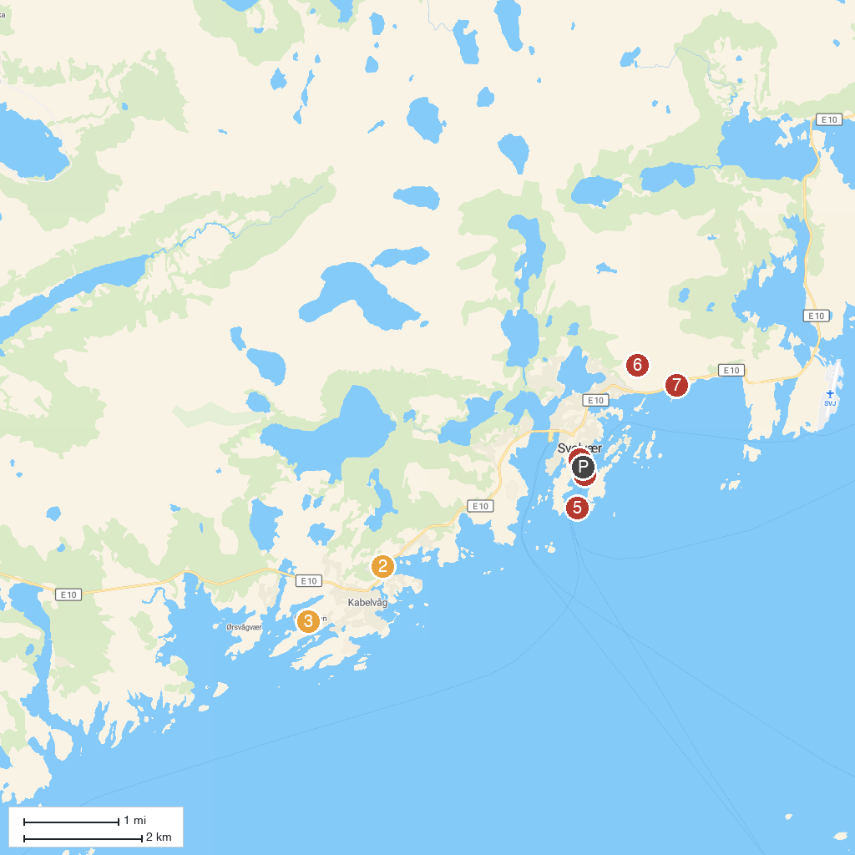
MAP KEY
1. Visit Lofoten | 5. Svolvær Pier
2. Vågan Church | 6. Svolværgeita
3. Lofotmuseet | 7. Svolvær Strand
4. Magic Ice Lofoten
P. Cruise port / terminal
Map © MapTiler © OpenStreetMap contributors · cruiseports.org

