Svishtov, Northern Bulgaria, Bulgaria
Bulgaria's 'Town of Firsts' sits at the Danube's southernmost bend — a compact university town where Roman legions once camped and the country's first secular school, choir, and library were founded.
⚓ Docked (pier) · 🕒 Typical call: 6–8 hrs · 💵 Bulgarian Lev (BGN) · 🗣️ Bulgarian (some English near university)
✍️ MY DAY IN PORT (FILL IN)
Ship / Date
In port | arrive ______ · all aboard ______
Booked excursion
Notes / meeting point
GETTING ASHORE
- Docking: Pier — direct alongside at Svishtov Passenger Quay
- Walk to center: ~700 m uphill to Freedom Square (10–15 min)
- Best For: Roman history, National Revival architecture, affordable dining
- Don't Miss: Novae Roman ruins and Holy Trinity Church by master builder Kolyo Ficheto
GETTING AROUND
- 🚕 Taxi: €3–€6 — Metered taxis are the main transport option in Svishtov. The port is close to town; a ride to the city center costs roug
- 📱 Rideshare: ❌ not available
TOP THINGS TO DO
- Novae Roman Legionary Fortress — Some 4 km east of the pier lie the excavated ruins of Novae, a major Roman military base for the VIII Augusta and I Italica…
- Holy Trinity Church & National Revival Walk — The 1867 Holy Trinity Church by master builder Kolyo Ficheto is the town's architectural crown — the two entrance columns can be…
- Pametnitsite — 1877 Liberation Crossing Monument — A vast park on the Danube riverbank west of town marks the exact spot where Russian forces crossed in 1877 to liberate Bulgaria…
- Aleko Konstantinov House-Museum — Svishtov's most famous son was the writer and traveler who founded Bulgaria's tourist movement.
- Mehana Lunch & Svishtov Wine — As a university town, Svishtov has excellent, affordable mehanas (traditional Bulgarian taverns).
BEST WALKS
- Pier to Freedom Square & Holy Trinity Church: 1.5 km round trip · mostly uphill going · 30–45 min — From the quay, head uphill along the main road to Freedom Square (Ploshtad Svoboda).
WEATHER · DAYLIGHT · MONEY
Month | High °F | Low °F | Rainy days
May | 75 | 53 | 1
Jul | 89 | 64 | 0
Sep | 82 | 56 | 0
Daylight: May 5:53AM–8:36PM · Jul 5:51AM–8:57PM · Sep 6:58AM–7:28PM
cruiseports.org/svishtov · Confirm terminal & all-aboard time with your ship

Svishtov, Northern Bulgaria, Bulgaria — Port Map
Red = walkable sights · Amber = excursions farther out · P = cruise terminal
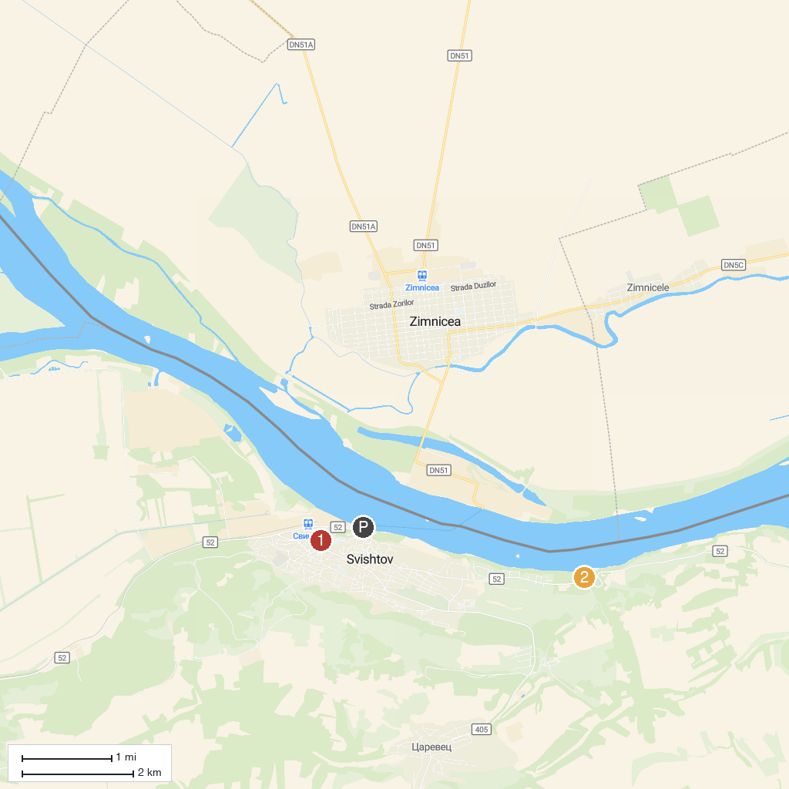
MAP KEY
1. House-Museum of Aleko Konstantinov | 2. Monuments Park
P. Cruise port / terminal
Map © MapTiler © OpenStreetMap contributors · cruiseports.org

