Suva, Viti Levu, Fiji
Fiji's capital is a proper city — a colonial waterfront, a world-class Fiji Museum, a bustling market, and lush rainforest trails just minutes from the dock. Warm, wet, and wonderfully alive.
⚓ Docked (Kings Wharf) · 🕒 Typical call: 7–9 hrs · 💵 Fijian Dollar (FJD) · 🗣️ Fijian · Hindi · English
✍️ MY DAY IN PORT (FILL IN)
Ship / Date
In port | arrive ______ · all aboard ______
Booked excursion
Notes / meeting point
GETTING ASHORE
- Docking: Kings Wharf, Suva Harbour
- Walk to center: 10–15 min on foot
- Best For: Culture · Rainforest · Markets
- Don't Miss: Fiji Museum, Thurston Gardens
GETTING AROUND
- 🚕 Taxi: FJ$8–15 (short city rides) — Taxis wait at the wharf and are plentiful. Negotiate the fare before departure as meters are not always used; short hops
TOP THINGS TO DO
- Fiji Museum & Thurston Gardens — The finest museum in the Pacific, housed in a colonial building inside the beautiful Thurston Gardens.
- Colo-i-Suva Forest Park — A cool rainforest reserve 11 km north of the city with marked trails, natural swimming holes, and waterfalls.
- Suva Municipal Market — One of the most vibrant markets in the South Pacific — produce, root vegetables, tropical fruit, kava roots, fresh fish, and…
- Pacific Harbour & Arts Village — About 45 km west of Suva, Pacific Harbour is known as the adventure capital of Fiji.
- Colonial Suva Walking Tour — Explore Suva's colonial heritage — the Grand Pacific Hotel (opened 1914, visited by royals), Government House, the Holy Trinity…
BEST WALKS
- Waterfront to Fiji Museum: ~2 km · 1–1.5 hrs · easy — Walk the waterfront road from Kings Wharf past the seawall toward the city centre, then cut inland…
- Downtown Suva market loop: ~2.5 km · 1.5 hrs · easy — From the wharf, walk into the city grid to Suva Municipal Market for kava, tropical produce, and…
WEATHER · DAYLIGHT · MONEY
Month | High °F | Low °F | Rainy days
May | 79 | 73 | 19
Jul | 77 | 71 | 16
Sep | 78 | 71 | 19
Daylight: May 6:24AM–5:40PM · Jul 6:38AM–5:46PM · Sep 6:02AM–6:01PM
cruiseports.org/suva · Confirm terminal & all-aboard time with your ship

Suva, Viti Levu, Fiji — Port Map
Red = walkable sights · Amber = excursions farther out · P = cruise terminal
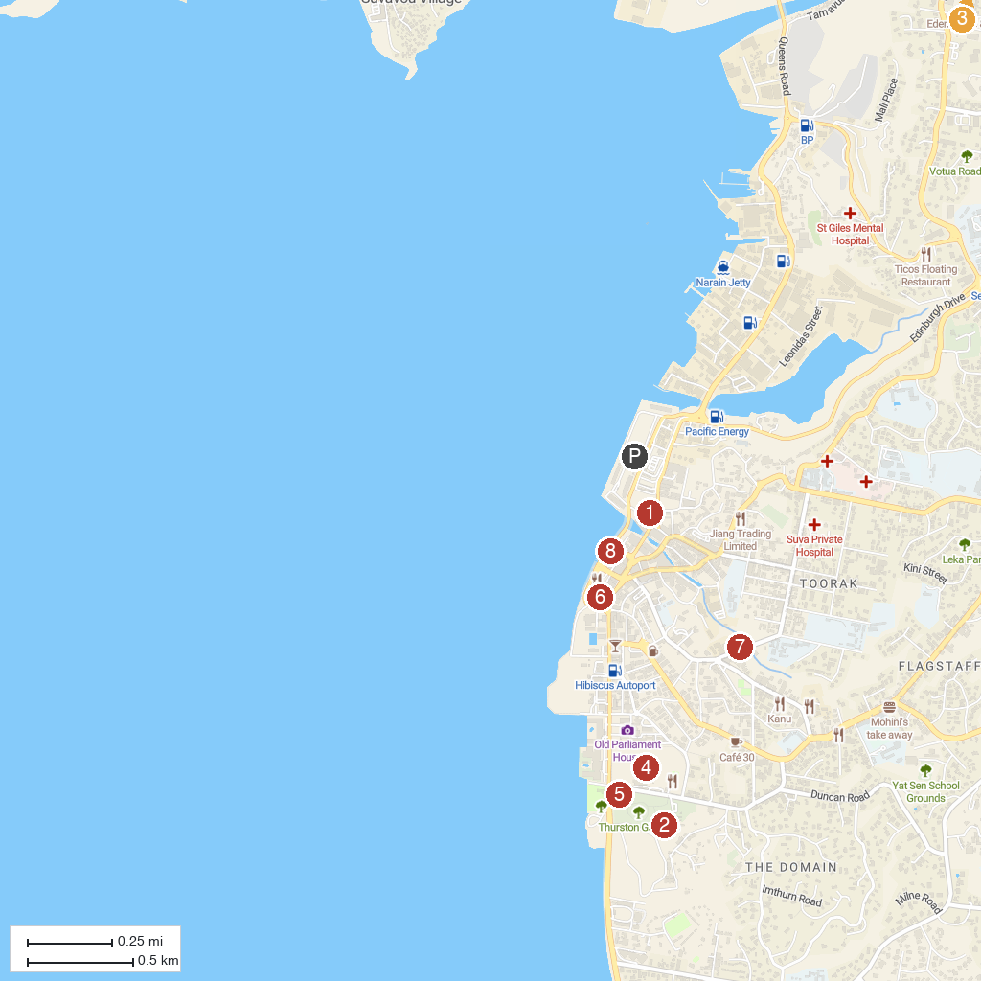
MAP KEY
1. Suva Municipal Market | 5. Thurston Gardens
2. Fiji Museum | 6. Ratu Sukuna Park
3. Colo-I-Suva Forest Park | 7. Laxmi Narayan Mandir
4. Albert Park | 8. Municipal Handicraft Centre
P. Cruise port / terminal
Map © MapTiler © OpenStreetMap contributors · cruiseports.org

