Surabaya, Java, Indonesia
Indonesia's gritty, proud second city — a place of colonial heritage, diverse mosques, a vintage submarine in the river, and the smoking volcanoes of East Java just a long drive away.
⚓ Docked (Tanjung Perak port) · 🕒 Typical call: 8–10 hrs · 💵 Indonesian Rupiah (IDR) · 🗣️ Indonesian / Javanese
✍️ MY DAY IN PORT (FILL IN)
Ship / Date
In port | arrive ______ · all aboard ______
Booked excursion
Notes / meeting point
GETTING ASHORE
- Docking: Tanjung Perak terminal
- Walk to center: Transfer needed (~20–40 min)
- Best For: History · Culture · Religion
- Don't Miss: House of Sampoerna
GETTING AROUND
- 🚕 Taxi: IDR 50,000–80,000 (~$3–5 USD) — Blue Bird is the most reliable metered taxi in Indonesia. Find them at the Tanjung Perak terminal exit; insist the meter
- 📱 Rideshare: ✅ Grab, Gojek
TOP THINGS TO DO
- House of Sampoerna — A beautifully preserved Dutch colonial complex that was once a cigarette factory — now a museum tracing the Sampoerna family's…
- Monkasel — Submarine Monument — A decommissioned Soviet-era submarine (KRI Pasopati 410) permanently docked on the Kalimas River, now a museum you can walk…
- Arab Quarter & Ampel Mosque — The Ampel district is one of Indonesia's oldest Islamic neighborhoods, centered on the revered Masjid Ampel mosque (15th century)…
- Cheng Hoo Mosque & Chinatown — The Muhammad Cheng Hoo Mosque is a striking red-and-gold Chinese-style mosque built to honor the Muslim admiral Zheng He.
- Mount Bromo — Full-Day Volcano — One of Indonesia's most dramatic landscapes: the smoldering caldera of Bromo inside the vast Tengger sand sea, with pre-dawn…
BEST WALKS
- Old City Walk: Sampoerna to Ampel: ~2 km · 1.5 hrs · easy (flat, hot) — Start at the House of Sampoerna in the Dutch colonial quarter, walk through the old harbor district…
WEATHER · DAYLIGHT · MONEY
Month | High °F | Low °F | Rainy days
May | 87 | 78 | 13
Jul | 87 | 75 | 5
Sep | 90 | 76 | 4
Daylight: May 5:31AM–5:18PM · Jul 5:43AM–5:26PM · Sep 5:22AM–5:25PM
cruiseports.org/surabaya · Confirm terminal & all-aboard time with your ship

Surabaya, Java, Indonesia — Port Map
Red = walkable sights · Amber = excursions farther out · P = cruise terminal
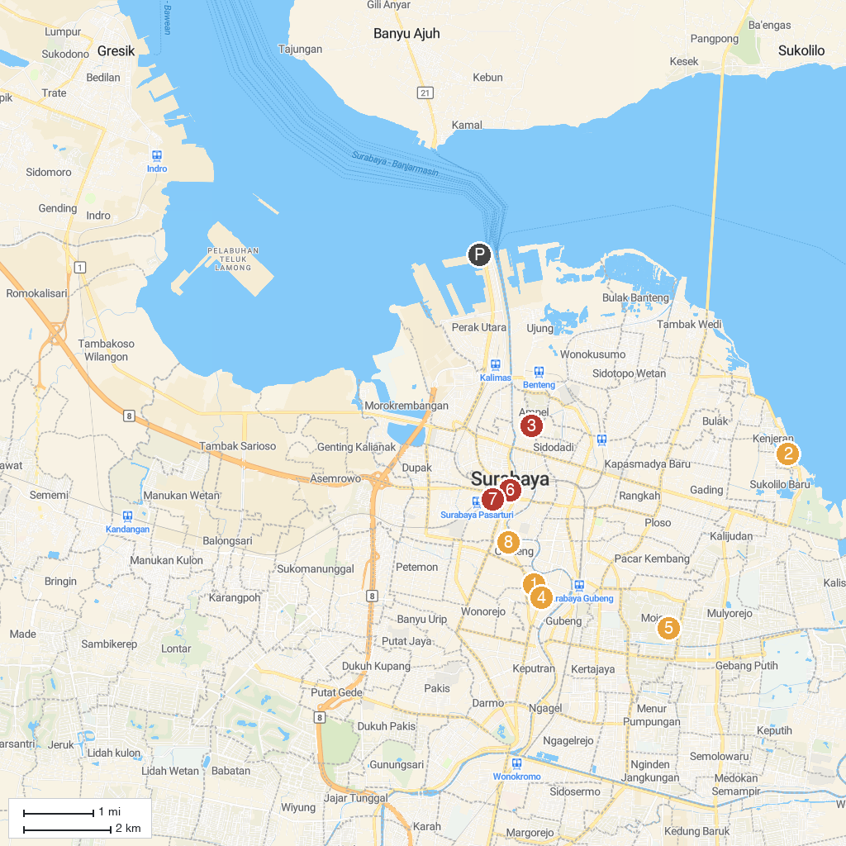
MAP KEY
1. Arca Joko Dolog | 5. Atlas Sports Club
2. Kenjeran Park | 6. Monumen Tugu Pahlawan dan Museum Sepuluh Nopember Surabaya
3. Pasar Ampel | 7. Kampoeng Lawas Maspati
4. Monumen Bambu Runcing | 8. Siola Surabaya Museum
P. Cruise port / terminal
Map © MapTiler © OpenStreetMap contributors · cruiseports.org

