Sur, Ash Sharqiyah, Oman
Oman's ancient maritime capital still builds wooden dhows by hand on its lagoon shore — and just down the coast, hundreds of green sea turtles haul themselves ashore each night at one of the world's great wildlife spectacles.
⚓ Tender port (no pier) · 🕒 Typical call: 7–9 hrs · 💵 Omani Rial (OMR) · 🗣️ Arabic (English in tourism)
✍️ MY DAY IN PORT (FILL IN)
Ship / Date
In port | arrive ______ · all aboard ______
Booked excursion
Notes / meeting point
GETTING ASHORE
- Docking: Tender to Al Khor quay / Corniche pontoon
- Walk to center: Steps off the tender — Corniche is right there
- Best For: Maritime heritage, sea turtles, wadis
- Don't Miss: Al Qanjah Dhow Yard & Fatah Al Khair
GETTING AROUND
- 🚕 Taxi: 3–5 OMR (~$8–13) — Taxis are the main transport from the port to Sur city center. Negotiate the fare before departure as meters may not be
- 📱 Rideshare: ❌ not available
TOP THINGS TO DO
- Al Qanjah Dhow Yard & Maritime Museum — Watch craftsmen build ocean-going wooden dhows entirely by hand without blueprints — a tradition stretching back a thousand years.
- Ras Al Jinz Sea Turtle Reserve — One of the world's largest green turtle nesting beaches, just 40 km south of Sur.
- Wadi Shab Gorge Swim — A 45-minute drive north leads to one of Oman's most spectacular canyons.
- Sunaysilah Fort & Al Ayjah Watchtowers — The 300-year-old Sunaysilah Fort crowns a hill above the Corniche with sweeping harbor views and a small collection of local…
- Bimmah Sinkhole & Fins Beach — An hour north, Bimmah Sinkhole (Hawiyat Najm) is a 40-metre-wide natural pool of turquoise water perfect for a swim.
BEST WALKS
- Corniche to Dhow Yard: 2 km · 30–40 min · Easy — Walk the lagoon promenade south from the tender quay past Sunaysilah Fort (detour up for views)…
- Suspension Bridge & Al Ayjah: 2.5 km round-trip · 45 min · Easy — From the Corniche, walk north to the Khor Al Batah suspension bridge — the only one in Oman — and…
WEATHER · DAYLIGHT · MONEY
Month | High °F | Low °F | Rainy days
May | 107 | 87 | 0
Jul | 105 | 85 | 0
Sep | 103 | 82 | 0
Daylight: May 5:21AM–6:34PM · Jul 5:26AM–6:49PM · Sep 5:48AM–6:05PM
cruiseports.org/sur-city · Confirm terminal & all-aboard time with your ship

Sur, Ash Sharqiyah, Oman — Port Map
Red = walkable sights · Amber = excursions farther out · P = cruise terminal
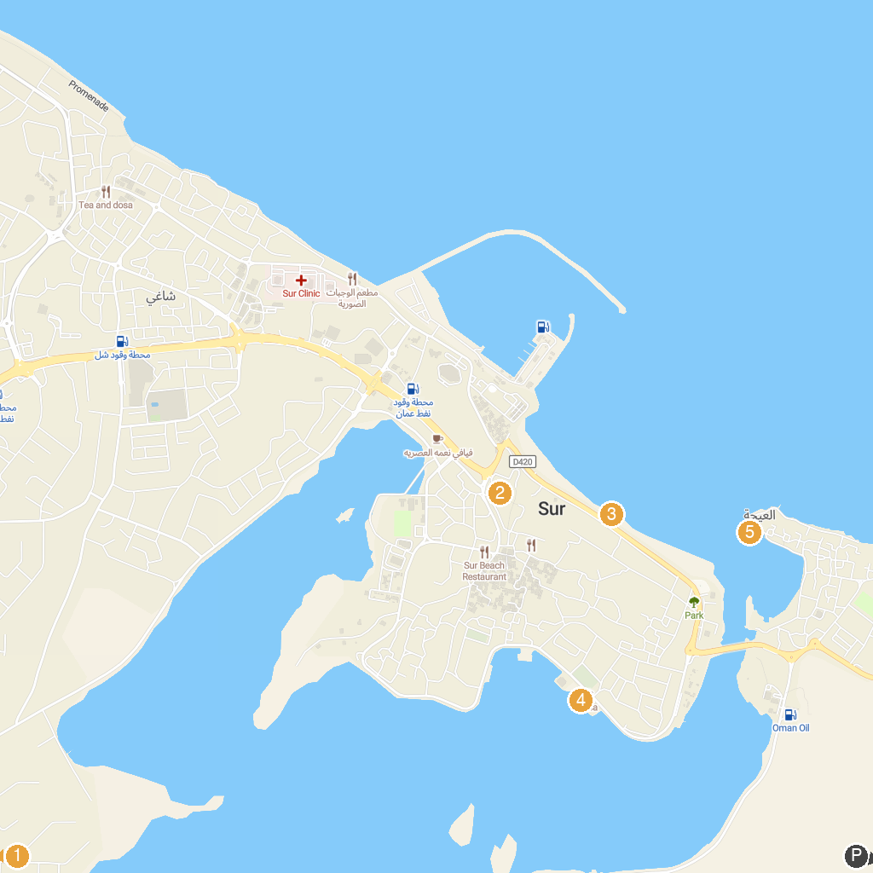
MAP KEY
1. Bilad Sur Castle | 4. Fatah Al Khair
2. Sur Traditional Souq | 5. Al-Ayjah Lighthouse
3. Sur Beach
P. Cruise port / terminal
Map © MapTiler © OpenStreetMap contributors · cruiseports.org

