Sundsvall, Västernorrland, Sweden
Rebuilt in stone after a catastrophic 1888 fire, Sundsvall is Sweden's only city of stone — an architectural gem on the Gulf of Bothnia and gateway to the High Coast UNESCO World Heritage Site.
⚓ Pier — Tunadal Port (shuttle required) · 🕒 Typical call: 8-10 hrs · 💳 Cashless — cards only (Sweden rarely accepts cash) · 🗣️ Swedish (English spoken everywhere) · 🏛️ Architecture & history
✍️ MY DAY IN PORT (FILL IN)
Ship / Date
In port | arrive ______ · all aboard ______
Booked excursion
Notes / meeting point
GETTING ASHORE
- Docking: Pier at Tunadal Port, ~5.5 km from city center; cruise line shuttle required (no walkable route)
- Walk to Center: Not walkable from port — shuttle 10–15 min to Kulturmagasinet / Inre Hamnen
- Best For: Architecture lovers, history buffs, Nordic culture, UNESCO High Coast excursions
- Don't Miss: Stenstaden stone city walk, Kulturmagasinet, Norra Berget lookout tower
GETTING AROUND
- 🚕 Taxi: 90–120 SEK — Taxis are available at the Tunadal port. The city center (Stenstaden) is ~2–3 km away; expect around 90–120 SEK for the
- 📱 Rideshare: ❌ not available
TOP THINGS TO DO
- Stenstaden Stone City Walking Tour — Sundsvall burned entirely in 1888 and was rebuilt in stone by Germany's finest architects within five years.
- High Coast (Höga Kusten) UNESCO Excursion — About 1.5–2 hours north by road, the High Coast is one of the world's most dramatic examples of post-glacial land uplift — rocky…
- Kulturmagasinet Museum & Library — Four 19th-century brick harbor warehouses joined by soaring glass roofs now house the city library, a regional history museum…
- Norra Berget Open-Air Museum & Panorama — The North Mountain open-air museum features relocated historic farmsteads, animals, and Swedish heritage crafts — Sundsvall's…
- Himlabadet Water Park & Spa — Award-winning adventure water park within walking distance of the city center, featuring waterslides, a surf machine, and a…
BEST WALKS
- Stenstaden Architecture Walk: 2–3 km · 1–2 hrs · Easy — Start at Kulturmagasinet on the inner harbour, walk up Storgatan past ornate Neo-Gothic and…
- Inner Harbour to Norra Berget: 3 km · 1.5 hrs · Easy–Moderate (uphill finish) — Walk from the inner harbour along the waterfront, through the city center, and up to Norra Berget…
WEATHER · DAYLIGHT · MONEY
Month | High °F | Low °F | Rainy days
May | 57 | 37 | 0
Jul | 71 | 53 | 1
Sep | 60 | 44 | 1
Daylight: May 3:53AM–9:42PM · Sep 6:16AM–7:13PM
cruiseports.org/sundsvall · Confirm terminal & all-aboard time with your ship

Sundsvall, Västernorrland, Sweden — Port Map
Red = walkable sights · Amber = excursions farther out · P = cruise terminal
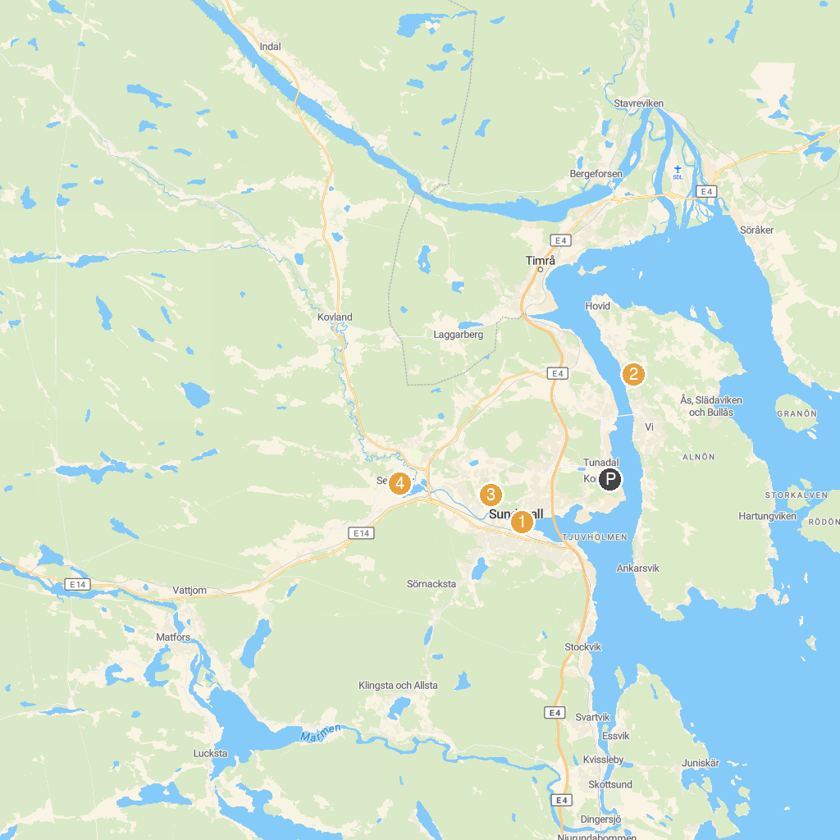
MAP KEY
1. Sundsvalls museum | 4. Bureplatsen
2. Alnö hembygdsförening | 5. Selånger pilgrimscenter
3. Nolby högar
P. Cruise port / terminal
Map © MapTiler © OpenStreetMap contributors · cruiseports.org

