Sulina, Tulcea County, Romania
The easternmost point of the EU, Sulina is reachable only by water — a faded 19th-century free port frozen in time at the exact spot where the Danube meets the Black Sea.
⚓ Docked (riverfront quay) · 🕒 Typical call: 6-8 hrs · 💵 Romanian Leu (RON); cash useful · 🗣️ Romanian; some English in tourism · 🦩 UNESCO Danube Delta Biosphere Reserve
✍️ MY DAY IN PORT (FILL IN)
Ship / Date
In port | arrive ______ · all aboard ______
Booked excursion
Notes / meeting point
GETTING ASHORE
- Docking: Ships dock alongside the Faleza Sulina riverfront quay — no tender required
- Walk to Center: Step off ship onto Strada I promenade; Old Lighthouse 10 min, Cemetery 25 min on foot
- Best For: Delta boat tours, birdwatching, offbeat history, wild beach
- Don't Miss: Cosmopolitan Cemetery — Orthodox, Jewish, Muslim, Protestant graves plus Europe's only pirate tombstone
GETTING AROUND
- 🚕 Taxi: 10–20 RON (~–4) per ride — Local taxis are available for short trips within town. Fares are low by Romanian standards; confirm the price or ask for
- 📱 Rideshare: ❌ not available
TOP THINGS TO DO
- Danube Delta Canal Boat Tour — The must-do: hire a local boat to weave through narrow Delta canals surrounded by white pelicans, great white egrets, herons, and…
- Cosmopolitan Cemetery Walk — Sulina's most haunting site: a 19th-century multi-faith cemetery with Orthodox, Catholic, Protestant, Jewish, and Muslim sections.
- Old Lighthouse Museum — Built in 1870, this decommissioned lighthouse charts the golden age of the European Commission of the Danube — the 19th-century…
- Sulina Wild Beach — Where the Danube meets the Black Sea, Sulina Beach is wide, uncrowded, and semi-wild — fine Danube silt sand, warm shallow water…
- Letea Forest Excursion — Europe's northernmost subtropical forest, home to ancient oaks draped in vines and famously wild horses roaming freely.
BEST WALKS
- Waterfront Promenade & Town Center: 1.5 km | 25-30 min | Easy | Flat — Stroll Strada I from the dock past the Palace of the European Commission of the Danube (built…
- Cemetery Walk: 2.5 km return | 45-60 min | Easy | Flat — Walk or take a short taxi to the Cosmopolitan Cemetery (Cimitirul Cosmopolit), Sulina's most…
WEATHER · DAYLIGHT · MONEY
Month | High °F | Low °F | Rainy days
May | 66 | 58 | 0
Jul | 81 | 70 | 0
Sep | 73 | 63 | 0
Daylight: May 5:32AM–8:24PM · Jul 5:28AM–8:45PM · Sep 6:40AM–7:12PM
cruiseports.org/sulina · Confirm terminal & all-aboard time with your ship

Sulina, Tulcea County, Romania — Port Map
Red = walkable sights · Amber = excursions farther out · P = cruise terminal
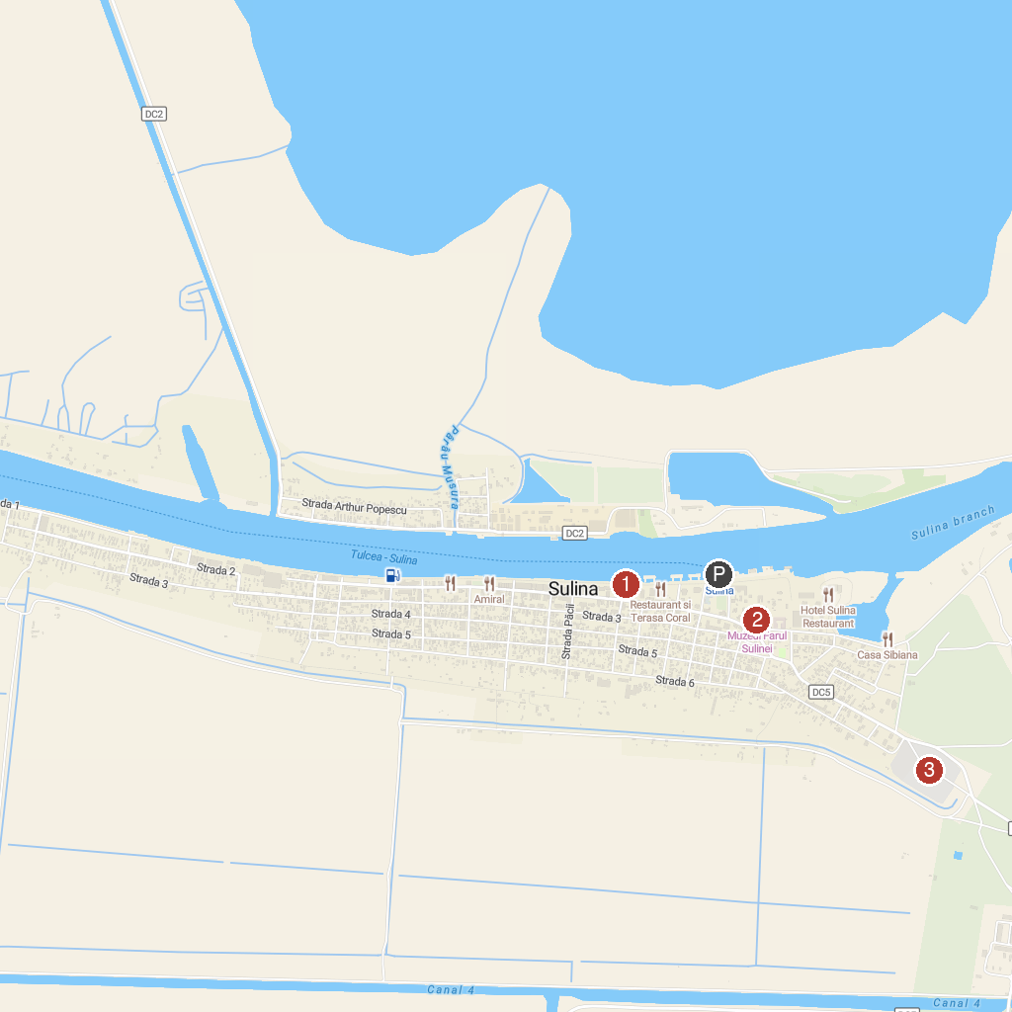
MAP KEY
1. Faleza | 3. The Cosmopolitan Cemetery
2. Farul Comisiei Europene a Dunării
P. Cruise port / terminal
Map © MapTiler © OpenStreetMap contributors · cruiseports.org

