Subic Bay Freeport, Central Luzon, Philippines
A former US Navy base reborn as a self-contained freeport zone, Subic Bay blends jungle survival trails, open-water marine parks, WWII shipwreck dives, and duty-free shopping — all in one of the safest, most organized port towns in the Philippines.
⚓ Pier port (Alava/Rivera Wharf) · 🕒 Typical call: 8–10 hrs · 💵 Philippine Peso (PHP); USD accepted at many venues · 🗣️ English widely spoken · 🌿 Former US naval base turned freeport
✍️ MY DAY IN PORT (FILL IN)
Ship / Date
In port | arrive ______ · all aboard ______
Booked excursion
Notes / meeting point
GETTING ASHORE
- Docking: Ships dock at Alava Wharf or Rivera Wharf — no tender required
- Walk to center: 10 min to Waterfront Road; 15 min to Harbor Point Mall
- Best For: Wildlife parks, jungle hikes, wreck diving, duty-free shopping
- Don't Miss: Zoobic Safari tiger Jeepney ride or Pamulaklakin Aeta forest trail
GETTING AROUND
- 🚕 Taxi: PHP 100–700 (~–12 USD) — Unmetered SUV taxis operate inside the Subic Bay Freeport Zone. Agree on fare before boarding; prices vary by distance w
- 📱 Rideshare: ✅ Grab
TOP THINGS TO DO
- Zoobic Safari Tiger Jeepney — Board a protected Jeepney and drive through a tiger enclosure while staff feed the big cats raw chicken through the grates.
- Pamulaklakin Aeta Forest Trail — Indigenous Aeta guides lead you through pristine rainforest, demonstrating fire-making, bamboo water traps, and jungle survival…
- Ocean Adventure Marine Park — Southeast Asia's first open-water marine park features dolphin and sea lion shows, aquarium exhibits, and a chance to swim with…
- Wreck Diving in Subic Bay — Subic Bay is home to some of the best wreck diving in Asia — WWII-era vessels including the USS New York and USS Lanikai rest in…
- Camayan Beach Resort — White sand, clear turquoise water, and a forested backdrop beside Ocean Adventure.
BEST WALKS
- Pier to Waterfront Boardwalk & Harbor Point: 2.5 km round-trip | ~45 min | Easy | Flat — Walk from Alava Wharf along the bay to the Waterfront Road restaurant strip, past the Spanish Gate…
- Boardwalk Sunset Stroll: 1 km | ~20 min | Easy | Waterfront — A relaxed evening walk along the bay boardwalk as the cruise ship lights up behind you.
WEATHER · DAYLIGHT · MONEY
Month | High °F | Low °F | Rainy days
May | 93 | 78 | 1
Jul | 87 | 77 | 7
Sep | 88 | 76 | 5
Daylight: May 5:31AM–6:19PM · Jul 5:37AM–6:32PM · Sep 5:47AM–6:00PM
cruiseports.org/subic-bay-freeport · Confirm terminal & all-aboard time with your ship

Subic Bay Freeport, Central Luzon, Philippines — Port Map
Red = walkable sights · Amber = excursions farther out · P = cruise terminal
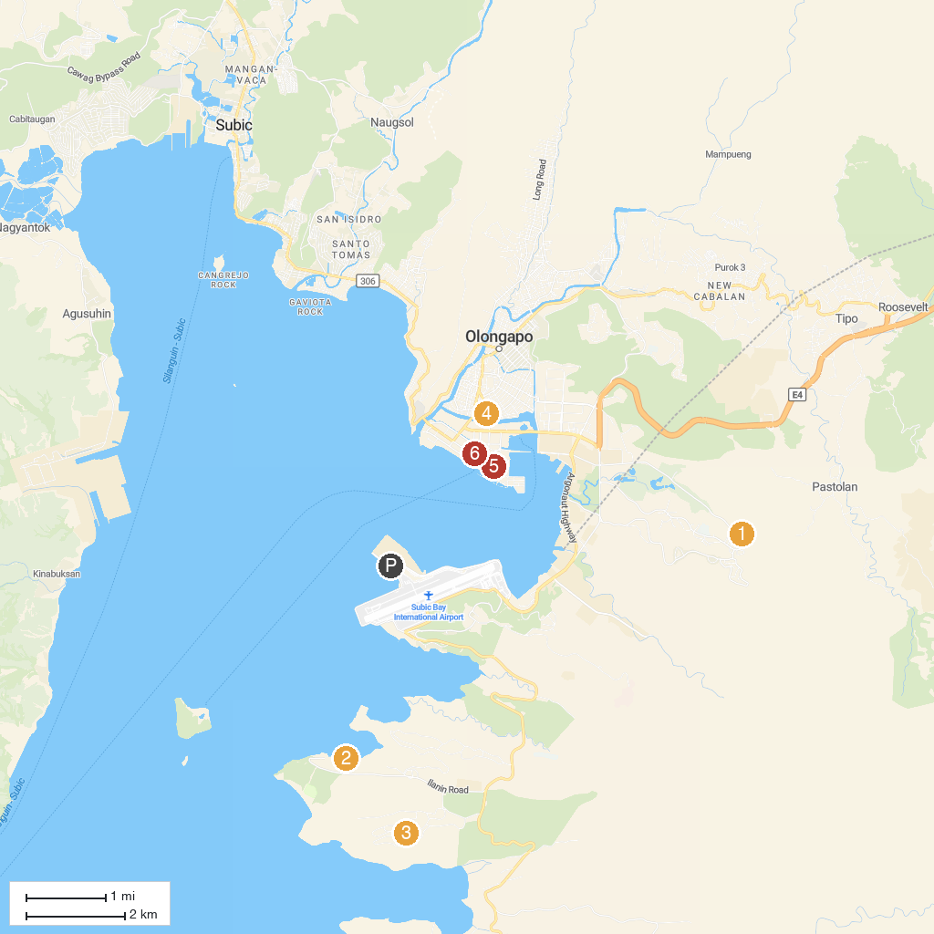
MAP KEY
1. Pamulaklakin Trail | 4. Diocesan Shrine and Parish of Saint Columban - Asinan, Olongapo City, Zambales (Diocese of Iba)
2. Adventure Beach Waterpark, Subic Bay | 5. Spanish Gate
3. Zoobic Safari | 6. San Roque Chapel
P. Cruise port / terminal
Map © MapTiler © OpenStreetMap contributors · cruiseports.org

