Sturgeon Bay, Wisconsin, USA
The Shipbuilding Capital of the Great Lakes drops you right into Door County's only city — where working 1,000-foot freighters share the canal with drawbridges, maritime museums, and cherry-pie shops.
⚓ Pier — Graham Park Dock · 🕒 Typical call: 6-8 hrs · 💵 USD · 🗣️ English · 🍒 Door County cherries
✍️ MY DAY IN PORT (FILL IN)
Ship / Date
In port | arrive ______ · all aboard ______
Booked excursion
Notes / meeting point
GETTING ASHORE
- Docking: Direct pier at Graham Park, central waterfront
- Walk to center: 5-10 min to Third Ave Historic District
- Best For: Maritime history, walkable downtown, Door County food
- Don't Miss: Jim Kress Maritime Lighthouse Tower views & a cherry pie
GETTING AROUND
- 🚕 Taxi: Varies (zone-based ~$4 within core) — Door County Cab and 1 Awesome Cab offer 24/7 local taxi service. Door 2 Door Rides uses a zone system with an ~$4 flat f
- 📱 Rideshare: ✅ Uber, Lyft
TOP THINGS TO DO
- Door County Maritime Museum & Kress Tower — This standout waterfront museum on the West Side (120 N Madison Ave) covers Great Lakes shipbuilding and shipwrecks with…
- Cave Point & Whitefish Dunes — The crown jewels of Door County — limestone cliffs where Lake Michigan crashes into underwater caves at Cave Point County Park…
- Door County Trolley Tour — A narrated tour that winds through the peninsula's scenic lighthouses, cherry orchards, bluff overlooks, and historic villages…
- Kayak the Sturgeon Bay Canal — Paddle alongside working Great Lakes freighters and under the historic drawbridges on a guided kayak tour of the canal — an…
- Door County Fish Boil — A regional culinary tradition: whitefish, potatoes, and onions boiled in a massive outdoor kettle, ending with a dramatic…
BEST WALKS
- Historic Downtown Loop: 2.5 miles | Flat | 60-75 min — From Graham Park, walk north along the waterfront to Third Avenue Historic District, then cross the…
- Waterfront to Sunset Park: 1.5 miles one way | Flat | 30 min — Head south from the dock along the East Side shoreline to Sunset Park, a peaceful spot with bay…
WEATHER · DAYLIGHT · MONEY
Month | High °F | Low °F | Rainy days
May | 63 | 46 | None
Jul | 78 | 61 | 1
Sep | 69 | 55 | None
Daylight: May 5:20AM–8:11PM · Jul 5:18AM–8:32PM · Sep 6:28AM–6:59PM
cruiseports.org/sturgeon-bay-wi · Confirm terminal & all-aboard time with your ship

Sturgeon Bay, Wisconsin, USA — Port Map
Red = walkable sights · Amber = excursions farther out · P = cruise terminal
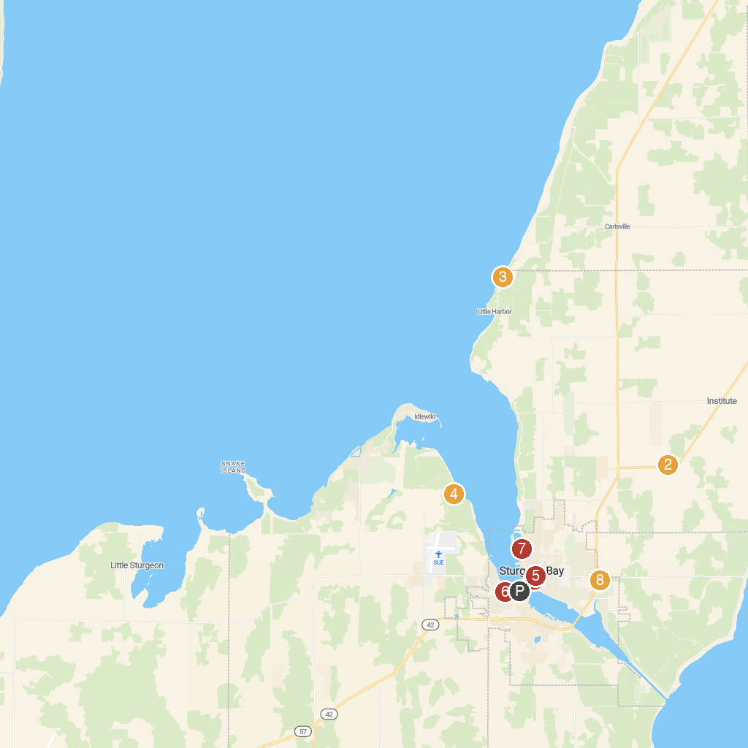
MAP KEY
1. Destination Sturgeon Bay | 5. Door County Museum and Archives
2. The Farm | 6. Otumba Park
3. Bayshore Blufflands State Natural Area | 7. Sunset Park & Beach
4. Potawatomi State Park | 8. Crossroads At Big Creek
P. Cruise port / terminal
Map © MapTiler © OpenStreetMap contributors · cruiseports.org

