Stromness, Orkney, Scotland
A labyrinth of flagstone lanes and stone piers jutting into Hamnavoe harbour — Stromness puts Orkney's Neolithic wonders, wartime history, and wild Norse landscapes within arm's reach of the pier.
⚓ Pier (direct) or tender — ship-size dependent · 🕒 Typical call: 6–9 hrs · 💷 Currency: British Pound (GBP) · 🗣️ Language: English
✍️ MY DAY IN PORT (FILL IN)
Ship / Date
In port | arrive ______ · all aboard ______
Booked excursion
Notes / meeting point
GETTING ASHORE
- Docking: Small/expedition ships dock at Stromness Ferry Terminal; larger ships may tender or dock at Hatston Pier, Kirkwall (15 mi away)
- Walk to center: 1–2 min from pier to main street
- Best For: Neolithic sites, WWII maritime history, independent galleries, dramatic scenery
- Don't Miss: Ring of Brodgar, Pier Arts Centre (free), Stromness Museum
GETTING AROUND
- 🚕 Taxi: £4 first mile, ~£1.80/mile after — Local firms (Orkney Taxis, Ronnie's Taxis) serve the islands. Kirkwall is ~15 miles away, expect £30–£45 each way — pre-
- 📱 Rideshare: ❌ not available
TOP THINGS TO DO
- Ring of Brodgar & Standing Stones of Stenness — Two UNESCO-listed stone circles dating back 4,000–5,000 years, just 10 minutes by bus or taxi from Stromness.
- Skara Brae Neolithic Village — A 5,000-year-old stone village preserved beneath coastal sand dunes — older than Stonehenge and the Egyptian pyramids.
- Scapa Flow & Italian Chapel — Scapa Flow was the Royal Navy's main anchorage in both World Wars and the site where the German High Seas Fleet was scuttled in…
- Pier Arts Centre — A world-class modern and contemporary art gallery in a restored waterfront building right in Stromness.
- Cycle to the Standing Stones — Rent a bike from Cycle Orkney in Stromness and pedal the 8-mile route to the Ring of Brodgar along relatively flat roads through…
BEST WALKS
- The Main Street End to End: 1 mile | Easy | 30–40 min one way — Walk the full length of Stromness's remarkable main street — Victoria Street, Dundas Street, and…
- Warebeth Beach Walk: 1.5 miles one way | Easy | ~30 min — Head south from town past the golf course to Warebeth Beach — a wild, sandy stretch with dramatic…
WEATHER · DAYLIGHT · MONEY
Month | High °F | Low °F | Rainy days
May | 54 | 43 | 1
Jul | 61 | 51 | 1
Sep | 59 | 50 | 1
Daylight: May 4:42AM–9:37PM · Jul 4:26AM–10:10PM · Sep 6:42AM–7:32PM
cruiseports.org/stromness · Confirm terminal & all-aboard time with your ship

Stromness, Orkney, Scotland — Port Map
Red = walkable sights · Amber = excursions farther out · P = cruise terminal
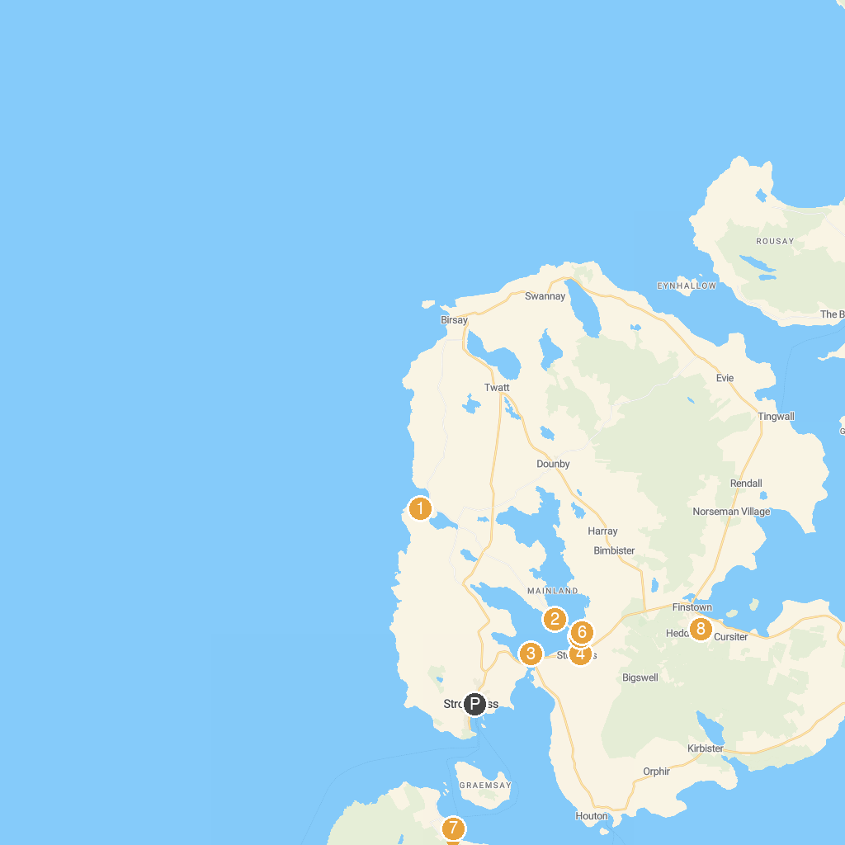
MAP KEY
1. Skara Brae Prehistoric Village | 5. Standing Stones of Stenness
2. Ring of Brodgar | 6. Barnhouse Settlement
3. Unstan Chambered Cairn | 7. OLD WORLD ORDER MEGALITHIC THE DWARFIE STANE, HOY, ORKNEY ISLANDS, UNITED KINGDOM OF GREAT BRITAIN
4. Maeshowe Visitor Centre | 8. Cuween Hill Chambered Cairn
P. Cruise port / terminal
Map © MapTiler © OpenStreetMap contributors · cruiseports.org

