Stromboli Island, Aeolian Islands, Italy
The Lighthouse of the Mediterranean — Stromboli has been erupting continuously for 2,000 years. Black sand beaches, whitewashed lanes, and a glowing summit make this one of the most dramatic ports in the world.
⚓ Tender (no pier) · 🕒 Typical call: 5–8 hrs · 💶 Currency: Euro (€) · 🗣️ Language: Italian · 🌋 Active volcano island
✍️ MY DAY IN PORT (FILL IN)
Ship / Date
In port | arrive ______ · all aboard ______
Booked excursion
Notes / meeting point
GETTING ASHORE
- Docking: Tender only — ships anchor offshore, tenders to Porto di Scari
- Walk to town: 10–15 min uphill from tender pier to Piazza San Vincenzo
- Best For: Volcano hiking, black-sand beaches, dramatic scenery
- Don't Miss: Sciara del Fuoco viewpoint and Spiaggia di Ficogrande
GETTING AROUND
- 🚕 Taxi: €5–€15 per ride — Small electric taxis (golf carts) meet arrivals at the pier and can shuttle you to beaches or the far end of the village
- 📱 Rideshare: ❌ not available
TOP THINGS TO DO
- Guided Volcano Hike — Authorized volcanologist guides lead small groups up to the 400 m viewing platform (above 290 m requires a guide by law).
- Sciara del Fuoco Sunset Boat Tour — Board a local boat and sail around to the northwest coast to watch lava and volcanic debris cascade down the Sciara del Fuoco…
- Strombolicchio Boat Tour — A short boat trip to Strombolicchio, the sheer basalt sea stack that was Stromboli's original volcanic vent.
- Free Crater Walk to 290 m — You can hike independently up to 290 m on the volcano's southern flank without a guide.
- Black Sand Beaches — Stromboli's beaches are jet-black volcanic sand and pebbles with brilliant turquoise water.
BEST WALKS
- Pier to Piazza San Vincenzo: 1.2 km · 15 min · Easy–Moderate uphill — From the tender landing at Porto di Scari, walk uphill along Via Marina and Via Roma to Piazza San…
- Town to Ficogrande Beach: 1 km · 15 min · Flat — From Piazza San Vincenzo, follow Via Vittorio Emanuele north to the wide black-sand beach at…
- Observatory Trail (Sciara del Fuoco viewpoint): 2.5 km · 40–50 min · Moderate — A scenic path leads from the town center up toward the old observatory (now a restaurant…
WEATHER · DAYLIGHT · MONEY
Month | High °F | Low °F | Rainy days
May | 68 | 64 | 1
Jul | 82 | 79 | 0
Sep | 78 | 75 | 0
Daylight: May 5:46AM–8:04PM · Jul 5:46AM–8:23PM · Sep 6:40AM–7:06PM
cruiseports.org/stromboli-island · Confirm terminal & all-aboard time with your ship

Stromboli Island, Aeolian Islands, Italy — Port Map
Red = walkable sights · Amber = excursions farther out · P = cruise terminal
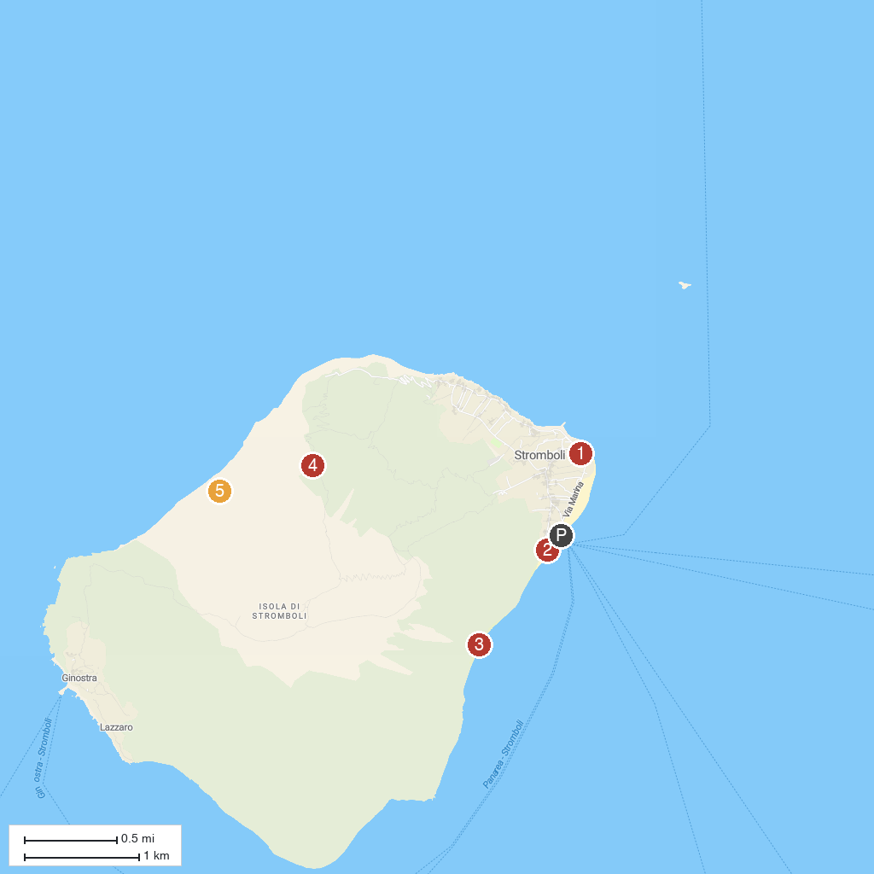
MAP KEY
1. Ciminiera | 4. Viewpoint at 400m
2. Spiaggia di Sabbia Nera | 5. Sciara del Fuoco
3. Forgia Vecchia
P. Cruise port / terminal
Map © MapTiler © OpenStreetMap contributors · cruiseports.org

