Straubing, Bavaria, Germany
A perfectly preserved medieval Bavarian city on the Danube — dock steps from the old town, explore Roman treasures, Gothic churches, and one of Germany's greatest folk festivals.
⚓ Docked (pier) · 🕒 Typical call: 6–8 hrs · 💶 Euro (€) · 🗣️ German (English widely spoken) · 🍺 Bavarian culture
✍️ MY DAY IN PORT (FILL IN)
Ship / Date
In port | arrive ______ · all aboard ______
Booked excursion
Notes / meeting point
GETTING ASHORE
- Docking: Pier on the Danube, right bank — ships dock very close to the city center
- Walk to center: 5–10 min on foot to Stadtplatz from the dock
- Best For: Medieval history, Roman artifacts, Bavarian food and beer, architecture
- Don't Miss: The Roman Parade Armor at Gäubodenmuseum — the largest known collection in the world
GETTING AROUND
- 🚕 Taxi: €5–€12 — Licensed taxis are available near the port and town center. The regulated daytime base fare is €4.60 (€5.90 nights) plus
TOP THINGS TO DO
- Gäubodenmuseum & Roman Treasure — The Gäubodenmuseum houses the famous Straubing Roman Treasure — the largest known collection of Roman cavalry parade armor…
- Medieval Old Town Walking Tour — Explore the elongated Stadtplatz, climb the 14th-century Stadtturm for panoramic views, admire the Gothic Basilika St.
- Bavarian Beer & Food Experience — Sample beers from the Karmeliten Brewery, one of the oldest monastic breweries in Bavaria.
- Bavarian Forest & Regensburg Day Trip — Straubing sits at the edge of the Bavarian Forest National Park.
- NAWAREUM Sustainability Museum — Opened in 2023, Germany's first museum dedicated entirely to sustainability explores future technologies and environmental…
BEST WALKS
- The Golden Way: Historic Center Loop: 2–3 hrs | Easy | ~3 km — Follow the brass plates of 'Der Goldene Weg' from the riverfront through the Stadtplatz, past the…
- Danube Riverfront Stroll: 45 min | Easy | ~2 km — A relaxed walk along the Danube embankment from the cruise dock past the Herzogsschloss grounds…
WEATHER · DAYLIGHT · MONEY
Month | High °F | Low °F | Rainy days
May | 67 | 46 | 1
Jul | 79 | 55 | 1
Sep | 70 | 48 | 1
Daylight: May 5:28AM–8:44PM · Jul 5:22AM–9:08PM · Sep 6:46AM–7:22PM
cruiseports.org/straubing · Confirm terminal & all-aboard time with your ship

Straubing, Bavaria, Germany — Port Map
Red = walkable sights · Amber = excursions farther out · P = cruise terminal
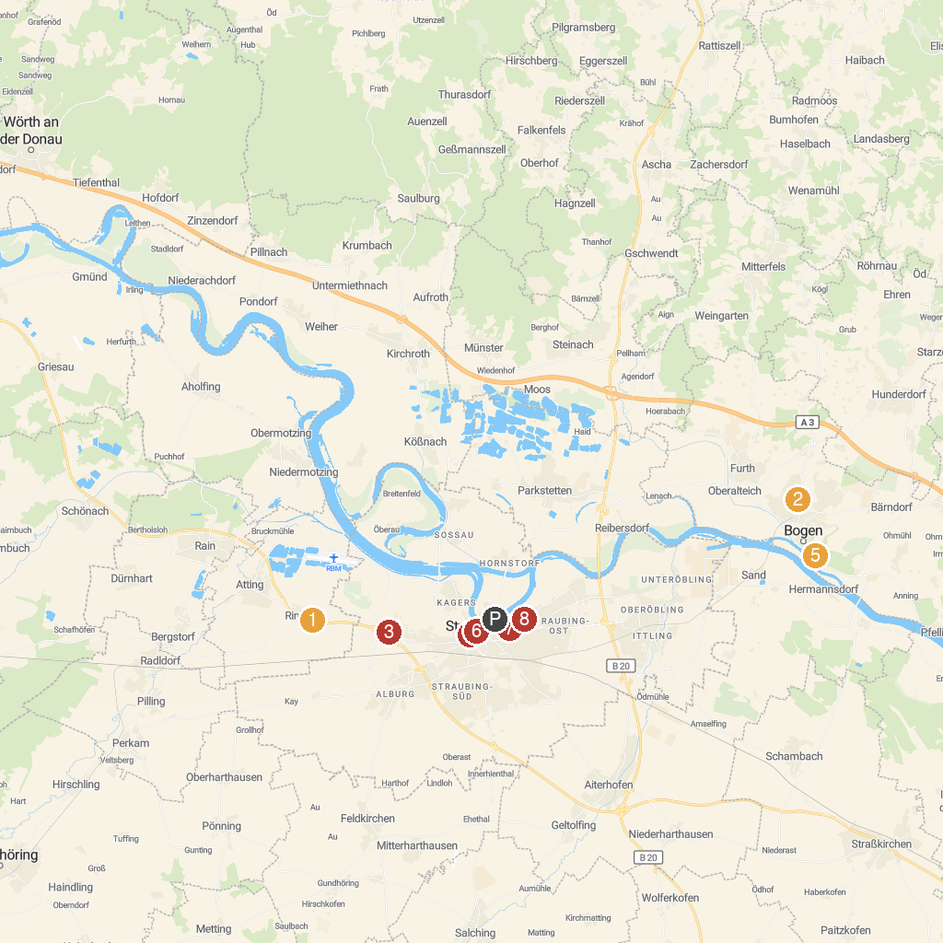
MAP KEY
1. Irrgarten Straubing - im Sommer 2025 | 5. Pfarr- und Wallfahrtskirche Heilig Kreuz
2. Europapark Bayern-Böhmen | 6. Gäubodenmuseum
3. Straubing Zoo | 7. NAWAREUM
4. Basilica of St. Jacob | 8. Church of St. Peter
P. Cruise port / terminal
Map © MapTiler © OpenStreetMap contributors · cruiseports.org

