Stranraer-Cairnryan, Dumfries & Galloway, Scotland
At the sheltered head of Loch Ryan, Stranraer is southwest Scotland's quiet gem — famous for wild native oysters, Gulf Stream gardens that grow palms, and the rugged Rhins of Galloway peninsula stretching toward Ireland.
⚓ Tender (Loch Ryan anchorage) · 🕒 Typical call: 7-9 hrs · 💷 GBP (Scottish banknotes accepted everywhere) · 🗣️ English · 🌿 Gardens & coastal walks
✍️ MY DAY IN PORT (FILL IN)
Ship / Date
In port | arrive ______ · all aboard ______
Booked excursion
Notes / meeting point
GETTING ASHORE
- Docking: Tender to Stranraer Marina; small expedition ships occasionally dock at West Pier
- Walk to centre: 5–10 min flat walk from tender landing to Castle of St. John and town centre
- Best For: Botanic gardens, coastal scenery, fresh oysters, off-the-beaten-track Scotland
- Don't Miss: Loch Ryan native oysters, Logan Botanic Garden, Portpatrick harbour village
GETTING AROUND
- 🚕 Taxi: £15–£23 — Local taxis (McLean's Taxis, OTS Ltd.) run 24/7 between Cairnryan terminals and Stranraer town centre. Pre-booking with
TOP THINGS TO DO
- Logan Botanic Garden — Scotland's most exotic garden flourishes 14 miles south thanks to the Gulf Stream — tree ferns, palm trees, giant gunnera, and…
- Mull of Galloway Lighthouse — Perched on Scotland's most southerly point, this lighthouse offers views stretching to Ireland, the Isle of Man, and the Lake…
- Portpatrick Harbour Village — A postcard-perfect harbour village 8 miles west — pastel-fronted houses, crabbing boats, and the clifftop ruins of Dunskey Castle…
- Castle of St. John, Stranraer — A compact 16th-century tower house in Stranraer's centre that served as a noble home, military garrison, and Victorian prison.
- Castle Kennedy Gardens — Spectacular 17th-century estate gardens set on a narrow isthmus between two lochs, with champion trees, a lily pond, and the…
BEST WALKS
- Marina to Castle of St. John & Town Centre: 0.5 km · 10 min · Flat · Easy — From Stranraer Marina, walk inland to the Castle of St.
- Waterfront Agnew Park Walk: 1.5 km · 20 min · Flat · Easy — Head west along the Loch Ryan shoreline from the marina to Agnew Park, a well-kept waterfront park…
WEATHER · DAYLIGHT · MONEY
Month | High °F | Low °F | Rainy days
May | 58 | 44 | 0
Jul | 65 | 52 | 1
Sep | 62 | 49 | 2
Daylight: May 5:13AM–9:21PM · Jul 5:02AM–9:48PM · Sep 6:53AM–7:36PM
cruiseports.org/stranraer-cairnryan · Confirm terminal & all-aboard time with your ship

Stranraer-Cairnryan, Dumfries & Galloway, Scotland — Port Map
Red = walkable sights · Amber = excursions farther out · P = cruise terminal
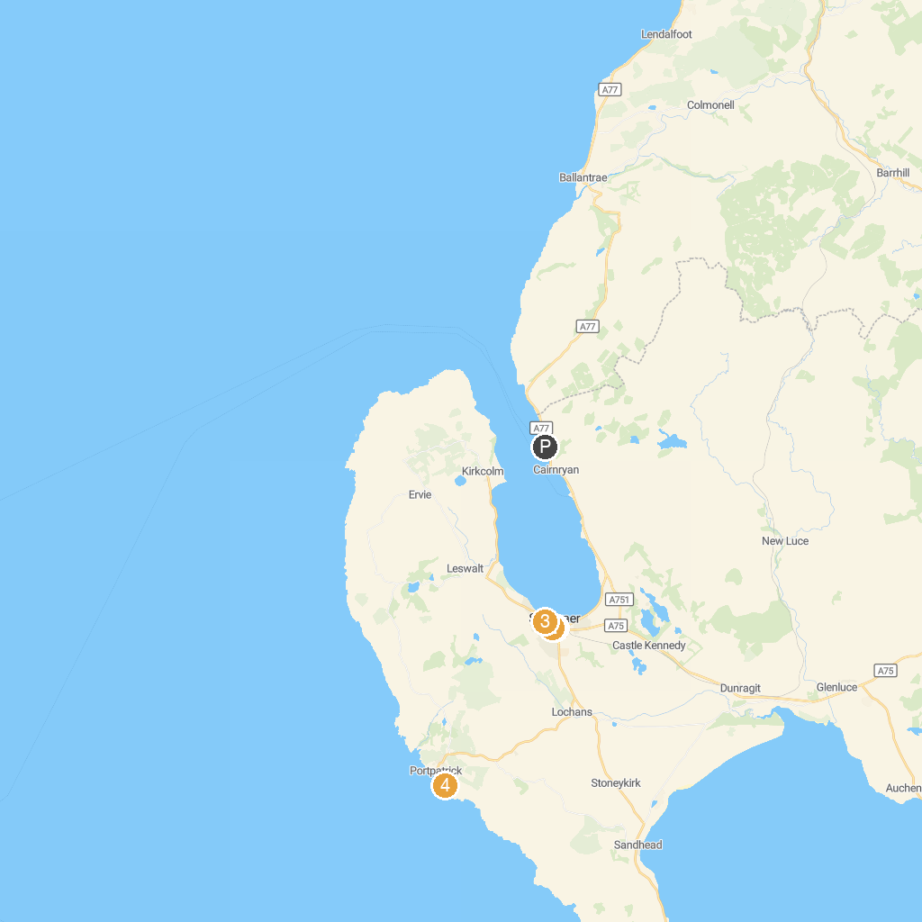
MAP KEY
1. Castle of St. John | 4. Agnew Park
2. Kirkmadrine Chapel | 5. Dunskey Castle
3. Stranraer Museum | 6. Glenluce Abbey
P. Cruise port / terminal
Map © MapTiler © OpenStreetMap contributors · cruiseports.org

