Stornoway, Isle of Lewis, Scotland
The gateway to the Outer Hebrides, where 5,000-year-old standing stones rise from the peat moor and hand-loomed Harris Tweed fills the shops. Gaelic voices, world-class beaches, and one of Britain's most distinctive island cultures await.
⚓ Pier (Deep Water Terminal) or tender · 🕒 Typical call: 7-10 hrs · 💷 GBP — cards widely accepted · 🗣️ English & Scottish Gaelic · 🌧️ Bring waterproofs — weather changes fast
✍️ MY DAY IN PORT (FILL IN)
Ship / Date
In port | arrive ______ · all aboard ______
Booked excursion
Notes / meeting point
GETTING ASHORE
- Docking: Larger ships: Deep Water Terminal at Arnish (shuttle to town). Small ships: inner harbour quay (walkable). Some anchor & tender to Cromwell Street Quay.
- Walk to center: 0 min from inner harbour; ~20 min shuttle from Deep Water Terminal (buses provided by cruise line)
- Best For: Ancient history, Hebridean scenery, Harris Tweed shopping, beach walks
- Don't Miss: Callanish Standing Stones — older than Stonehenge, 30 min drive; free to enter
GETTING AROUND
- 🚕 Taxi: £9–11 to town center; £20–25 to Callanish Stones — Several local taxi firms operate in Stornoway (Quick Cabs, Stornoway Cabs, Central Cabs). Official 2025 metered fares st
- 📱 Rideshare: ❌ not available
TOP THINGS TO DO
- Callanish Standing Stones (Calanais) — A cross-shaped Neolithic stone circle with a 4.8-metre central megalith — predating Stonehenge by centuries.
- Gearrannan Blackhouse Village — A coastal hamlet of restored thatched-stone blackhouses — the traditional dwelling of Hebridean crofters — inhabited until 1974.
- Dun Carloway Broch — One of Scotland's best-preserved Iron Age drystone roundhouses, over 2,000 years old, with walls still standing to height.
- Tolsta & Garry Beach — Golden sand beaches on Lewis's northeast coast — Garry Beach has dramatic sea stacks rising from the water, and both offer…
- Museum nan Eilean & Lews Castle — Inside the restored Victorian castle overlooking the harbour, this free museum displays six of the original Lewis Chessmen…
BEST WALKS
- Town Centre to Lews Castle Grounds: 2 miles round trip | Easy | 45-60 min — Walk from Cromwell Street along the harbour front, cross the bridge over the River Creed, and enter…
- Stornoway Harbour & An Lanntair: 0.5 miles | Easy | 20 min — A short harbour-front stroll from the pier to An Lanntair arts centre, taking in views across the…
WEATHER · DAYLIGHT · MONEY
Month | High °F | Low °F | Rainy days
May | 55 | 44 | 1
Jul | 62 | 52 | 1
Sep | 59 | 50 | 1
Daylight: May 4:59AM–9:45PM · Jul 4:45AM–10:16PM · Sep 6:55AM–7:44PM
cruiseports.org/stornoway · Confirm terminal & all-aboard time with your ship

Stornoway, Isle of Lewis, Scotland — Port Map
Red = walkable sights · Amber = excursions farther out · P = cruise terminal
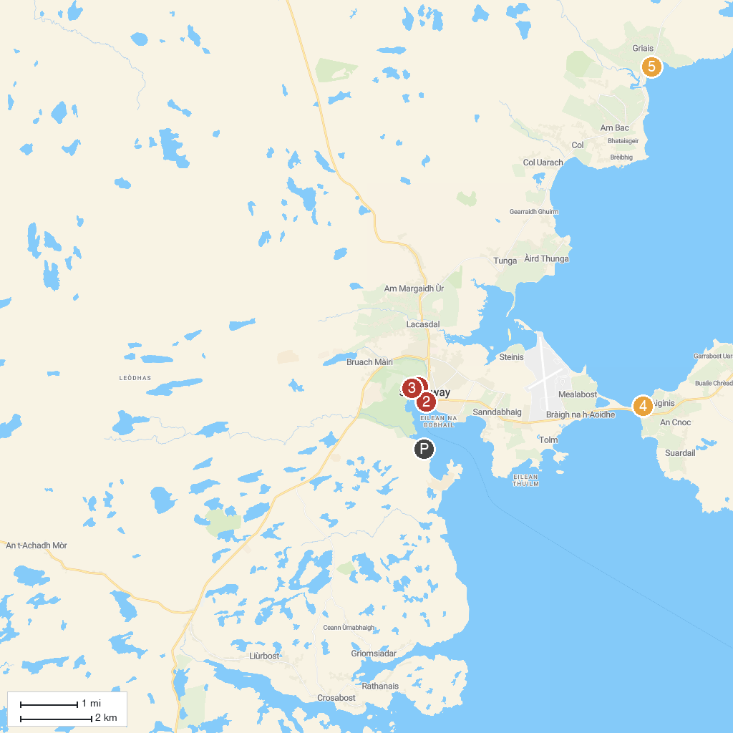
MAP KEY
1. Woodlands Centre | 4. St Columba's Church (Eaglais na h-Aoidhe)
2. An Lanntair | 5. Gress Beach
3. Lews Castle Grounds
P. Cruise port / terminal
Map © MapTiler © OpenStreetMap contributors · cruiseports.org

