Stolzenau, Lower Saxony, Germany
A quiet Weser market town where a twisted church spire rises above half-timbered lanes — perfect for a leisurely bike ride through the Lower Saxon countryside.
⚓ Docked (river pier) · 🕒 Typical call: 5–8 hrs · 💶 Euro (cash preferred) · 🗣️ German
✍️ MY DAY IN PORT (FILL IN)
Ship / Date
In port | arrive ______ · all aboard ______
Booked excursion
Notes / meeting point
GETTING ASHORE
- Docking: River pier (Schiffsanleger) on the Weser — no tender
- Walk to center: 5–10 min to Marktplatz (~400 m flat)
- Best For: Cycling, church architecture, white asparagus season
- Don't Miss: The crooked spire of St.-Jacobi-Kirche
GETTING AROUND
- 🚕 Taxi: €5–€15 — Local taxis serve the Stolzenau area. The town center is very close to the port; longer trips to nearby Nienburg (22 km)
TOP THINGS TO DO
- St.-Jacobi-Kirche & the Crooked Spire — Stolzenau's signature sight: a deliberately twisted spire helmet, coiled by carpenters when the tower was built in 1679 (local…
- Weser-Radweg Cycling — Cycle a stretch of Germany's famous Weser Cycle Path — flat, paved, and scenic.
- Altstadt Half-Timbered Walk — Wander Hohe Straße and the backstreets of the old town, where Fachwerk (half-timbered) houses dating to the 16th–17th centuries…
- Burg Stolzenau Site & Weser Promenade Stroll — The medieval Weser border castle (built 1346, destroyed in the Thirty Years' War in 1627) survives only as an archaeological site…
- Asparagus Season (mid-Apr to Jun 24) — The Middle Weser region is celebrated for its white Spargel.
BEST WALKS
- Pier to Marktplatz & Crooked Spire Loop: 1.5 km · 30–45 min · Flat · Free — From the river pier, walk along the promenade to the town center.
- Burg Site & Riverside Promenade: 2 km · 40–55 min · Flat · Free — From the pier, follow the promenade past the town center toward the old Burg Stolzenau site near…
WEATHER · DAYLIGHT · MONEY
Month | High °F | Low °F | Rainy days
May | 66 | 45 | 1
Jul | 76 | 56 | 1
Sep | 70 | 50 | 1
Daylight: May 5:27AM–9:13PM · Jul 5:19AM–9:39PM · Sep 6:58AM–7:38PM
cruiseports.org/stolzenau-weser · Confirm terminal & all-aboard time with your ship

Stolzenau, Lower Saxony, Germany — Port Map
Red = walkable sights · Amber = excursions farther out · P = cruise terminal
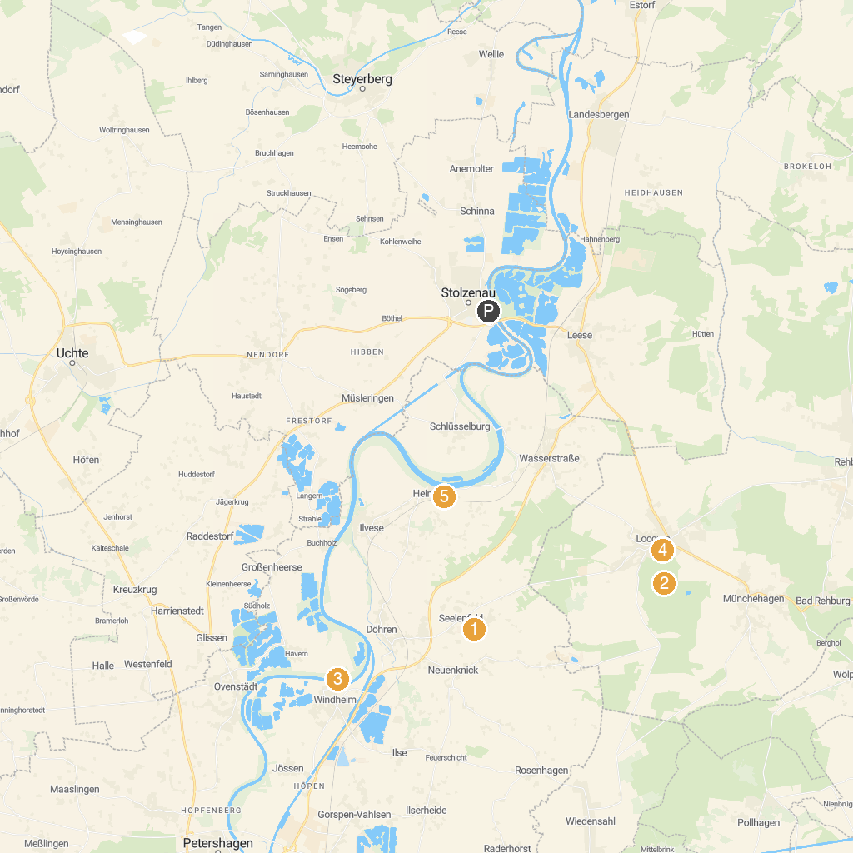
MAP KEY
1. Königsmühle Seelenfeld | 5. Loccum Abbey
2. Luccaburg | 6. Wilhelmsturm
3. Weseraue | 7. LWL-Museum Glashütte Gernheim
4. Windheimer Marsch | 8. Heimat- und Heringsfängermuseum Heimsen e. V.
P. Cruise port / terminal
Map © MapTiler © OpenStreetMap contributors · cruiseports.org

