Stockton, California, USA
A working river port at the heart of the California Delta, Stockton surprises with a walkable waterfront promenade, a beautifully restored 1930s Fox Theatre, and one of the most diverse food scenes in the Central Valley.
⚓ Docked (Downtown Marina) · 🕒 Typical call: 6–8 hrs · 💵 USD · 🗣️ English (Spanish widely spoken) · 🌡️ Hot summers, tule fog in winter
✍️ MY DAY IN PORT (FILL IN)
Ship / Date
In port | arrive ______ · all aboard ______
Booked excursion
Notes / meeting point
GETTING ASHORE
- Docking: Docked at Downtown Stockton Marina, Stockton Channel
- Walk to center: 0–5 min to waterfront; downtown is walkable
- Best For: Delta scenery, history, multicultural dining, baseball
- Don't Miss: Haggin Museum, Bob Hope Fox Theatre, Weber Point Park
GETTING AROUND
- 🚕 Taxi: $10–18 — Taxis are available at the port for the short 2–3 mile ride to downtown Stockton. The trip typically takes 5–10 minutes
- 📱 Rideshare: ✅ Uber, Lyft
TOP THINGS TO DO
- California Delta River Tour — Explore the largest estuary on the US West Coast — a maze of waterways dotted with houseboats, historic drawbridges, and abundant…
- Haggin Museum — One of California's finest regional museums, with 19th-century European paintings (including a Renoir), Albert Bierstadt Yosemite…
- Bob Hope Fox Theatre — A lavishly restored 1930s movie palace in the heart of downtown, hosting concerts, classic films, and live performances.
- Downtown Multicultural Food Tour — Stockton's historic diversity — Filipino, Cambodian, Mexican, Sikh, Portuguese — translates into over 50 ethnic eateries within…
- Lodi Wine Country Day Trip — Just 15 miles north, Lodi is a world-class wine region famous for old-vine Zinfandels.
BEST WALKS
- Waterfront Promenade Walk: 1.5 miles · flat · 30 min — Follow the Joan Darrah Promenade along the Stockton Channel from the marina past Weber Point Park…
- Downtown Historic Core: 1 mile loop · flat · 20–30 min — Stroll from the marina into the downtown grid to see the Bob Hope Fox Theatre, the Adventist Health…
WEATHER · DAYLIGHT · MONEY
Month | High °F | Low °F | Rainy days
May | 81 | 54 | 2
Jul | 95 | 62 | 0
Sep | 89 | 60 | 1
Daylight: May 5:54AM–8:08PM · Jul 5:55AM–8:26PM · Sep 6:47AM–7:12PM
cruiseports.org/stockton-ca · Confirm terminal & all-aboard time with your ship

Stockton, California, USA — Port Map
Red = walkable sights · Amber = excursions farther out · P = cruise terminal
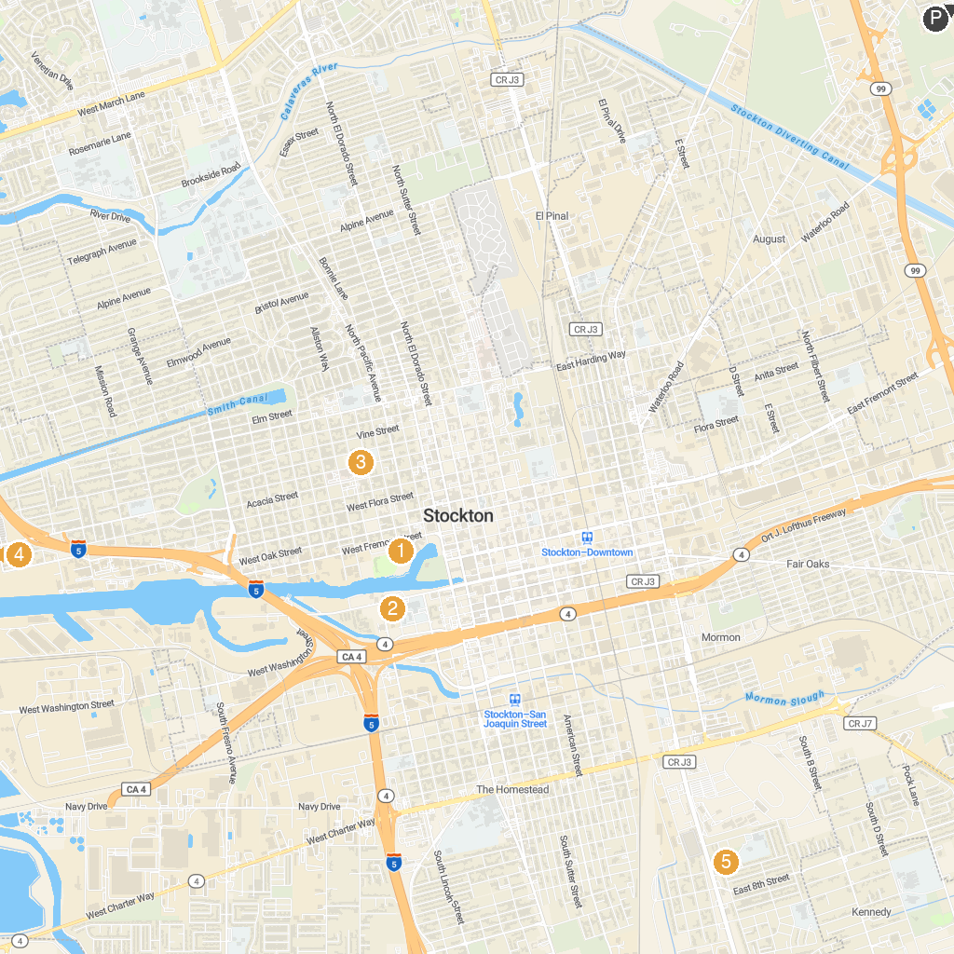
MAP KEY
1. Micke Grove Zoo | 5. Cathedral of the Annunciation- Stockton
2. Adventist Health Arena | 6. Shumway Oak Grove Regional Park
3. San Joaquin County Historical Museum | 7. Louis Park
4. Children's Museum of Stockton | 8. Williams Brotherhood Park
P. Cruise port / terminal
Map © MapTiler © OpenStreetMap contributors · cruiseports.org

