Stockholm, Stockholm County, Sweden
Built across 14 islands where Lake Mälaren meets the Baltic, Stockholm rewards cruise passengers with a walkable medieval old town, world-class museums, and one of the most dramatic harbor sail-ins in Europe.
⚓ Docked — Stadsgården or Frihamnen · 🕒 Typical call: 8–12 hrs (often overnight) · 💳 Cashless city — card/Apple Pay only · 🗣️ Swedish (English universally spoken) · 🏝️ Archipelago sail-in: arrive on deck
✍️ MY DAY IN PORT (FILL IN)
Ship / Date
In port | arrive ______ · all aboard ______
Booked excursion
Notes / meeting point
GETTING ASHORE
- Docking: Stadsgården (central, 1.5 km to Gamla Stan) or Frihamnen (4.5 km northeast)
- Walk to center: 20 min from Stadsgården; taxi/bus required from Frihamnen
- Best for: History, design, museums, waterfront dining, archipelago day trips
- Don't miss: Arriving on deck — the 4-hour Stockholm Archipelago sail-in is spectacular
GETTING AROUND
- 🚕 Taxi: 150–200 SEK (~–19 USD) — Taxis wait outside all major cruise terminals. Frihamnen and Värtahamnen are 3–5 km from the city center; Stadsgården is
- 📱 Rideshare: ✅ Uber, Bolt
- 🚌 Hop-on hop-off: ✅
TOP THINGS TO DO
- Gamla Stan & Royal Palace — Wander Stockholm's preserved 13th-century Old Town — ochre facades, Stortorget square, Mårten Trotzigs Gränd (the 90 cm-wide…
- Vasa Museum — The most-visited museum in Scandinavia: a 64-meter warship that sank on its maiden voyage in 1628 and was raised almost perfectly…
- ABBA The Museum — Wildly fun interactive tribute to Sweden's most famous export.
- Drottningholm Palace by Steamship — The Swedish royal family's private residence, a UNESCO World Heritage site often called the Versailles of Sweden.
- Archipelago RIB Speedboat Tour — Blast out of Stockholm's harbor on a rigid inflatable boat (RIB) into the 24,000-island Stockholm Archipelago.
BEST WALKS
- Stadsgården to Gamla Stan: 1.5 km · 20 min · Flat waterfront path — Follow the painted blue/yellow line from the Stadsgården terminal along the water.
- Gamla Stan to Djurgården Museums: 2 km ferry + walk · 30–40 min · Easy — From Slussen, catch the Djurgårdsfärjan public ferry (tap contactless) across to Djurgården island.
WEATHER · DAYLIGHT · MONEY
Month | High °F | Low °F | Rainy days
May | 59 | 42 | 10
Jul | 71 | 56 | 11
Sep | 62 | 50 | 8
Daylight: May 4:14AM–9:14PM · Jul 3:58AM–9:48PM · Sep 6:16AM–7:07PM
cruiseports.org/stockholm · Confirm terminal & all-aboard time with your ship

Stockholm, Stockholm County, Sweden — Port Map
Red = walkable sights · Amber = excursions farther out · P = cruise terminal
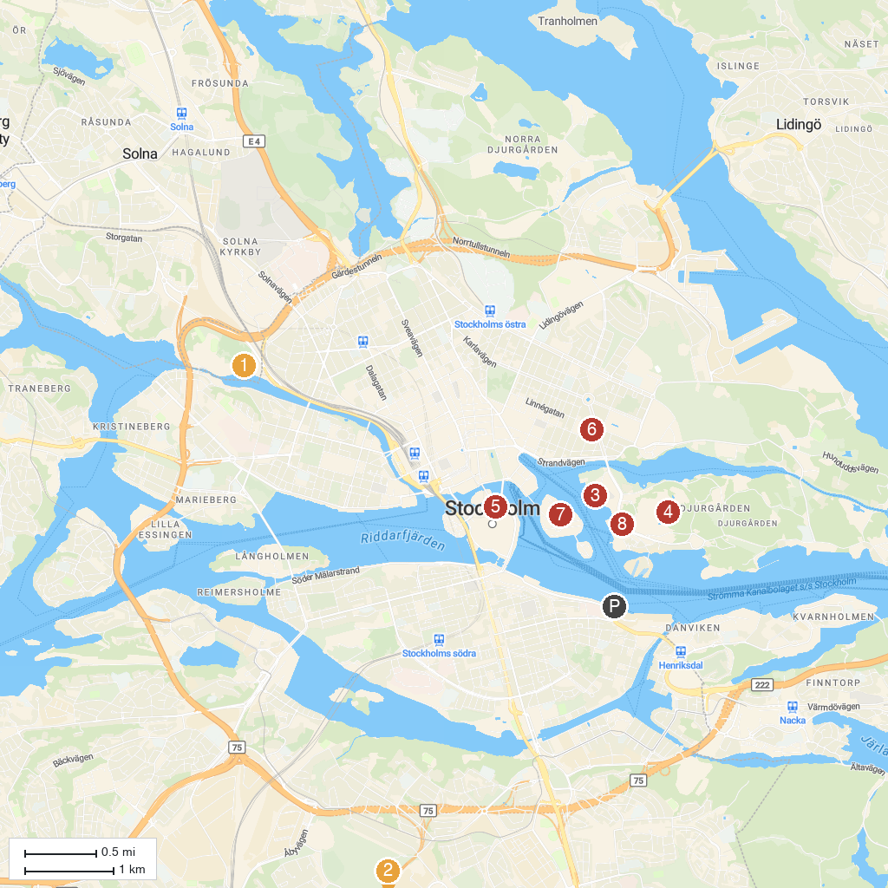
MAP KEY
1. Karlberg Palace | 5. The Royal Palace
2. Högdalstoppen | 6. Swedish History Museum
3. Vasa Museum | 7. Moderna Museet
4. Skansen | 8. ABBA The Museum
P. Cruise port / terminal
Map © MapTiler © OpenStreetMap contributors · cruiseports.org

