Stintino, Sardinia, Italy
One of Europe's most dazzling beaches hides at the tip of Sardinia — and only small luxury ships get close enough to anchor. Stintino rewards with crystal Caribbean-like waters, albino donkeys on a wild island, and honest Sardinian seafood.
⚓ Tender port · 🕒 Typical call: 6-8 hrs · 💶 Euro (EUR) · 🗣️ Italian / Sardinian
✍️ MY DAY IN PORT (FILL IN)
Ship / Date
In port | arrive ______ · all aboard ______
Booked excursion
Notes / meeting point
GETTING ASHORE
- Docking: Tender — ships anchor offshore; boats land at Porto Vecchio or Marina di Stintino
- Walk to center: 2–5 min from tender dock to Stintino village
- Best For: La Pelosa beach, Asinara Island excursions, seafood lunches
- Don't Miss: Booking your La Pelosa beach entry ticket online before sailing
GETTING AROUND
- 🚕 Taxi: €6–10 — Taxis are available at the marina. Short rides within town or to La Pelosa beach (~3.5 km) cost roughly €6–9; pre-agree
TOP THINGS TO DO
- La Pelosa Beach — Consistently ranked among Europe's top five beaches, La Pelosa dazzles with powder-white sand and water so clear it looks tropical.
- Asinara National Park — Just across the water, the former maximum-security prison island is now a protected national park.
- Tonnara Museum (MuT) — Stintino was founded by tuna fishermen displaced from Asinara in 1885.
- Capo Falcone Hike & Spanish Tower — Hike to the dramatic headland at the peninsula's tip for sweeping views of the 16th-century Aragonese watchtower standing on its…
- Sardinian Seafood Lunch — Stintino's restaurants do exceptional Sardinian seafood: spaghetti alla bottarga (pasta with dried mullet roe), freccia con…
BEST WALKS
- Old Harbor & Village Stroll: 1.5 km · 30 min · Easy · Flat — From the Porto Vecchio tender dock, walk the old harbor quay to admire traditional wooden fishing…
- Le Saline Beach & Flamingo Salt Pans: 2.5 km one-way · 35 min · Easy — Follow the coastal road south past the salt pans — where pink flamingos feed seasonally — to the…
WEATHER · DAYLIGHT · MONEY
Month | High °F | Low °F | Rainy days
May | 65 | 62 | 6
Jul | 77 | 74 | 1
Sep | 75 | 72 | 5
Daylight: May 6:09AM–8:37PM · Jul 6:08AM–8:57PM · Sep 7:08AM–7:35PM
cruiseports.org/stintino · Confirm terminal & all-aboard time with your ship

Stintino, Sardinia, Italy — Port Map
Red = walkable sights · Amber = excursions farther out · P = cruise terminal
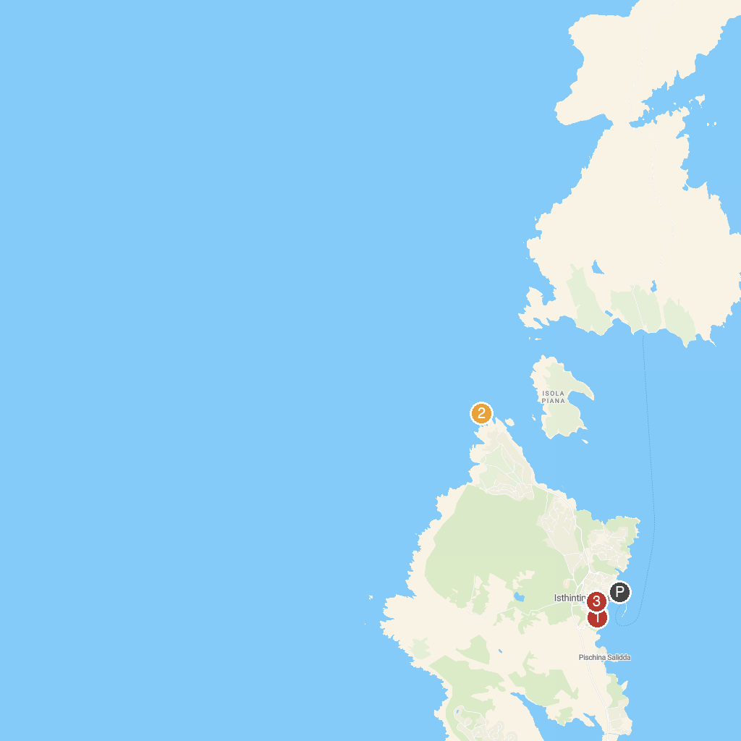
MAP KEY
1. MuT - Museo della Tonnara di Stintino | 3. Posidonia Charter Asinara
2. Scogliere di Capo Falcone
P. Cruise port / terminal
Map © MapTiler © OpenStreetMap contributors · cruiseports.org

