Stadt Wehlen, Saxony, Germany
Germany's smallest-town gateway to sandstone giants. Step off the ship onto a cobblestone promenade and within the hour you're standing on Bastei Bridge, 194 metres above the Elbe.
⚓ Docked (river berth) · 🕒 Typical call: 6–8 hrs · 💶 Euro (€) · 🗣️ German · 🥾 Hiking destination
✍️ MY DAY IN PORT (FILL IN)
Ship / Date
In port | arrive ______ · all aboard ______
Booked excursion
Notes / meeting point
GETTING ASHORE
- Docking: Pier — ships berth directly on the Uferpromenade (riverfront)
- Walk to center: 1 min to Marktplatz; 5–10 min to castle ruins
- Best For: Hiking, dramatic sandstone scenery, German Romantic landscape art
- Don't Miss: Bastei Bridge & the engine-free Gierseilfähre reaction ferry
GETTING AROUND
- 🚕 Taxi: €7–15 — Local taxis (e.g. TAXI A. Schubinski, Taxi Maik Abraham) serve the area. Base fare ~€4.50 plus per-km rate; useful for r
TOP THINGS TO DO
- Bastei Bridge & Felsenburg Neurathen — The 194 m-high stone bridge arcing across sandstone pillars is one of Germany's most photographed sights.
- Uttewalder Grund Ravine Walk — A shaded, fairy-tale gorge just 30 minutes' walk from town, featuring the Uttewalder Felsentor rock arch — a natural gateway made…
- Stadt Wehlen Castle Ruins — Five minutes uphill from the market square, the 12th-century Burgruine Wehlen offers a free panoramic view straight down to your…
- Kleine Sächsische Schweiz Miniature Park — Open-air park where local sandstone has been carved into precise scale replicas of the region's rock formations, castles, and…
- Elbe Kayak or Canoe Paddle — Rent a kayak or canoe from local outfitter Kanu Aktiv and paddle downstream toward Pirna through the sandstone canyon scenery at…
BEST WALKS
- Town Centre & Castle Ruins Stroll: 45 mins · Easy–Moderate · Free — Walk from the riverfront to the Marktplatz, visit the 'Bicycle Church', then climb the short steep…
- Wehlener Grund Trail to Bastei: 2 hrs one-way · Strenuous · Free (Neurathen castle ~€2.50) — The classic hike from town up through the wooded Wehlener Grund gorge to Bastei Bridge.
WEATHER · DAYLIGHT · MONEY
Month | High °F | Low °F | Rainy days
May | 64 | 47 | 11
Jul | 76 | 59 | 12
Sep | 68 | 52 | 11
Daylight: May 5:14AM–8:47PM · Jul 5:07AM–9:11PM · Sep 6:39AM–7:17PM
cruiseports.org/stadt-wehlen · Confirm terminal & all-aboard time with your ship

Stadt Wehlen, Saxony, Germany — Port Map
Red = walkable sights · Amber = excursions farther out · P = cruise terminal
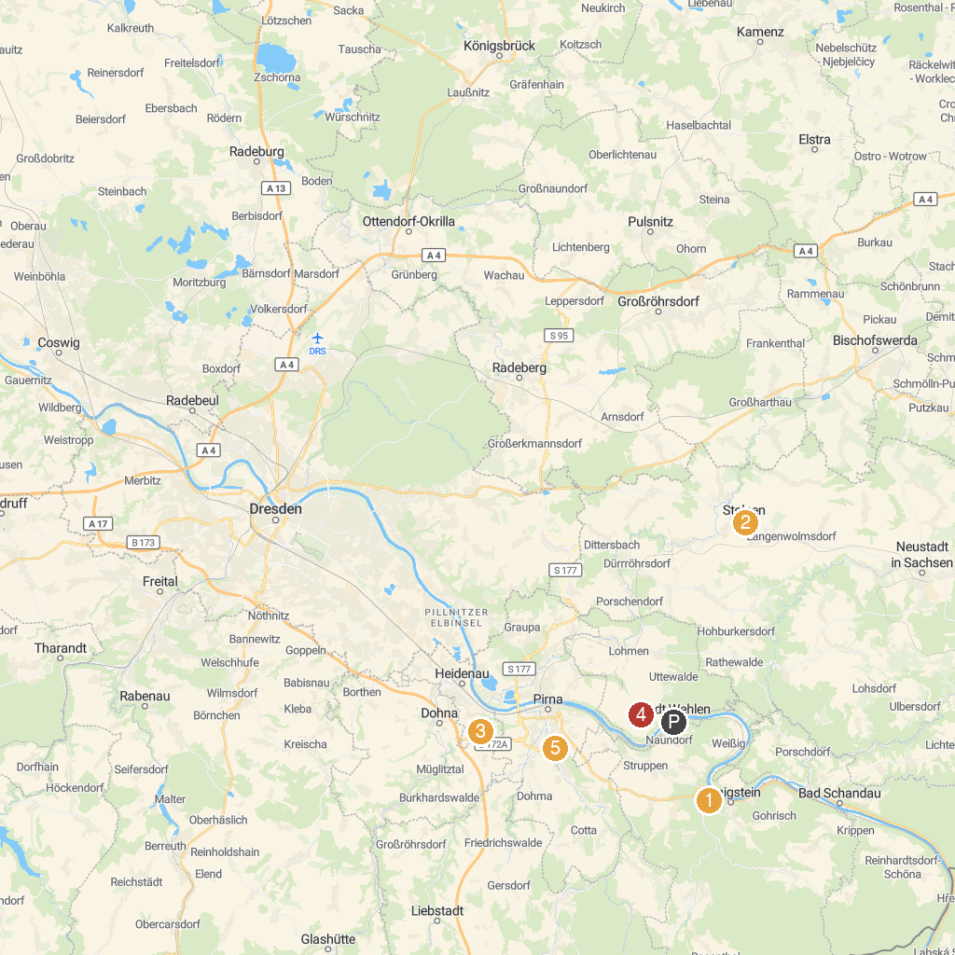
MAP KEY
1. Königstein Fortress | 5. Maria am Wasser Church
2. Pillnitz Castle | 6. Barockgarten Großsedlitz
3. Schloss Weesenstein | 7. Kleine Sächsische Schweiz
4. Stolpen Castle | 8. DDR Museum Pirna
P. Cruise port / terminal
Map © MapTiler © OpenStreetMap contributors · cruiseports.org

