Roth, Bavaria, Germany
A quietly rewarding stop on the Main-Danube Canal, Roth offers an unpolished slice of Franconian life: a Renaissance castle, half-timbered squares, hearty sausages, and zero crowds — plus quick access to Nuremberg.
⚓ Docked (canal quay) · 🕒 Typical call: 6–8 hrs · 💶 Euro (cash preferred) · 🗣️ German
✍️ MY DAY IN PORT (FILL IN)
Ship / Date
In port | arrive ______ · all aboard ______
Booked excursion
Notes / meeting point
GETTING ASHORE
- Docking: Tied up along the Main-Danube Canal quay (no tender)
- Walk to center: ~4.5 km (2.8 mi) — shuttle or taxi recommended
- Best For: Authentic Bavarian town life, history, Nuremberg day trips
- Don't Miss: Schloss Ratibor courtyard and Franconian Schäufele for lunch
GETTING AROUND
- 🚕 Taxi: €6 base + €3/km — Taxis are available for short transfers around Roth. For the short hop into town, expect a minimal fare of €8–12 dependi
- 📱 Rideshare: ❌ not available
TOP THINGS TO DO
- Schloss Ratibor & Old Town Walk — Explore the 16th-century Renaissance castle built for Margrave George the Pious, with its ornate ceremonial hall and castle…
- Nuremberg Day Trip — Just 25 km away, Nuremberg offers the Imperial Castle, Nazi Documentation Center, medieval old town walls, and the best…
- Franconian Wire Museum (Fabrikmuseum) — Roth was Europe's center for "Leonisch" gold and silver wire used in royal embroidery and Christmas tinsel.
- Rothsee & Franconian Lake District — A 10-minute taxi ride brings you to Rothsee, a reservoir with beaches, cycling paths, and water sports in the heart of Bavaria's…
- Franconian Food & Beer Garden — Franconia has more breweries per capita than anywhere on Earth.
BEST WALKS
- Marktplatz to Schloss Ratibor Loop: 1.5 km | 30–45 min | Easy — Start at the central Marktplatz with its Margrave Fountain and half-timbered facades, walk south to…
- Canal Quay Stroll: 1 km | 15 min | Easy — A short, pleasant walk along the Main-Danube Canal near the dock to watch river traffic and observe…
WEATHER · DAYLIGHT · MONEY
Month | High °F | Low °F | Rainy days
May | 65 | 48 | 14
Jul | 77 | 59 | 11
Sep | 68 | 52 | 10
Daylight: May 5:32AM–8:52PM · Jul 5:27AM–9:15PM · Sep 6:52AM–7:28PM
cruiseports.org/stadt-roth · Confirm terminal & all-aboard time with your ship

Roth, Bavaria, Germany — Port Map
Red = walkable sights · Amber = excursions farther out · P = cruise terminal
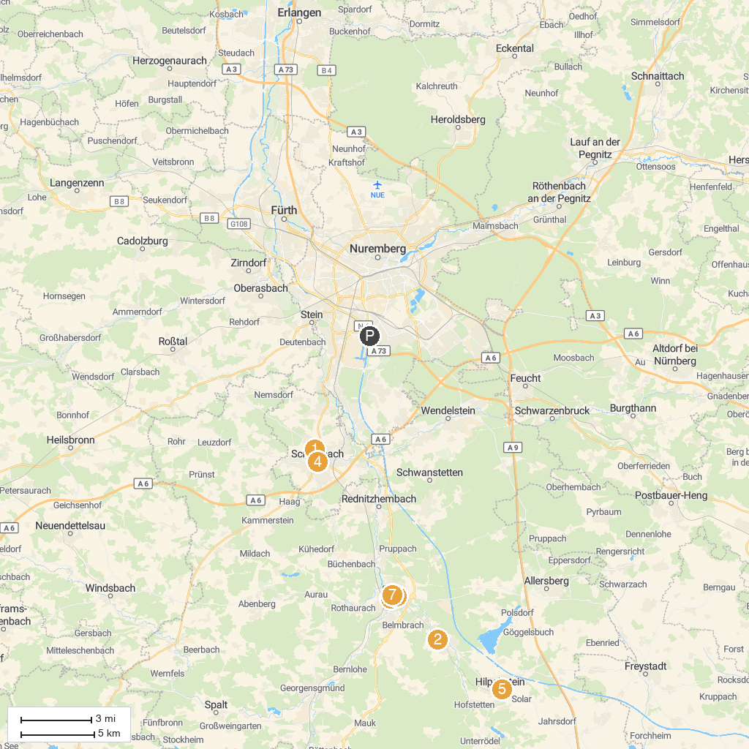
MAP KEY
1. Stadtmuseum Schwabach | 5. Burgruine Hilpoltstein
2. Historischer Eisenhammer | 6. Fabrikmuseum Roth
3. Schloss Ratibor | 7. Roth Marktplatz
4. Schwabach, marktplatz
P. Cruise port / terminal
Map © MapTiler © OpenStreetMap contributors · cruiseports.org

